

Hormel Foods Corporation (Hormel)

Operations and Integration Document

# Table of Contents

Table of Contents 2

Version Control 13

Revision History 13

Review History 13

Approval History 13

Abbreviation 13

1. Introduction 15

1.1 Executive Summary 15

1.2 Intended Audience 15

2. Saviynt Product Overview 15

2.1 Governance Platform 16

2.2 Lifecycle Manager 16

2.3 Provisioning Engine 17

2.4 Identity Intelligence 17

2.5 Integration Modules 18

3. Operational Architecture 18

3.1 Saviynt Users and Accounts 19

3.2 Service Accounts 19

3.2.1 Saviynt Application Database 19

3.2.2 Active Directory Application 20

3.2.3 Windows Connector Server 20

3.2.4 Oracle HCM 20

3.3 Server Infrastructure 20

3.3.1 DEV Environment 21

3.3.2 TEST Environment 21

3.3.3 PROD Environment 22

3.4 Disaster Recovery 22

3.4.1 DR Terminology 22

3.4.2 High-Level Backup and Archival Strategy 22

4. Server Lifecycle Support 24

4.1 Reboot Saviynt Application Pool deployed on Windows Connector Server 24

4.2 Reboot Saviynt Security Manager Server 27

4.3 Database Repository Operations 30

4.4 Saviynt Security Manager Patching 30

4.4.1 Patching Scope 30

4.4.2 Roles and Responsibilities 30

4.4.3 Patching Frequency 31

4.4.4 Saviynt Cloud Patch Management Cycle 32

4.4.5 Virtual Machines Patching Process 33

4.4.6 Applied Patches on Saviynt Security Manager Instance 34

4.5 Server Monitoring 34

4.5.1 Saviynt Security Manager (SSM) Monitoring 34

4.5.2 Monitor CPU Utilization on Windows Connector Server 35

4.6 Certificate Management: Renew SSL Certs 35

4.6.1 Digital Certificates 35

5. Saviynt Administrative Tasks 36

5.1 Permissions 36

5.1.1 Grant Admin SAV role to user 36

5.1.2 Grant End-User SAV role to user 40

5.1.3 Grant Helpdesk SAV role to user 41

5.1.4 Revoke administrator SAV role from user 44

5.1.5 Revoke Helpdesk SAV role from user 47

5.2 UI Customizations 50

5.2.1 Custom Branding 51

5.3 Scheduled Jobs 54

5.4 Use Case Customizations 56

5.4.1 Addition of New Email Domain 56

5.4.2 Addition of New OU Location Name 65

5.4.3 Addition of new Active Directory group to retain access on user account disable. 68

5.4.4 Change New Hire Number of 14 Days Prior Criteria. 70

5.4.5 Birthright Criteria changed for Active Directory 76

5.4.6 Birthright Criteria changed for Mailbox 80

5.4.7 New External OU addition 82

5.4.8 New Birthright Groups Adding or Removing 86

5.4.9 Delete Active Directory account after 30 days criteria change 90

5.4.10 Oracle HCM Atom feed settings 95

5.4.11 Onboard existing contingent worker into Oracle HCM and Saviynt 105

5.4.12 Change in First name, Last name, Display name and Username. 112

5.4.13 Updating UPN address in Saviynt 114

5.4.14 Manage Remove and Disable account in Pending task 116

5.4.15 Technical Rule 118

5.4.16 User Update Rule 120

5.5 Access Request Operation 122

5.5.1 Request Access 123

5.5.2 Remove Access 129

5.6 Request Approval 132

5.6.1 Request History 132

5.6.2 Request Approval 133

5.7 Password Management 136

5.7.1 Helpdesk Assisted Password Reset 136

5.7.2 Unlock User Account 139

5.8 Connections 141

5.8.1 Oracle HCM 142

5.8.2 Active Directory 142

5.8.3 Mailbox 143

5.9 Email Template 143

6. Saviynt UI 144

6.1 Analytics 144

6.1.1 View and Execute Analytic Reports 145

6.1.2 User Activity in Saviynt 147

6.1.3 Schedule Analytics 150

6.2 Identity Correlation 152

6.3 Workflows 154

6.4 Global Configuration 156

6.4.1 SMTP Configuration 156

6.5 Tasks 160

6.5.1 Pending Task 160

6.5.2 Managing Pending Tasks 161

6.5.3 Viewing Tasks Details 163

6.5.4 Discontinuing Selected Pending Tasks 166

6.5.5 Completed Tasks 167

7. Saviynt Security Manager Troubleshooting 168

7.1 Logging 168

7.1.1 Application Log Details 169

7.1.2 Application Audit Log Details 170

7.1.3 Monitor Oracle HCM Atom Feed logs in Saviynt. 173

7.1.4 PowerShell Script Log Details 174

7.2 Common Errors 174

7.2.1 Provisioning Retry Error 175

7.2.2 Connection Failure 177

7.3 Saviynt Support 177

7.3.1 Submit Ticket in Saviynt Support 177

7.3.2 Saviynt SLA Definition 179

7.3.3 Saviynt Helpline 180

7.4 Saviynt Community 180

8. Frequency Asked Questions (FAQs) 183

9. Reference 185

List of Figures

Figure 1: Saviynt Cloud Access Governance and Intelligence 15

Figure 2 : Internet Information Services 24

Figure 3 : IIS Manager Connection 25

Figure 4 : Application Pools 25

Figure 5 : SaviyntApp: Stop 26

Figure 6 : SaviyntAppPool: Start 27

Figure 7 : Application Pool: Started 27

Figure 8 : Freshdesk Support portal 28

Figure 9 : Submit a ticket 28

Figure 10 : Submit ticket 29

Figure 11 : Vulnerability Patching 32

Figure 12 : Zero Day and High Severity vulnerability patching 33

Figure 13 : Azure Console 34

Figure 14: CPU Utilization on Windows Connector Servers 35

Figure 15: SSM Dashboard 37

Figure 16: Identity Repository 37

Figure 17: SAV Roles 38

Figure 18: SAV Role List 38

Figure 19: SAV Role Details 39

Figure 20: SAV Role Detail 39

Figure 21: Add User 40

Figure 22: Users 40

Figure 23: SSM Dashboard 41

Figure 24: Identity Repository 41

Figure 25: SAV Roles 42

Figure 26: SAV Role List 42

Figure 27 : Helpdesk Role Detail 43

Figure 28: SAV Role Detail 43

Figure 29: Add User 44

Figure 30: Users 44

Figure 31: SSM Dashboard 45

Figure 32: Identity Repository 45

Figure 33: SAV Roles 46

Figure 34: SAV Role List 46

Figure 35: Admin SAV Role Details 47

Figure 36 : Remove User from Role 47

Figure 37: SSM Dashboard 48

Figure 38: Identity Repository 48

Figure 39: SAV Roles 49

Figure 40: SAV Role List 49

Figure 41: Admin SAV Role Details 50

Figure 42 : Remove User from Role 50

Figure 43 : SSM User Interface Branding 51

Figure 44 : UI Branding 52

Figure 45 : Top Navigation 52

Figure 46 : Application Logo 53

Figure 47 : UI Branding 53

Figure 48 : Top Navigation 54

Figure 49 : Provisioning Job 55

Figure 50 : Job Detail 55

Figure 51 :Schedule the Job 56

Figure 52 : Connection List 57

Figure 53 : Connection List 57

Figure 54 : Global Configuration 58

Figure 55 : Connection Save 59

Figure 56 : Connection 59

Figure 57 : Email Domain Update Connection 60

Figure 58 : User Import JSON 60

Figure 59 : Global Configuration 60

Figure 60 : Save Connection 62

Figure 61: Analytics Configuration List 63

Figure 62: Advanced Analytics Page 63

Figure 63 : Analytic 63

Figure 64 : Analytics Configuration List 64

Figure 65 : Analytics History 65

Figure 66 : Analytics View 65

Figure 67 : Analytics Result 65

Figure 68 : Accounts 66

Figure 69 : Upload Accounts 66

Figure 70 : Upload OU Location 67

Figure 71 : Account Upload Preview 67

Figure 72: Analytics Configuration List 68

Figure 73: Advanced Analytics Page 69

Figure 74 : Edit Analytic Edit 70

Figure 75 : Connection List 71

Figure 76 : Connection List 71

Figure 77 : Global Configuration 72

Figure 78 : Save Connection 73

Figure 79 : Technical Rule 73

Figure 80 : Technical List 74

Figure 81 : Condition 74

Figure 82 : Connection List 75

Figure 83 : Atom Feed Endpoint 76

Figure 84 : Oracle HCM Atom Feed 76

Figure 85 : Connection List 77

Figure 86 : Connection List 77

Figure 87 : Global Configuration 78

Figure 88 : Technical Rule 79

Figure 89 : Technical List 79

Figure 90 : Condition 80

Figure 91 : Connection List 80

Figure 92 : Technical Rule 81

Figure 93 : Technical List 82

Figure 94 : Action 82

Figure 95 : Object Type 82

Figure 96 : Endpoint 83

Figure 97 : Update Attribute 84

Figure 98 : Connection List 85

Figure 99 : Active Directory Update 85

Figure 100 : Endpoint 86

Figure 101 : Entitlement with new account 87

Figure 102 : Add Entitlement 87

Figure 103 : Add Entitlement 88

Figure 104 : Technical Rule 88

Figure 105 : Technical List 89

Figure 106 : Action 89

Figure 107 : Object Type 90

Figure 108: Analytics Configuration List 91

Figure 109: Advanced Analytics Page 91

Figure 110 : Edit Analytic 91

Figure 111: Analytics Configuration List 93

Figure 112: Advanced Analytics Page 93

Figure 113 : Edit Analytic 93

Figure 114 : Atom Feed Endpoint 96

Figure 115 : Oracle HCM Atom Feed 96

Figure 116 : Atom Feed Endpoint 97

Figure 117 : Oracle HCM Atom Feed Configuration 97

Figure 118 : Job Control Panel 99

Figure 119 : Utility 99

Figure 120 : Edit Trigger 100

Figure 121 : Job Details 100

Figure 122 : Cron Expression 101

Figure 123 : Endpoint 101

Figure 124 : Endpoint Details 102

Figure 125 : Trigger Chain Job 102

Figure 126 : Trigger Chain Job 103

Figure 127 : Trigger Chain Job 103

Figure 128 : Job Control Panel 104

Figure 129 : Trigger Details 105

Figure 130 : Job Trigger Schedule 105

Figure 131 : Incremental User Reconciliation 106

Figure 132 : Job Control Panel 107

Figure 133 : Utility 107

Figure 134 : Edit Trigger 108

Figure 135 : Job Details 108

Figure 136 : Cron Expression 109

Figure 137 : Users 109

Figure 138 : User List 110

Figure 139 : Profile 110

Figure 140 : Job Control Panel 111

Figure 141 : Trigger Details 112

Figure 142 : Job Trigger Schedule 112

Figure 143 : Job Control Panel 113

Figure 144 : User List 113

Figure 145 : User Profile 113

Figure 146 : User Profile 114

Figure 147 : Job Control Panel 114

Figure 148 : User List 115

Figure 149 : User Profile 115

Figure 150 : User Profile 116

Figure 151 : Pending Task 116

Figure 152 : Pending Task 117

Figure 153 : Provisioning Job 118

Figure 154 : Technical Rule 119

Figure 155 : Technical Rule Condition 120

Figure 156 : User Update Rules 121

Figure 157 : User Update Rule Search 121

Figure 158 : User Update Rule List 122

Figure 159 : User Update Rule Condition 122

Figure 160: Request Access 123

Figure 161: User Search 123

Figure 162: Add to Cart 124

Figure 163: Add Business Justification 124

Figure 164: Request Access 125

Figure 165: User Search 125

Figure 166: Add to Cart 126

Figure 167: Add Business Justification 126

Figure 168 : Access Request Details 127

Figure 169: Request Access 127

Figure 170: User Search 128

Figure 171: Add to Cart 128

Figure 172: Add Business Justification 129

Figure 173 : Access Request Details 129

Figure 174: Remove Access – ARS 130

Figure 175: Remove Access – Request Access for Others 130

Figure 176: Remove Access – Search Users 130

Figure 177: Remove Access from Cart 131

Figure 178: Remove Account 131

Figure 179: Remove Access – Submit 132

Figure 180 : ASR 132

Figure 181 : Request History 133

Figure 182 : List of Request History 133

Figure 183 : Task History 133

Figure 184: Request Approval tab 134

Figure 185: User Request ID 134

Figure 186: Accept/Reject Request 134

Figure 187: Add Comment and Submit 135

Figure 188: Confirm Request 135

Figure 189: Request Completed 136

Figure 190: Change Password 136

Figure 191: Helpdesk Assist - Reset Password 136

Figure 192 : Change Password 137

Figure 193 : Set Password 137

Figure 194 : Type New Password 138

Figure 195 : Change Password 138

Figure 196 : Change password submit 139

Figure 197: Unlock User Account- 1 139

Figure 198: Unlock User Account- 2 140

Figure 199: Unlock User Account- 3 140

Figure 200: Unlock User Account- 4 141

Figure 201: Unlock User Account - 5 141

Figure 202 : Connections 142

Figure 203 : Connection List 142

Figure 204 : Email Template 143

Figure 205 : Template Detail 144

Figure 206: Analytic 145

Figure 207: Analytics Configuration List 145

Figure 208: Advanced Analytics Page 146

Figure 209 : Analytic Configuration List 146

Figure 210 : Analytic History 146

Figure 211 : Analytic Result 147

Figure 212 : Analytic Result 147

Figure 213: Analytics 148

Figure 214: Analytics Configuration List 148

Figure 215: Advanced Analytics Page 148

Figure 216: Analytic Configuration List 149

Figure 217: Analytic History 149

Figure 218 : Anaytic Result 150

Figure 219: Analytics 150

Figure 220: Analytics Configuration List 151

Figure 221 : Schedule Analytic 151

Figure 222 : Schedule the Job 151

Figure 223 : Endpoint 152

Figure 224 : Endpoint Details 152

Figure 225 : Correlation Rule 153

Figure 226 : Rules 153

Figure 227: Workflow List 154

Figure 228: Workflow Designer 156

Figure 229 : SMTP 157

Figure 230: SMTP Configuration 157

Figure 231: PROD SMTP Configuration 159

Figure 232: SMTP Configuration 160

Figure 233 : Pending Task 161

Figure 234 : Pending Tasks 161

Figure 235 : Pending Task Column 162

Figure 236 : View Task Details 164

Figure 237 : View 164

Figure 238 : Detail View of Task 165

Figure 239 : Provisioning Comments 166

Figure 240 : Discontinued 166

Figure 241 : Confirm Discontinue 167

Figure 242 : Completed Tasks 167

Figure 243 : View Task details 168

Figure 244 : Application Logs 169

Figure 245 : Application Logs 170

Figure 246 : Download Log File 170

Figure 247 : Application Audit Log Page 172

Figure 248 : Download Reports 172

Figure 249: Admin tab 173

Figure 250: Application Logs 173

Figure 251 : Application Logs 174

Figure 252: Application Logs 174

Figure 253 : Saviynt Support 178

Figure 254 : Submit a ticket 178

Figure 255 : Submit ticket 179

Figure 256 : Saviynt SLA Definition 179

Figure 257 : Community Forums 181

Figure 258 : Saviynt User Community Forums 182

List of Tables

Table 1 : Governance Platform 16

Table 2 : Lifecycle Manager 17

Table 3 : Provisioning Engine 17

Table 4 : Identity Intelligence 17

Table 5 : Integration modules 18

Table 6 : Operational Architecture 18

Table 7: Hormel Actors in Saviynt System 19

Table 8: Saviynt Database Service Accounts 19

Table 9 : Active Directory Service Accounts 20

Table 10 : Windows Connector Server Service Accounts 20

Table 11 : HCM Service Accounts 20

Table 12: Development Environment Server Structure 21

Table 13: Development Environment Server Structure 21

Table 14: Production Environment Server Structure 22

Table 15 : DR Terminology 22

Table 16 : Patching Scope 30

Table 17 : Roles and Responsibilities 30

Table 18 : Patching Frequency 31

Table 19 : Applied Patches on SSM Instance 34

Table 20: Digital Certificates 35

Table 21 : Sav Role Details 36

Table 22 : Analytics 62

Figure 23 : Analytics 68

Table 24 : Analytics Configuration List 69

Figure 25 : Analytics 90

Figure 26 : Analytics 92

Table 27 : Oracle HCM Configuration Attributes and Values 98

Table 28 : User Correlation Rule for Other Application 154

Table 29: Workflow Component Details 154

Table 30 : SMTP Component 158

Table 31 : View Task Details 163

Table 32 : Pending Task Details 165

Table 33 : Task Failure Report 175

Table 34 : Active Directory Task Failure Report 175

Table 35 : insufficient access Error 176

Table 36 : Mailbox Failure Report 176

Table 37 : Reconcilation Failure Report 176

# Version Control

## Revision History

This section represents the change history of the document. All revisions of the document must be tracked by identifying a new version number, the date it was modified, the person making the change, and the reason for the change.

|  |  |  |  |
| --- | --- | --- | --- |
| Version | Date | Author | Comments |
| 0.1 | 04-Jan-2021 | Ajinkya Chavan | Initial Draft |
| 0.2 | 06-Jan-2021 | Ajinkya Chavan | Updated Section 2 to 4 |
| 1.0 | 09-Jan-2021 | Ajinkya Chavan | Updated Section 5 to 7 |
| 1.1 | 11-Jan-2021 | Ajinkya Chavan/Anjali Patil | Updated section 8 |
| 1.2 | 12-Jan-2021 | Ajinkya Chavan/Anjali Patil | Added content to sections 7 and 8 |
| 1.4.1 | 22-Feb-2021 | Wes Rowden | WT 114373, 113965 |

## Review History

|  |  |  |
| --- | --- | --- |
| Version | Reviewed By | Date |
| 1.3 | **Sai Mulam** | 12-Jan-2021 |
| 1.4 | **Vineet Gupta** | 13-Jan-2021 |
|  |  |  |
|  |  |  |
|  |  |  |

## Approval History

Signing of this document acknowledges everyone’s concurrence with the validity and accuracy of the information contained in this document.

|  |  |  |
| --- | --- | --- |
| Version | Approved By | Date |
| 1.4 | **Vineet Gupta** | 13-Jan-2021 |
| 1.4 | **Rajan Behal** | 14-Jan-2021 |
|  |  |  |

## Abbreviation

|  |  |  |
| --- | --- | --- |
| Abbreviation | Terms | Description |
| SSM | Saviynt Security Manager | Saviynt’s identity management product name |
| IAM | Identity Access Management | IAM refers to a framework of policies and technologies for ensuring that the people in an enterprise have the appropriate access to technology resources |
| DN | Distinguished Name | Every entry in the directory has a distinguished name (DN). DN is the name that uniquely identifies an entry in the directory. The first component of the DN is referred to as the Relative Distinguished Name (RDN). |
| OU | Organizational Unit | An organizational unit (OU) is a subdivision within an [Active Directory](https://kb.iu.edu/d/ambu) into which you can place users, groups, computers, and other organizational units |
| HTTP | Hypertext Transfer Protocol | An application protocol for distributed, collaborative, and hypermedia information systems. |
| HTTPS | Hypertext Transfer Protocol Secure | An application protocol for distributed, collaborative, and hypermedia information systems through an encrypted channel. |
| SSL | Secure Sockets Layer | Standard security technology for establishing an encrypted link between a server and a client. |
| OOTB | Out-of-the-Box | Used in the standard/default configuration without any special customization |
| TCP | Transmission Control Protocol | The Transmission Control Protocol is one of the main protocols of the Internet protocol suite. It originated in the initial network implementation in which it complemented the Internet Protocol. |

# Introduction

## Executive Summary

Hormel Food Corporation (Hormel) is implementing Saviynt Security Manager (SSM) solution to manage user (US Employees and Other Users) identities which includes identity lifecycle management, and provisioning/de-provisioning for in scope target systems (Active Directory, and Mailbox).

The purpose of this documentation is to provide guidance to the IAM admins of an organization to perform their functions correctly and efficiently in Saviynt Security Manager. This document is approved standard procedures for performing operations safely to provide services.

## Intended Audience

The intended audience for this document is identity management team of the Saviynt Security system.

# Saviynt Product Overview

Saviynt is a cloud-native Identity Governance and Administration (IGA) platform that protects an organization's most sensitive information and increases your organizational efficiency and agility by ensuring that the right people have the right access to the right resources for only the right amount of time.

It is one of the leading providers of Cloud Security and Identity Governance solution that provides a single platform to secure applications, data that are hosted on Cloud (E.g.: Office 365, AWS, Azure, Salesforce, Workday) and on-premises (E.g.: SAP, Oracle EBS) systems.

Saviynt platform unifies accounts across the target systems, creating one identity with [fine-grained entitlements](https://saviynt.com/solutions/features/fine-grained-entitlements/) for each user. Saviynt automates account and access provisioning aligned with organizational risk tolerance and workflows so organizations can reduce human error, risk, accelerate onboarding, and holistically view all users’ access.

Figure 1: Saviynt Cloud Access Governance and Intelligence

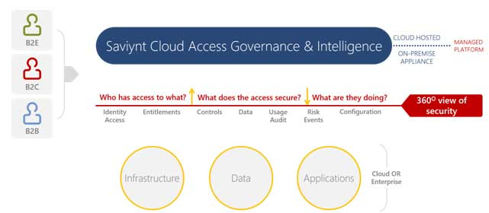

Saviynt implements a modular, loosely coupled architecture that provides a flexible approach in how it interacts with connected systems. The product comprises five modules, all of which have been licensed and will be deployed to meet business requirements.

* Governance Platform
* Lifecycle Manager
* Provisioning Engine
* Identity Intelligence
* Integration Module

## Governance Platform

It establishes a single framework that centralizes identity data, captures business policy, models roles, and takes a risk-based, proactive approach to manage users and resources. The Governance Platform provides following high-level functionality.

Table 1 : Governance Platform

|  |  |
| --- | --- |
| Identity Warehouse | The identity warehouse serves as the central repository for identity and access data across Saviynt connected enterprise applications in both cloud and on-premise. It transforms technical data into rich, business-relevant information that helps business users make informed and accurate access decisions. |
| Resource Connector | Resource connectors speed loading of data into the identity warehouse and provisioning of changes to user accounts across target systems. |
| Policy Model | The Saviynt policy model establishes a strong governance framework through efficient definition, validation and enforcement of enterprise access policies. By leveraging a centralized policy store, enterprises can efficiently apply all types of access policies across compliance, provisioning and access management activities. |
| Role Model | The role model makes it easy for organizations to align user access privileges with job function, providing a simpler approach for administering, requesting, reviewing, and fulfilling user access. |
| Workflow Engine | Workflow is a sequence of processing tasks for a set of data.  Workflow is created to pass data to systems. It is path that describes the flow of actions and possible output for actions being done or undone. |

## Lifecycle Manager

Saviynt Lifecycle Manager manages changes to access through user-friendly self-service request and password management interfaces and automated lifecycle events. It provides a flexible, scalable solution for addressing the constantly evolving access needs of your business in a way that's both efficient and compliant. The Lifecycle Manager module provides following high-level functionality

Table 2 : Lifecycle Manager

|  |  |
| --- | --- |
| Self-Service Access Request | Saviynt empowers business users to self-manage their access by delivering an efficient, compliant access request process with an intuitive e-commerce user experience. |
| Password Management | Password management significantly reduces calls to the IT/help desk by providing end users with an easy, intuitive way to change or reset their passwords—without ever having to contact IT. |
| Lifecycle Event Management | Lifecycle event management provides an automated, efficient, and secure means to synchronize access changes to user lifecycle events while enhancing governance to ensure the right access is granted or revoked at the right time. |
| Configurable Workflows | Track access approvals and drive provisioning request and ensure close-loop access fulfilment |

## Provisioning Engine

Saviynt simplifies all user lifecycle management activities with self-service access request and automated provisioning. In addition, Saviynt enables IT to automate provisioning activities associated with user lifecycle activities, such as a new user on-boarding or an existing user departing the organization. As a result, organizations can enhance their security posture even as they lower the ongoing expense of user lifecycle management. The Provisioning Engine provides following high-level functionality:

Table 3 : Provisioning Engine

|  |  |
| --- | --- |
| Provisioning | Automates account changes made on target systems, in close to real time, to deliver access requests, access changes. This eliminates the need for IT to use slow, error-prone manual processes for performing access processes. |
| Data Synchronization | Detects and synchronizes changes across resources & applications. |
| Resource Connector | Provides out-of-the-box read/write connectors for quickly connecting to enterprise resources. |

## Identity Intelligence

With Identity Intelligence, organizations can transform technical identity data scattered across multiple enterprise systems into centralized, easily understood and business-relevant information. The visibility and insights offered by Saviynt Analytics and Reporting provide a clear understanding of identity and access information.

Table 4 : Identity Intelligence

|  |  |
| --- | --- |
| Analytics and Reporting | Saviynt provides business-friendly reports and analytics tools that makes it easy to track and monitor critical metrics and processes. |
| Dashboard | The Saviynt dashboard simplifies how business users manage access. Both business and IT users can personalize their dashboards with easy drag-and-drop formatting and content selection. |

## Integration Modules

Saviynt Integration Modules provide out-of-box integration with other IT management tools, such as third-party provisioning systems. By facilitating integration with existing tools, Saviynt gives organizations better visibility and control, and its pre-built connectivity options speed deployment and reduce costs. Saviynt enables secure connectivity to resources across the cloud and on-premises domains.

Table 5 : Integration modules

|  |  |
| --- | --- |
| Provisioning Integration Module | These modules maximize investments in existing provisioning systems and speed deployment of compliance, governance, and access request processes by leveraging existing connector infrastructure. |
| Service Desk Integration Module | Pre-packaged service desk integration modules streamline orchestration of manual provisioning activities through integration with leading service desk solutions. |

Considering the features of Saviynt, Hormel has chosen Saviynt as their Identity management solution which will begin automated handling of user lifecycle management across Active Directory will be used for provisioning users to Active Directory, and Mailbox target applications in the organization, and leveraging other features in Saviynt.

# Operational Architecture

This section details the architecture of the enterprise Identity Manager (IDM) solution in Development (DEV), TEST, Production (PROD) environments. To understand the architecture details clearly, it is important to understand the components in the solution and their role.

The table below provides detailed overview of individual components

Table 6 : Operational Architecture

|  |  |
| --- | --- |
| Components | Description |
| Saviynt Cloud | Saviynt Cloud represents the Identity Management solution which are deployed in Azure Cloud. It is exposed to enterprise as a web application. This is the centralized IDM system which facilitates automated user on-boarding, user transfer, user separation, user rehire, and self-service password management. |
| Saviynt Express Route |  |
| Enterprise Applications | This represents combination of the Active Directory, and Mailbox which are integrated with Saviynt for provisioning user accounts during birthright provisioning and profile updates. |
| HCM HR Source | HCM is the source of all full-time employees (Including pending workers, and temporary employees) and Contingent worker. This provides new and updated information of each employee which will be reconciled daily by Saviynt to automatically process all user lifecycle events. |

## Saviynt Users and Accounts

Below are various types of actors involved in Hormel for managing the User Lifecycle and Password Management in Saviynt system.

Table 7: Hormel Actors in Saviynt System

|  |  |
| --- | --- |
| User Type | Description |
| Employee | Full Time Employee is onboarded through HCM HR processes. |
| Pending Employee | Temporary Employee is onboarded through HCM HR processes. |
| Contingent Worker | Contingent Worker Employee is onboarded through HCM HR processes. |
| IAM Admin | The ‘IAM Admin’ is group of people who has system administrator privileges in Saviynt and manages the day to day operations in Saviynt. |
| Help Desk Admin | The ‘Help Desk Admin’ is group of people who has helpdesk capability to submit user requests such as account unlock/password reset in Saviynt as per ServiceNow tickets or helpdesk call. |

## Service Accounts

A service account is a special account that an application or service uses to interact with the trusted and target system. Saviynt use these service accounts to log on and make changes to the target system or update in trusted source. These service accounts are given the restricted permissions to perform the designated job from Saviynt.

### Saviynt Application Database

Saviynt is the Identity Management system being used and this system uses database as repository for storing all the user information and configurations. My SQL running on Azure RDS (Relational Database Service) has been chosen for high performance, high availability and scalability purpose. Below are the service accounts that are used for connecting database instances for each environment.

Table 8: Saviynt Database Service Accounts

|  |  |
| --- | --- |
| Environment | Service Accounts |
| DEV | hormel-dev-svc-acct@hormeldevmysql |
| TEST | hormel-uat-svacc@hormeluatmysql |
| PRD | hormel-prod-svacc@hormelprodmysql |

### Active Directory Application

All users will provisioned to Active Directory as part of birthright provisioning as per their Employee type, Location and People Group. Active Directory application is configured in Saviynt using the LDAP connector. Below are the service accounts used in each environment to connect to Active Directory.

Table 9 : Active Directory Service Accounts

|  |  |
| --- | --- |
| Environment | Service Accounts |
| DEV | CN=mrsaviyntdev,OU=Service Accounts,OU=Admin Groups,OU=HormelTestLab,DC=hormeltestlab,DC=com |
| TEST | CN=mrsaviyntdev,OU=Service Accounts,OU=Admin Groups,OU=HormelTestLab,DC=hormeltestlab,DC=com |
| PRD | CN=mrsaviyntprd,OU=O365_Service-Accounts,OU=Admin Groups,OU=Hormel,DC=HFC,DC=AD |

### Windows Connector Server

Purpose of this server is to run “Saviynt Application Pool” agent and execute PowerShell script for mailbox provisioning. Below are the service accounts used in each environment to connect to Window server

Table 10 : Windows Connector Server Service Accounts

|  |  |
| --- | --- |
| Environment | Service Accounts |
| DEV | [mrsaviyntdev@hfc.ad](mailto:mrsaviyntdev@hfc.ad) |
| TEST | [mrsaviyntdev@hfc.ad](mailto:mrsaviyntdev@hfc.ad) |
| PRD | mrsaviyntprd@hfc.ad |

### Oracle HCM

Oracle HCM is the source of all Full Time Employee and Contingent worker records, and this is the source of truth for all data regarding Employee and Contingent worker being on-boarded, managed or off-boarded. Saviynt is integrated with this HR source to reconcile employee data in incremental recon and based on the data reconciled, employee lifecycle events are automated within Saviynt.

For this integration with Saviynt, Rest connector and custom jar is used for reconciling employee personal and assignment-related information from HCM. Below are the service accounts used in each environment to connect to HCM HR system:

Table 11 : HCM Service Accounts

|  |  |
| --- | --- |
| Environment | Service Accounts |
| DEV | Saviynt.HCMTest |
| TEST | Saviynt.HCMTest |
| PRD | Saviynt.HCMProd |

## Server Infrastructure

This section describes all the servers used for Development (DEV) and Production (PROD) environment as part of this implementation.

### DEV Environment

Below table lists all the servers and components for the Development environment.

Table 12: Development Environment Server Structure

|  |  |  |  |  |  |
| --- | --- | --- | --- | --- | --- |
| Server Name | IP Address or URL | Environment | Type | OS | Function |
| [Saviynt](https://ssm-dev-ads.ssmcloud.net/ECM) Cloud | ssm-dev-hormel.ssmcloud.net | Development | Cloud | N/A | Saviynt DEV Environment |
| HCM Server | https://ekkh-test.fa.us2.oraclecloud.com/ | Development | Cloud | N/A | HCM Server for Trusted Source |
| Active Directory | 172.16.40.82, 172.16.42.78 | Development | On-Premise | Windows Server | Active Directory for Provisioning |
| Windows Connector Server (used for mailbox provisioning) | 172.16.41.62 | Development | On-Premise | Windows Server | Mailbox Provisioning |

### TEST Environment

Below table lists all the servers and components for the TEST environment.

Table 13: Development Environment Server Structure

|  |  |  |  |  |  |
| --- | --- | --- | --- | --- | --- |
| Server Name | IP Address or URL | Environment | Type | OS | Function |
| [Saviynt](https://ssm-dev-ads.ssmcloud.net/ECM) Cloud | hormel-uat.ssmcloud.net/ECM | TEST | Cloud | N/A | Saviynt DEV Environment |
| HCM Server | https://ekkh-test.fa.us2.oraclecloud.com/ | TEST | Cloud | N/A | HCM Server for Trusted Source |
| Active Directory | 172.16.40.82, 172.16.42.78 | TEST | On-Premise | Windows Server | Active Directory for Provisioning |
| Windows Connector Server (used for mailbox provisioning) | 172.16.41.62 | TEST | On-Premise | Windows Server | Mailbox Provisioning |

### PROD Environment

Below table lists all the servers and components for the Production environment.

Table 14: Production Environment Server Structure

|  |  |  |  |  |  |
| --- | --- | --- | --- | --- | --- |
| Server Name | IP Address or URL | Environment | Type | OS | Function |
| [Saviynt](https://ssm-dev-ads.ssmcloud.net/ECM) Cloud | https://hormel.ssmcloud.net/ECM | Production | Cloud |  | Saviynt DEV Environment |
| HCM Server | [https://ekkh.fa.us2.oraclecloud.com/](https://urldefense.com/v3/__https:/ekkh.fa.us2.oraclecloud.com/__;!!N8Xdb1VRTUMlZeI!1TbP0JnHC94rC-4bLalecslEoSG8p2dvZtuZmW3OhB03dv2eJuZFtkmwMZKeFxoIRJg$) | Production | Cloud |  | HCM Server for Trusted Source |
| Active Directory | 172.16.40.1  172.16.40.2  172.16.32.1  172.16.56.1 | Production | On-Premise | Windows Server | Active Directory for Provisioning |
| Windows Connector Server (used for mailbox provisioning) | 172.16.41.62 | Production | On-Premise | Windows Server 2019 | Mailbox Provisioning |

## Disaster Recovery

Disaster recovery (DR) is an area of security planning that aims to protect an organization from the effects of significant negative events. Having a disaster recovery strategy in place enables an organization to maintain or quickly resume mission-critical functions following a disruption.

### DR Terminology

1. Recovery Time Objective (RTO): Once an outage/disruption occurs, this is the acceptable time frame within which an asset or business process needs to be recovered/restored in accordance to the set SLA levels.
2. Recovery Point Objective (RPO): This refers to the point in time in the past to which the system will need to recover once an outage/disruption has occurred.
3. The RPO is the point to which we will have all data up to that point recovered. The gap between the disaster and the RPO will likely be lost as a result of the disaster.
4. On the timeline, RTO is the point at which the system will be back up and running. The gap between the disaster and the RTO is the timeframe for which the app will be down and non-functioning.

### High-Level Backup and Archival Strategy

Table 15 : DR Terminology

|  |  |  |  |
| --- | --- | --- | --- |
| Data | Storage | Technology | Typical Retention Period |
| Logs Backup | Application Server logs and Tomcat logs | Azure | Saviynt policy is to maintain logs for active viewing in Azure instance.  Application Logs will be maintained on Azure instance or a centralized logging server as per requirement.   1. Logs up-to last 1 week will be persisted on Azure instance or (Centralized Logging Server). 2. Logs which are older than 1 week will be purged. |
| Data Backup | Snapshot of RDS instance volumes | Azure | As per our backup policy, Saviynt stores snapshot of RDS instances.  The frequency of snapshots is 1 back-up per day at 10:00 AM UTC.  The retention policy for RDS as below:   1. Retention Period for Prod: 30 days 2. Retention Period for Non-Prod: 7 days |

# Server Lifecycle Support

This section provides the details about starting and stopping various processes that are part of Saviynt.

**Note**: The machines have been setup to automatically restart the services in case of a reboot or service disruption.

## Reboot Saviynt Application Pool deployed on Windows Connector Server

The purpose of Saviynt Application Pool deployed on Windows Connector Server is to allow SSM to execute Windows PowerShell scripts and hence able to accomplish IGA use cases related to “Exchange Online” account creation, and Office-365 (O365) use cases supported only using PowerShell.

Follow below instructions to reboot Saviynt Application Pool deployed on Windows Connector Server and then to validate the services. IAM administrator might need to reboot this service, if the script fails to execute continuosly with errors not related to script.

**Note**: Service account must have appropiate permission to do RDP.

1. Login into Windows Connector Server as ‘mrsaviyntdev’ user, where Saviynt Application Pool agent is installed.
2. Search for IIS in Windows search box and click on 🡪 Internet Information Servers Manager (IIS).

Figure 2 : Internet Information Services

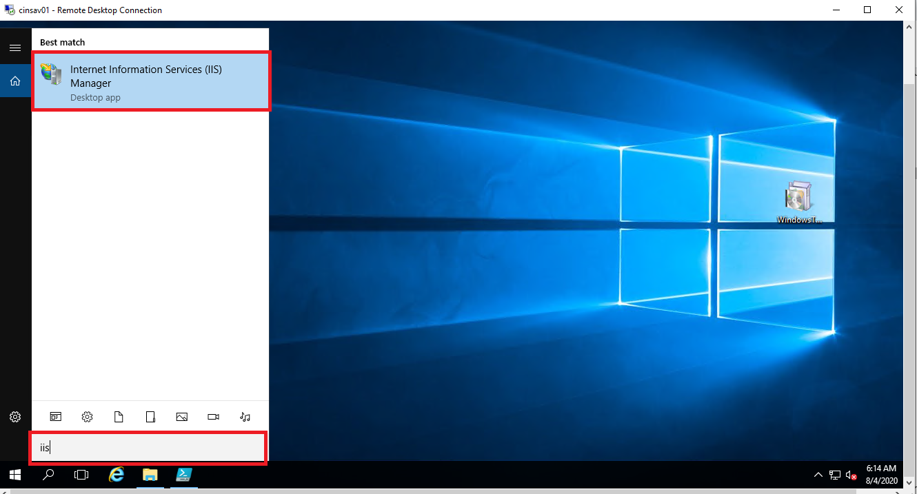

1. Expand “HORMELTESTLAB\KPMG”(This will differ for production server) from connection.

Figure 3 : IIS Manager Connection

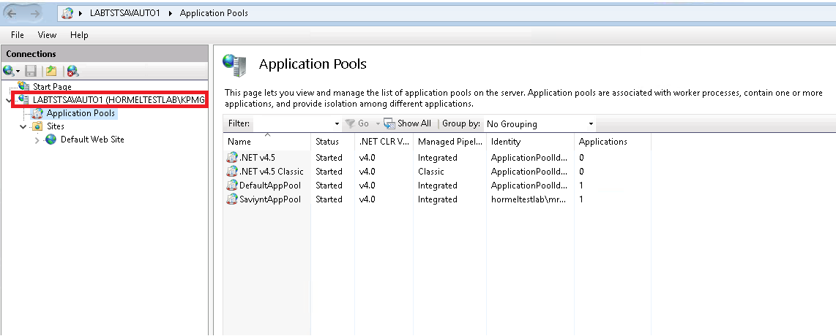

1. Click on 🡪 Application Pools and right click on “SaviyntAppPool”.

Figure 4 : Application Pools

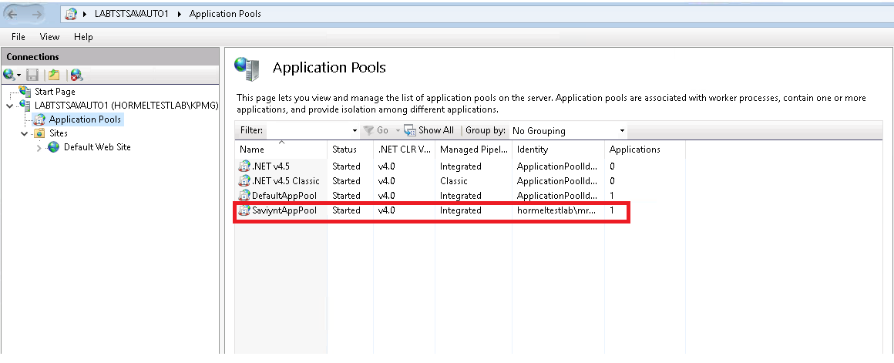

1. Select “Stop” to stop Saviynt Applicaion Pool.

Figure 5 : SaviyntApp: Stop

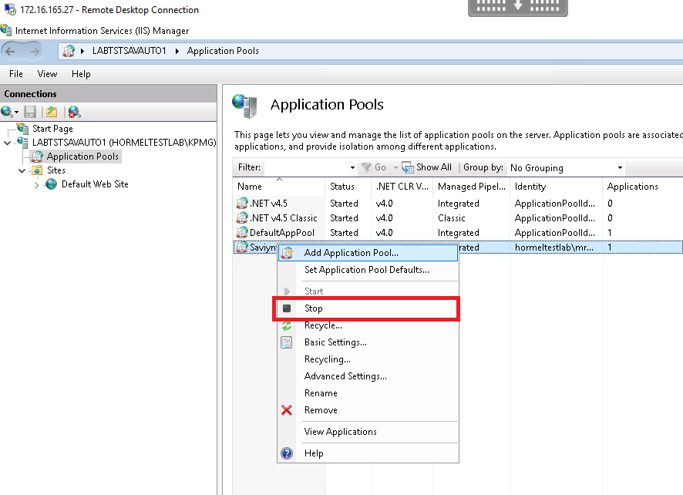

1. Right click on SaviyntApp and select 🡪 “Start” option from menu to start Saviynt application pool.

Figure 6 : SaviyntAppPool: Start

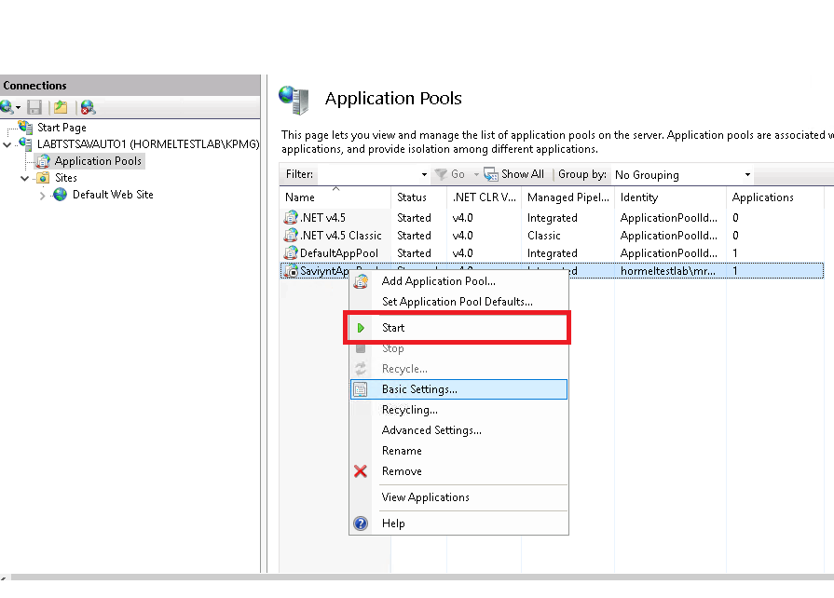

1. Verify SaviyntApp service is running.

Figure 7 : Application Pool: Started

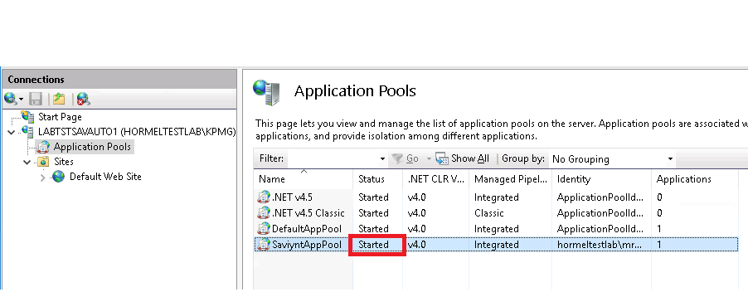

## Reboot Saviynt Security Manager Server

Saviynt Security Manager represents the Identity Management solution which is deployed on Azure Cloud. It is exposed to enterprise as a web application. To reboot Saviynt Security Manager Server, IAM Admin must submit a Freshdesk (Saviynt Customer Portal) ticket must be created.

**Note :** IAM admin must have access to raise ticket in Saviynt Freshdesk portal.

Perform following steps to raise ticket on Saviynt Freshdesk.

1. Login into Saviynt Freshdesk [<https://saviynt.freshdesk.com/support/login>].

Figure 8 : Freshdesk Support portal

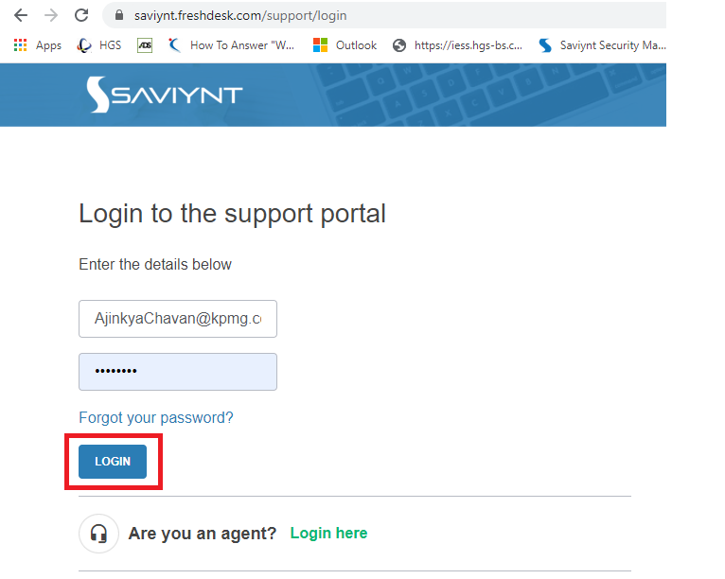

1. After login to Saviynt Click on “Submit a ticket”.

Figure 9 : Submit a ticket

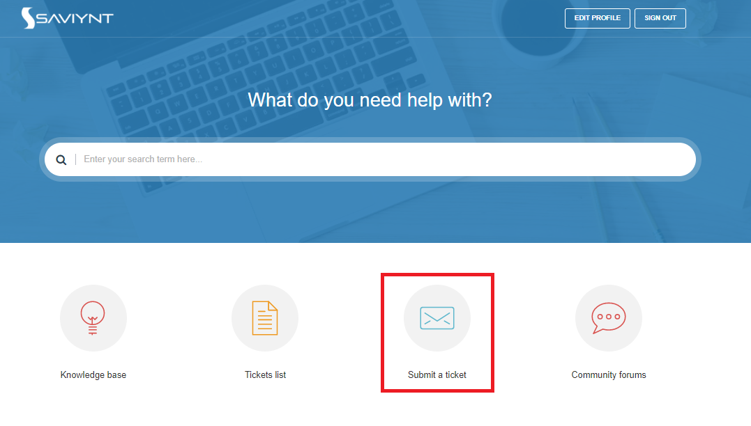

1. Enter ticket detail regarding server restart by providing appropriate information.

Figure 10 : Submit ticket

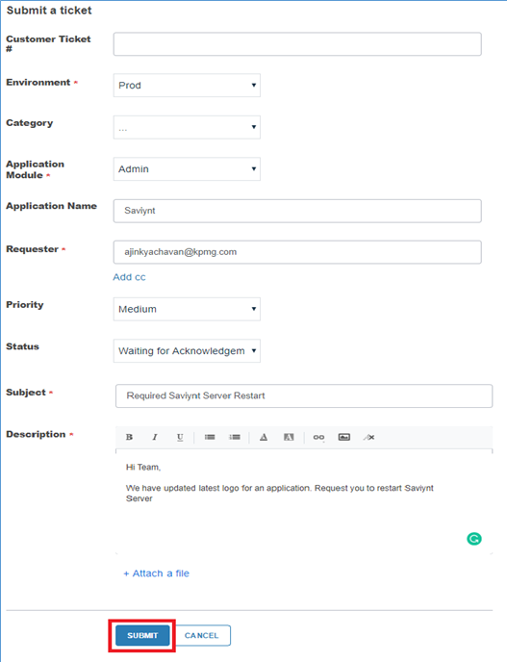

1. After submitting ticket in Saviynt Freshdesk, Saviynt Ops team will restart Saviynt application as per SLA of ticket.

## Database Repository Operations

Saviynt uses Azure RDS service (with Maria Database) as Database repository. As this is a PaaS offering from Azure, status of the service can be checked from Azure console by Saviynt infrastructure team. Hormel infarstructure team does not own the deployment or operation of this component.

## Saviynt Security Manager Patching

A patch is a set of changes to a computer program or its supporting data designed to update, fix, or improve it. Saviynt releases patches periodically, which includes fixing security vulnerabilities and other bugs. Such patches are usually called bug fixes, and improves the functionality, usability or performance.

The purpose of this section is to provide procedure and guidelines necessary for vulnerability patch management

### Patching Scope

The patching on Cloud is a shared responsibility between cloud provider and Saviynt. Cloud provider is responsible for patching and fixing flaws within the infrastructure. Saviynt is responsible for patching the guest OS and Saviynt applications.

The processes addressed in this document covers the patching for operating system (including updates and security patches) running on Saviynt cloud

Table 16 : Patching Scope

|  |  |
| --- | --- |
| Resource/Service | Patch responsibility |
| Application Server (VM) | Saviynt |
| Application Patching | Saviynt |
| Saviyntpool Agent | Saviynt |
| Database | Cloud provider |
| Elasticsearch Service | Cloud provider |

### Roles and Responsibilities

Table 17 : Roles and Responsibilities

|  |  |  |
| --- | --- | --- |
| SR No | Role | Responsibilities |
| 1 | Information Security | * Review and approve changes to the vulnerability and patch management process. * Providing guidance to groups in issues of security and patch management * Customer Advisory for zero-day vulnerabilities |
| 2 | Infra Operations | * Maintain vulnerability scanning tool and process; conduct periodic scans of critical systems to identify known vulnerabilities * Assess vulnerabilities, security updates and do impact analysis * Communication and change ticket * Apply patches * Post patching validation |
| 3 | Application Operations | * Assist with post patching validation * Do application sanity test after patch deployment |
| 4 | Change Control Board | * Review and approve centrally deployed patches prior to deployment |

### Patching Frequency

Table 18 : Patching Frequency

|  |  |  |
| --- | --- | --- |
| Vulnerability Type | Managed by | Patching Frequency |
| Zero-day vulnerability | Saviynt | Immediate |
| Vulnerability Patching | Saviynt | Weekly |
| Vulnerability Patching | Saviynt | Bi-Weekly |

### Saviynt Cloud Patch Management Cycle

#### Vulnerability Patching

Figure 11 : Vulnerability Patching

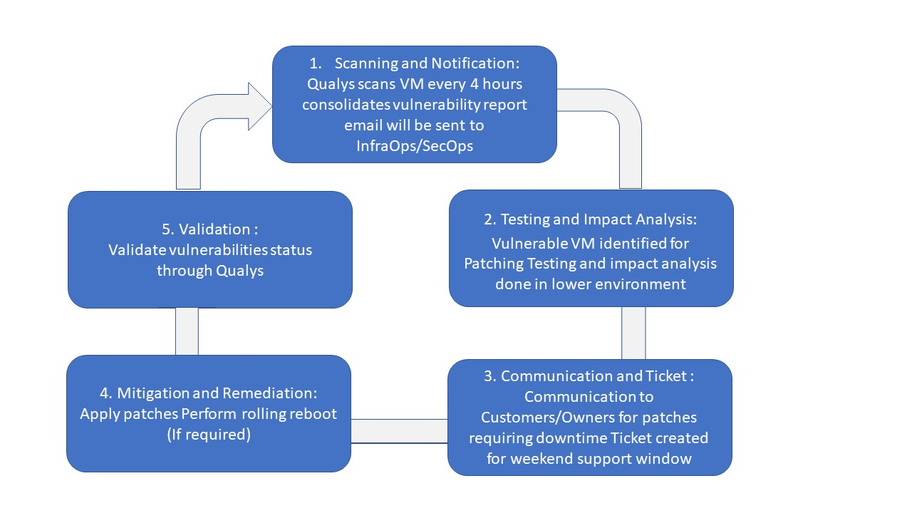

1. Qualys agent is baked into the golden images and comes by default as part of the VM deployment.
2. Qualys Vulnerability Scan runs every 4 hours and monitors the virtual machine for the latest Operating System, Software, and Certificate Vulnerabilities. These findings are then pushed to the Qualys Centralized Platform.
3. Qualys assigns a severity level for each vulnerability and possible threat.
4. Infra Operation and Infosec team gets the consolidated report of vulnerabilities identified by Qualys on daily basis via email.
5. List of servers are identified for patching.
6. Patches are assessed and tested by Infra operations team before implementation in a production environment to ensure that there is no negative impact.
7. Once successfully tested, a ticket is entered to patch production servers during weekend support window.
8. Patches are then deployed in production during weekend support window.
9. Post patching validation done through new scans/reports from Qualys.

#### Zero Day and High Severity vulnerability patching

Figure 12 : Zero Day and High Severity vulnerability patching

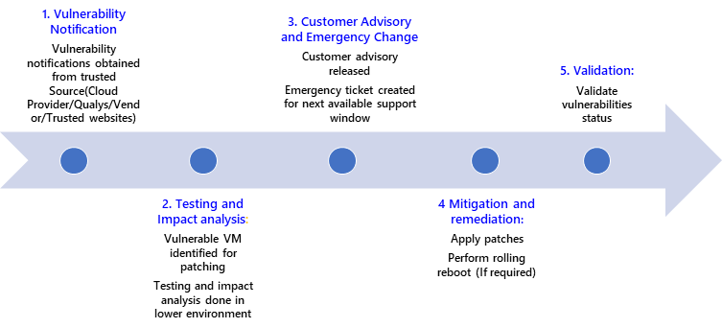

1. Information regarding any Zero-Day vulnerability is received by Saviynt from trusted sources (Cloud Provider/OS Vendor/Qualys).
2. Infra Operation and Infosec team evaluate the impact of vulnerability.
3. List of servers are identified for patching.
4. Customer advisory is released, and emergency change ticket is created
5. Patches are assessed and tested by Infra operations team before implementation in a production environment to ensure that there is no negative impact.
6. Once successfully tested, a ticket is entered to patch production servers during weekend support window.
7. Patches are then deployed in production during weekend support window.
8. Post patching validation done through new scans.

### Virtual Machines Patching Process

#### Azure

1. Azure Update Management Service is used for Server Patch Management.
2. Security updates are tested in non-prod environment and production servers are patched in approved change windows every weekend.
3. Critical security updates are pushed immediately, advisory is sent to all customers on critical updates.
4. Below is the screenshot of the Update Patch Management Service from Azure Portal

Figure 13 : Azure Console

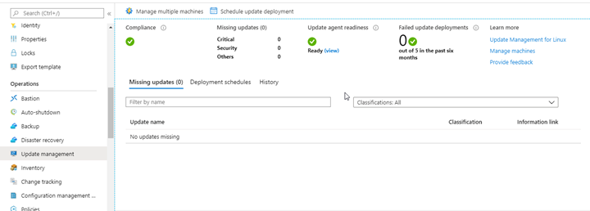

### Applied Patches on Saviynt Security Manager Instance

Saviynt instance on cloud is deployed with vanilla version 5.5 SP 3.3 along with all the required patches/fixes mentioned below. Below table describes the issues identified in lower environments and steps taken to resolve the issues.

Table 19 : Applied Patches on SSM Instance

|  |  |  |
| --- | --- | --- |
| JIRA# | Issue Description | Resolution (patch/configuration update) |
| SD-25026 | After AD Entitlement recon, owners are getting deleted from entitlement | Applied Patch |
| SD- 687436 | Access Query column size is small to store big query | Applied Patch |
| SD- 644733 | Trigger Chain Sequence | Applied Patch |
|  | Database 'wait_timeout' setting is configured | Configuration is done on Azure database |

## Server Monitoring

Server monitoring is a process to monitor server's system resources such as CPU Usage, Memory Consumption, I/O, Network, Disk Usage, Process etc. It helps understanding system's resource usage which can help us better capacity planning and provide a better end-user experience.

### Saviynt Security Manager (SSM) Monitoring

Health check monitoring for Saviynt cloud is natively managed by Saviynt and Azure. SaaS typically obligated to inform organizations in case of environment availability issues that are outside the contractually obligated SLAs.

### Monitor CPU Utilization on Windows Connector Server

Follow the below instructions to check the CPU utilization on Windows Connector servers in Windows operating system

1. Login to Windows Connector Server
2. To check CPU Utilization, Right click on task bar and open Task Manager. Switch to Performance Tab and click on CPU.

Figure 14: CPU Utilization on Windows Connector Servers

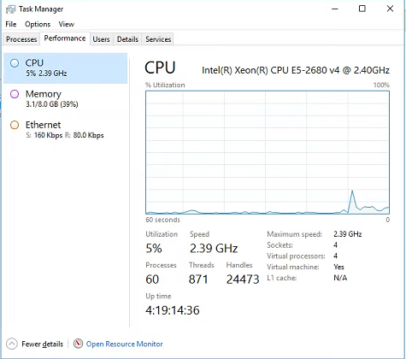

1. Contact Hormel Infrastructure team (emailsecadmin@hormel.com) if the server has high CPU utilization.

Note: All Saviynt servers are actively monitored by Hormel Infra Team.

## Certificate Management: Renew SSL Certs

### Digital Certificates

1. All certificates linked to SSM components will be managed by SSM.
2. Certificates linked to SaaS solutions like Oracle HCM integration will be managed by SSM.
3. Certificates linked to Active Directory integration will need to be **managed by the Hormel and Saviynt team**. Instructions around how to update certificates would be part of the Configuration guide. Certificates can be managed by Cert Management technology.

The following digital certificates have been deployed on SSM. These Active Directory certificates are most important to track the date of expiry.

Table 20: Digital Certificates

|  |  |  |
| --- | --- | --- |
| Environment | Active Directory Domain | Date of Expiry |
| PROD | ldaps://172.16.40.1:636,ldaps://172.16.40.2:636,ldaps://172.16.32.1:636,ldaps://172.16.56.1:636 |  |

# Saviynt Administrative Tasks

This section describes typical SSM administrative activities. This includes process for granting SAV roles and user group access to users and managing UI customization, scheduling jobs, use case customization and user life cycle operation.

## Permissions

This section describes process of granting and revoking SAV roles to identities in SSM. SAV roles are set of permissions within SSM which gives ability to view and perform operations based on role assigned.

Table 21 : Sav Role Details

|  |  |  |
| --- | --- | --- |
| SAV Role Name | User Type | Description |
| [ROLE_HORMEL_ENDUSER](https://ssm-dev-hormel.ssmcloud.net/ECM/savRoles/show/3) | End-User | This role provides basic access to user. End-Users are employees or other users. |
| Role_Admin | IAM Admin | IAM administrator is considered as ‘superusers’ within Saviynt and has administrative abilities to manage users, accounts, roles, and configurations within Saviynt. |
| [ROLE_HORMEL_HELPDESK](https://ssm-dev-hormel.ssmcloud.net/ECM/savRoles/show/5) | Help Desk | Helpdesk is the user with the ROLE_Hormel_HELPDESK SAV role that has administrative capabilities like assisting with the end user's password reset for Active Directory account . |
| [ROLE_HORMEL_CONNECT_ADMIN](https://hormel.ssmcloud.net/ECM/savRoles/show/5) | Connect Admin | Connection Admin is the user with [ROLE_HORMEL_CONNECT_ADMIN](https://hormel.ssmcloud.net/ECM/savRoles/show/5) SAV role that has capabilities to update connection in Saviynt. |

### Grant Admin SAV role to user

IAM administrator adds user into ROLE_ADMIN SAV role to provide admin access to Saviynt.

1. Login to SSM as administrator
2. Navigate to Admin tab on menu bar and click on it.

Figure 15: SSM Dashboard

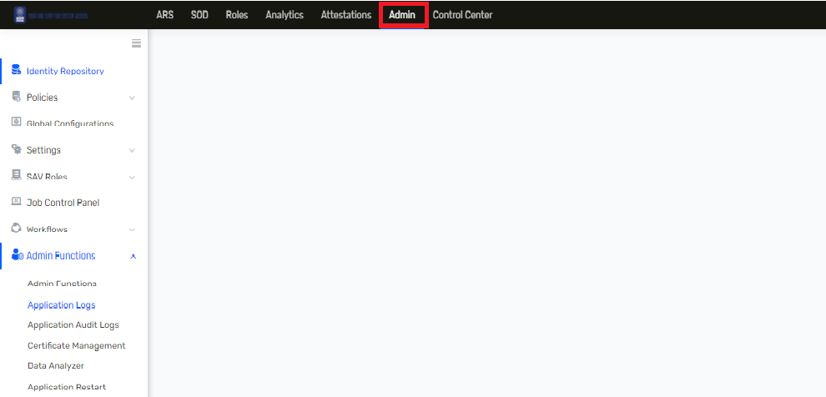

1. Navigate to toggle sidebar and click on Identity Repository.

Figure 16: Identity Repository

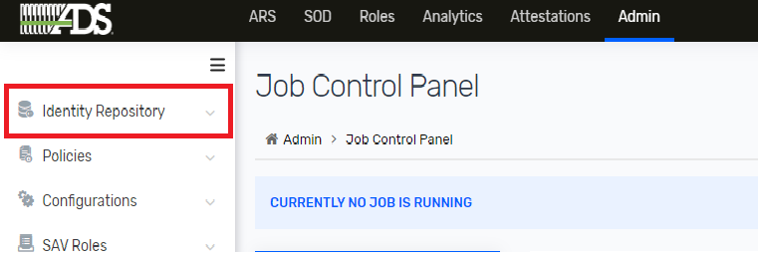

1. Navigate to SAV Roles and click on it.

Figure 17: SAV Roles

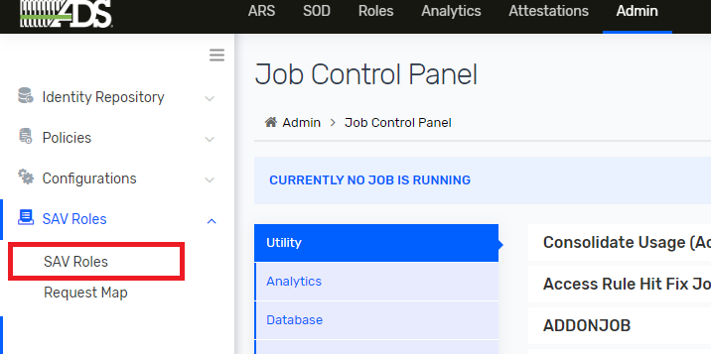

1. Click on Role_Admin from SAV Role List.

Figure 18: SAV Role List

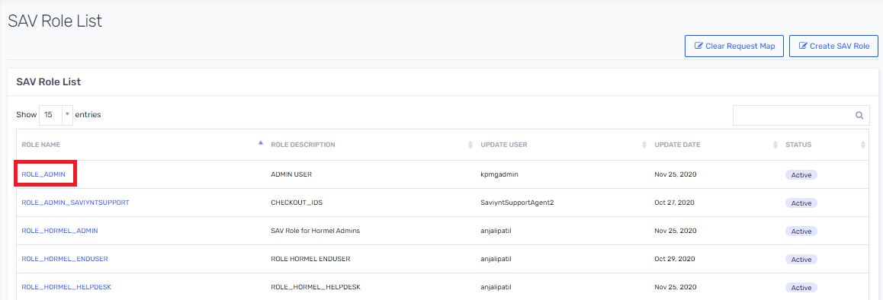

1. Click on 🡪 Users tabs.

Figure 19: SAV Role Details

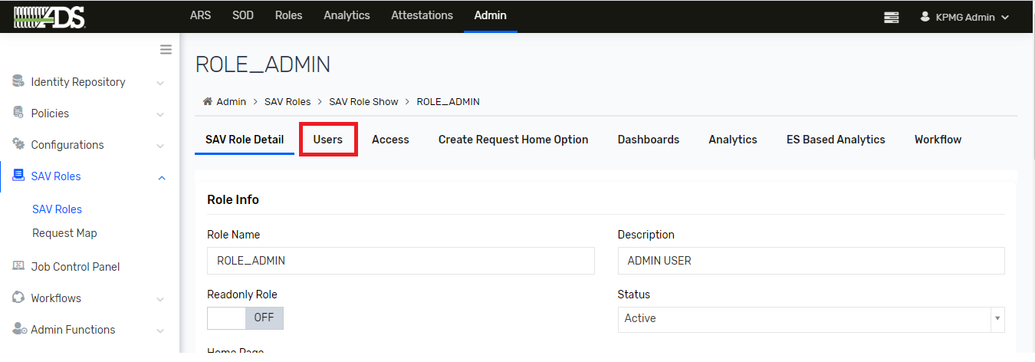

1. Click on Actions button and select Add new user.

Figure 20: SAV Role Detail

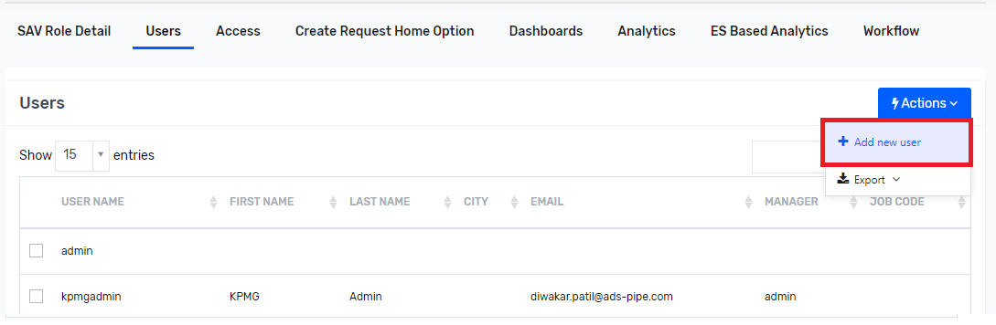

1. Search user and select checkbox and click on Save button to add user into SAV Role.

Figure 21: Add User

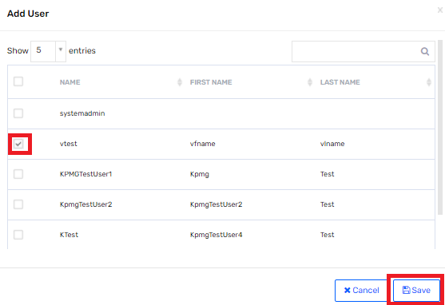

1. Verify user is added into users list.

Figure 22: Users

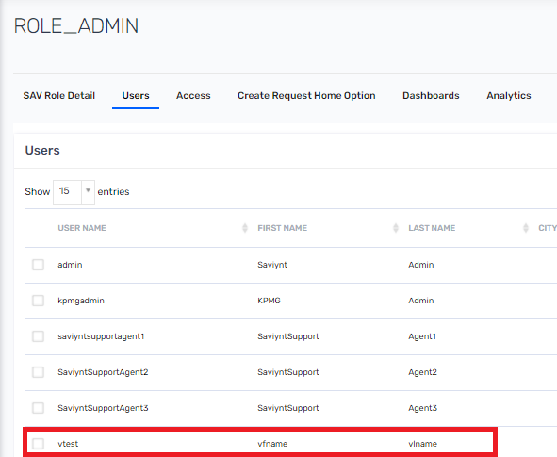

### Grant End-User SAV role to user

Whenever Employee and Other user are onboarded into Saviynt end-user gets ‘ROLE_HORMEL_ENDUSER’ as default SAV role. This SAV role provides basic access to end-user.

### Grant Helpdesk SAV role to user

IAM administrator adds user into ROLE_HORMEL_HELPDESK role to provide helpdesk access to Saviynt.

1. Login to SSM as administrator
2. Navigate to Admin tab on menu bar and click on it.

Figure 23: SSM Dashboard

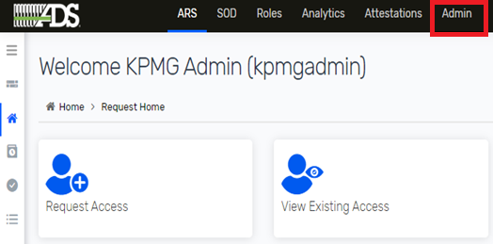

1. Navigate to toggle sidebar and click on Identity Repository.

Figure 24: Identity Repository



1. Navigate to SAV Roles and click on it.

Figure 25: SAV Roles



1. Click on ROLE_Hormel_HELPDESK from SAV Role List.

Figure 26: SAV Role List

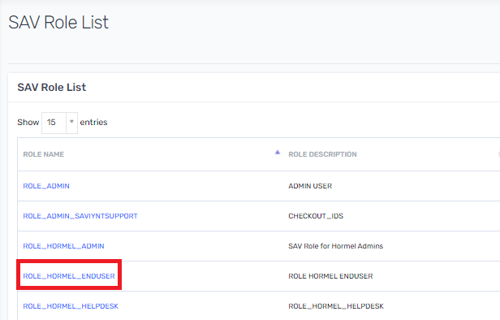

1. Click on 🡪 Users tabs.

Figure 27 : Helpdesk Role Detail

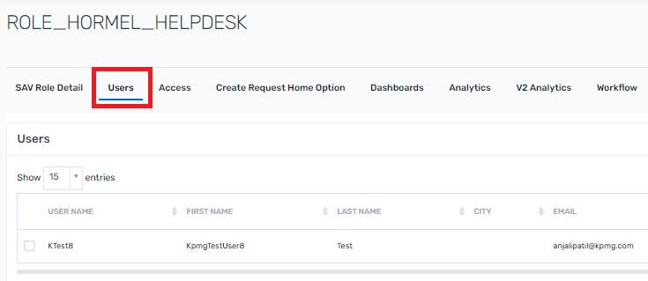

1. Click on Actions button and select Add new user.

Figure 28: SAV Role Detail



1. Search user and select checkbox and click on save button to add user into SAV Role.

Figure 29: Add User



1. Verify user is added into users list.

Figure 30: Users



### Revoke administrator SAV role from user

IAM administrator removes user from ROLE_HORMEL_ADMIN SAV role to revoke admin access from Saviynt.

1. Login to SSM as administrator
2. Navigate to Admin tab on menu bar and click on it.

Figure 31: SSM Dashboard



1. Navigate to toggle sidebar and click on Identity Repository.

Figure 32: Identity Repository



1. Navigate to SAV Roles and click on it.

Figure 33: SAV Roles



1. Click on 🡪 Role_Admin from SAV Role List.

Figure 34: SAV Role List

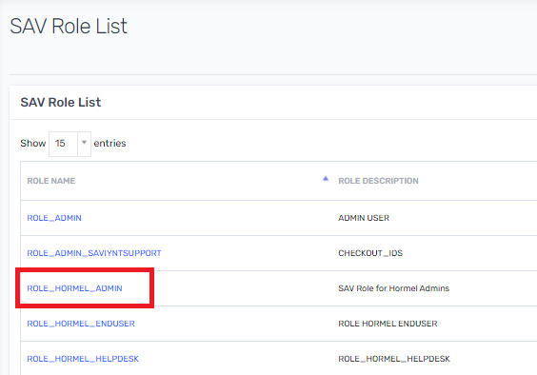

1. Click on Users tabs.

Figure 35: Admin SAV Role Details

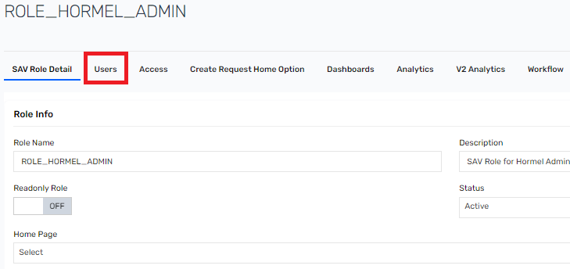

1. Search user that you wanted to remove from Role_Admin SAV role. And click on checkbox and then click on Remove User from Role. User will be removed from SAV role.

Figure 36 : Remove User from Role

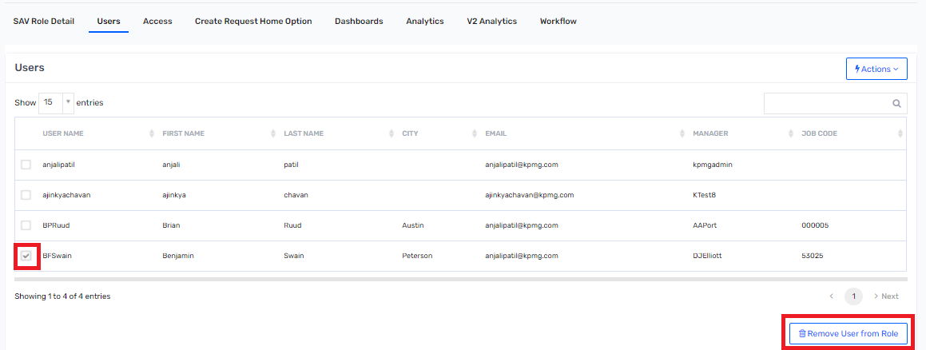

### Revoke Helpdesk SAV role from user

IAM administrator removes user from ROLE_HORMEL_HELPDESK SAV role to revoke Helpdesk access from Saviynt.

1. Login to SSM as administrator
2. Navigate to Admin tab on menu bar and click on it.

Figure 37: SSM Dashboard



1. Navigate to toggle sidebar and click on Identity Repository.

Figure 38: Identity Repository



1. Navigate to SAV Roles and click on it.

Figure 39: SAV Roles



1. Click on ROLE_Hormel_HELPDESK from SAV Role List.

Figure 40: SAV Role List

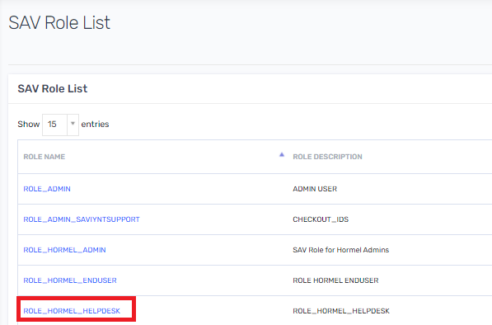

1. Click on Users tabs.

Figure 41: Admin SAV Role Details

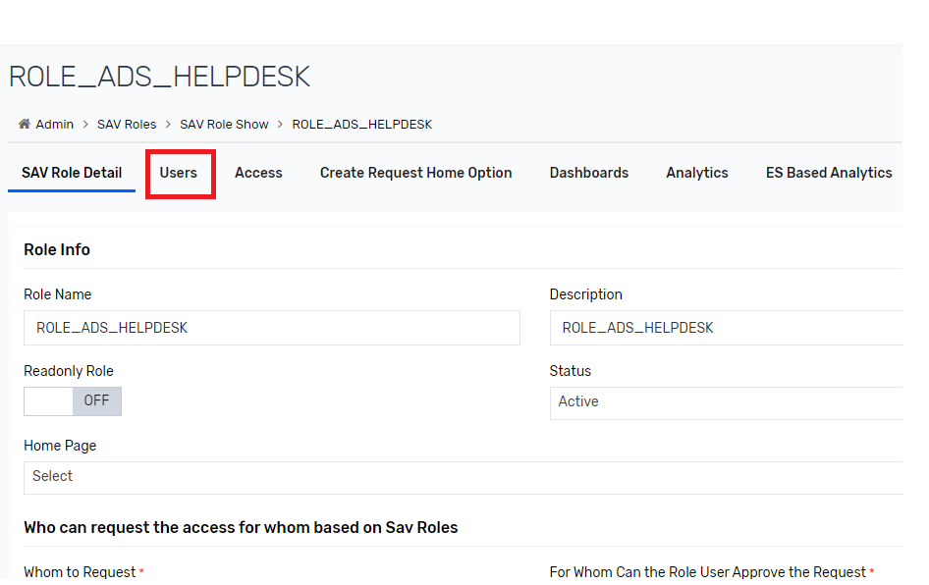

1. Search user that you wanted to remove from ROLE_HORMEL_HELPDESK SAV role. And click on checkbox and then click on Remove User from Role. User will be removed from SAV role.

Figure 42 : Remove User from Role



## UI Customizations

This section describes steps taken for UI customization that are made to SSM. If any UI changes are needed in the future (logo changes, browser tab icon, etc.), the steps below should be followed.

### Custom Branding

SSM will be configured to provide a customized look and feel for the enterprise users. The OOTB color scheme, pages, and text will be changed as per the enterprise needs. The SSM UI will include Hormel logo wherever possible.

To change an organization's logo on login, logout, browser tab and application screen, perform the following steps

#### Hormel Login Screen Logo

To update login screen logo, perform below steps:

Figure 43 : SSM User Interface Branding

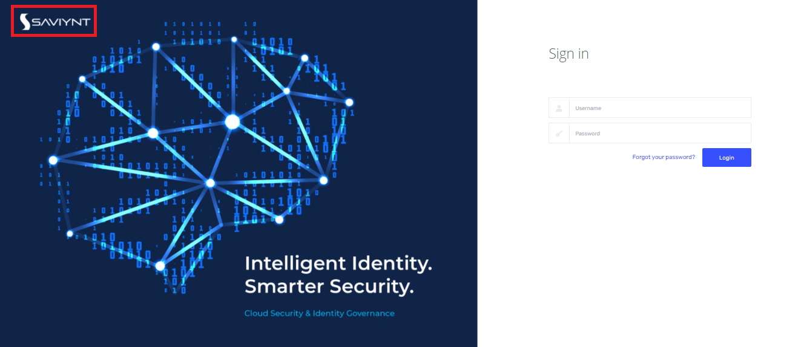

Note: The image used as an organization's logo to be displayed on the login screen must be in .png format with transparent background and must meet the following size specifications: Height: 43 pixels and Width: 200 pixels

1. Go to Admin 🡪 Configurations 🡪 UI Branding.

Figure 44 : UI Branding

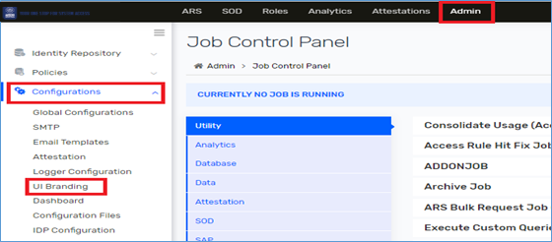

1. Select Top Navigation on UI Branding page. Select Logo under Top Navigation menu. And click on Change button to change Login Screen logo.

Figure 45 : Top Navigation

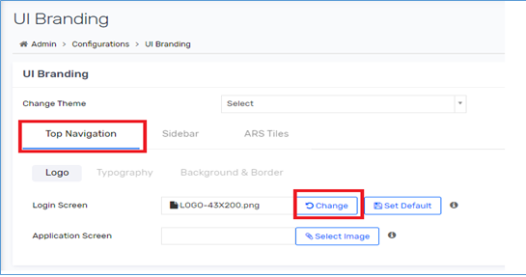

**Note**:Saviynt server restart is required for changes to take effect, this application restart is only required while changing the logo on both application and login screens.

#### Hormel Application Logo

To update Application logo, perform below steps:

Figure 46 : Application Logo

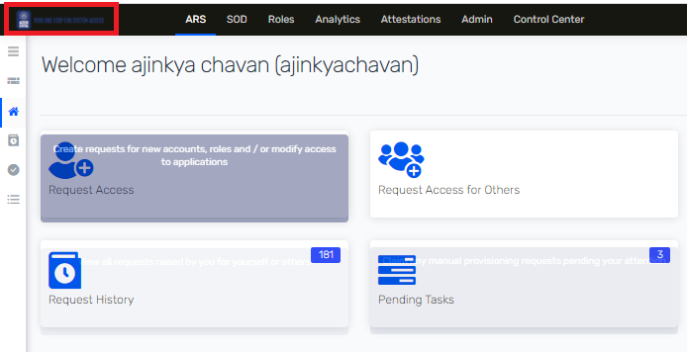

Note: The image used as an organization's logo to be displayed on the application screen must be in .png format with transparent background and must meet the following size specifications: Height: 43 pixels and Width: 200 pixels

1. Go to Admin 🡪 Configure 🡪 UI Branding.

Figure 47 : UI Branding

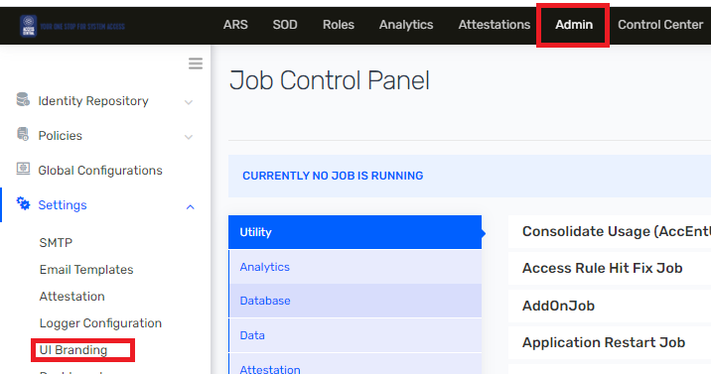

1. Select Top Navigation on UI Branding page. Select Logo under Top Navigation menu. And click on Change button to change Application Screen logo.
2. Upload an organization's logo to be displayed on the Application screen, click on Select Image and select another logo.

Figure 48 : Top Navigation

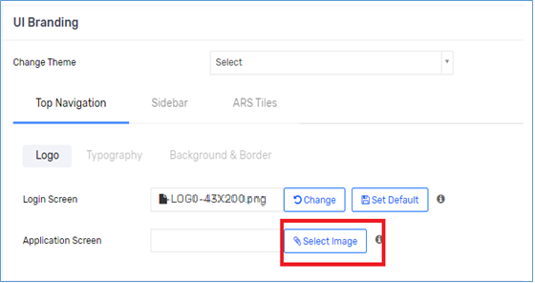

**Note**:Saviynt server restart is required for changes to take effect, this application restart is only required while changing the logo on both application and login screens.

#### Hormel Logout and Browser Tab Logo

To update Hormel logo on logout screen and browser tab logo in SSM, Freshdesk ticket is required to place the logo on Saviynt application server. Follow the steps mentioned in section 4.3 to create Freshdesk ticket.

**Note**:Saviynt server restart is required for changes to take effect, this application restart is only required while changing the logo on both logout and browser tab screens.

## Scheduled Jobs

SSM has an option to schedule any task to run on recurrence. Below are the steps to schedule any task

1. Login to SSM as administrator.
2. Select Admin 🡪 Job Control Panel.

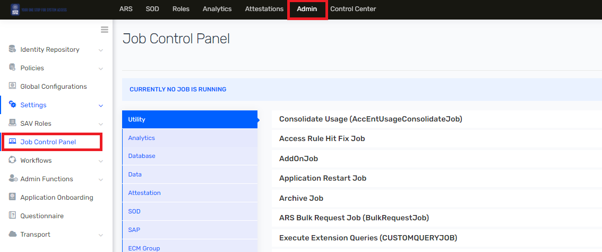

1. Click on 🡪 Edit Trigger under the Action. Edit Trigger pop-up is displayed with Job Name, Job Type, other fields related to selected Job type, and last saved job schedule for that trigger.

Figure 49 : Provisioning Job

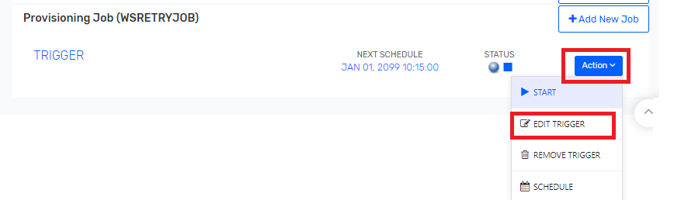

1. Select the systems you intend to schedule the job for and click on Next button to schedule

Figure 50 : Job Detail

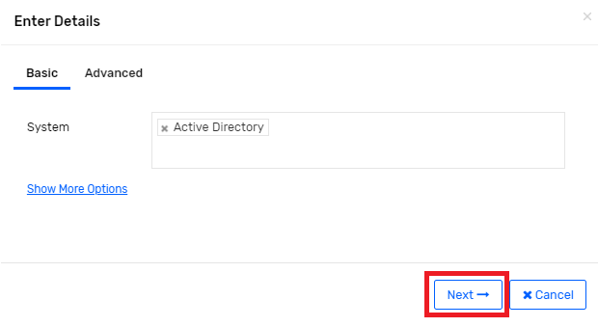

1. Select the schedule option such as Minutes, Hourly, Daily, Weekly, Cron Expression and Specify the time slot based on requirement. Click on Submit

Figure 51 :Schedule the Job

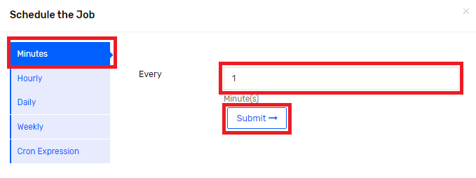

1. Click Save. A confirmation message is displayed as "The schedule would be changed henceforth. Click Yes to Proceed or Click No to Cancel".

Note: In below is an attached sheet for all scheduling job that are schedule in Saviynt with their schedule times in UTC time zone.



## Use Case Customizations

### Addition of New Email Domain

#### Change AD Connection Update JSON

If there is new requirement to add a new domain for Active Directory provision then IAM Admin must perform following step to add new domain.

1. Login to SSM as administrator.
2. Go to Admin🡪 Connections

Figure 52 : Connection List

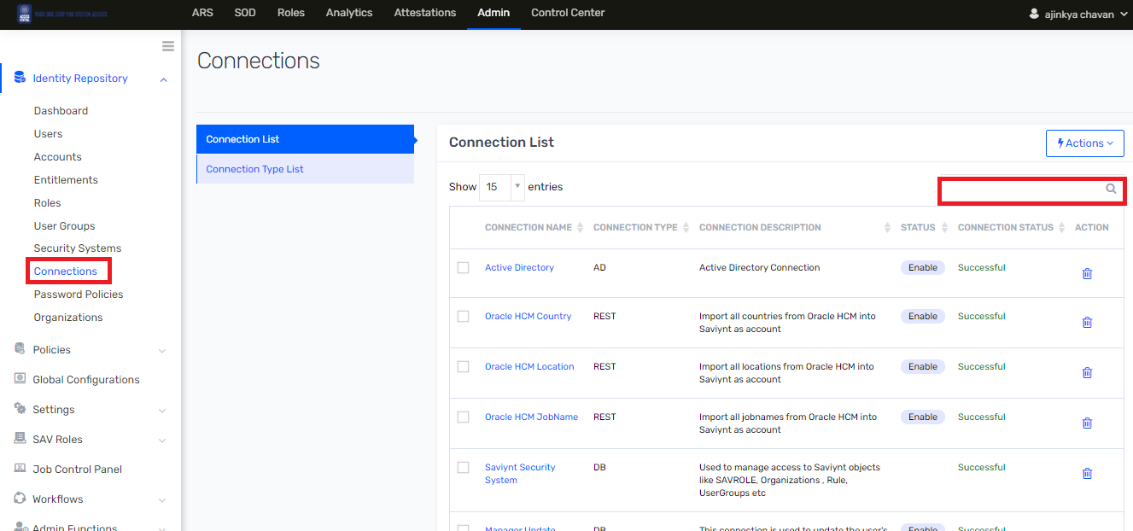

1. Search for “Active Directory” and click on it to view connection details.

Figure 53 : Connection List

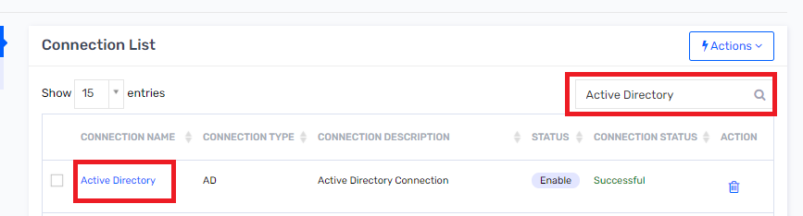

1. Search for “UPDATEACCOUNTJSON” section.

Figure 54 : Global Configuration

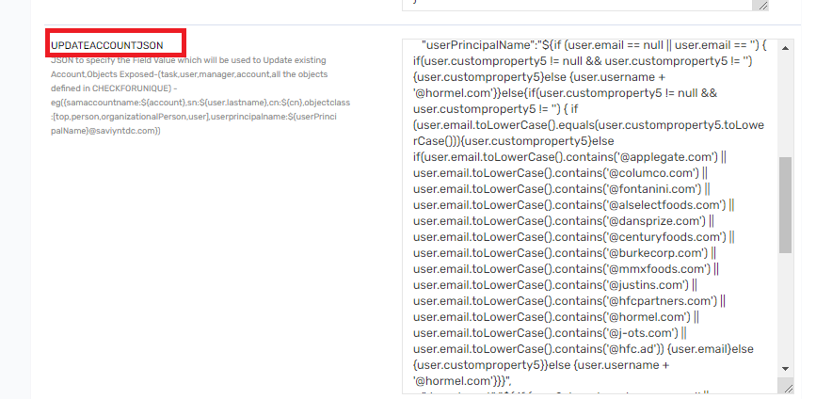

1. Suppose IAM Admin wants to add new email domain as “**XYZ**” then add following value in userPrincipalName field.

|  |
| --- |
| "userPrincipalName":"${if (user.email == null || user.email == '') { if(user.customproperty5 != null && user.customproperty5 != '') {user.customproperty5}else {user.username + '@hormel.com'}}else{if(user.customproperty5 != null && user.customproperty5 != '') { if (user.email.toLowerCase().equals(user.customproperty5.toLowerCase())){user.customproperty5}else if(user.email.toLowerCase().contains('@applegate.com') || user.email.toLowerCase().contains('@columco.com') || user.email.toLowerCase().contains('@fontanini.com') || user.email.toLowerCase().contains('@alselectfoods.com') || user.email.toLowerCase().contains('@dansprize.com') || user.email.toLowerCase().contains('@centuryfoods.com') || user.email.toLowerCase().contains('@burkecorp.com') || user.email.toLowerCase().contains('@mmxfoods.com') || user.email.toLowerCase().contains('@justins.com') || user.email.toLowerCase().contains('@hfcpartners.com') || user.email.toLowerCase().contains('@hormel.com') || user.email.toLowerCase().contains('@j-ots.com') || user.email.toLowerCase().contains('@hfc.ad')) **|| user.email.toLowerCase().contains('@xyz.com'))** {user.email}else {user.customproperty5}}else {user.username + '@hormel.com'}}}", |

1. One query is updated and then click on Save button.

Figure 55 : Connection Save

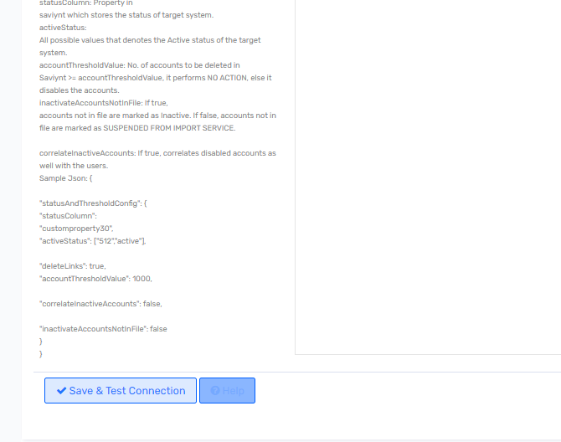

#### Addition of New Mailbox Domain

If there is new requirement to add a new domain for mailbox provision then IAM Admin must perform following step to add new domain.

1. Login to SSM as administrator.
2. Go to Admin🡪 Connections

Figure 56 : Connection



1. Search for “Email Domain Update” and click on it to view connection details.

Figure 57 : Email Domain Update Connection

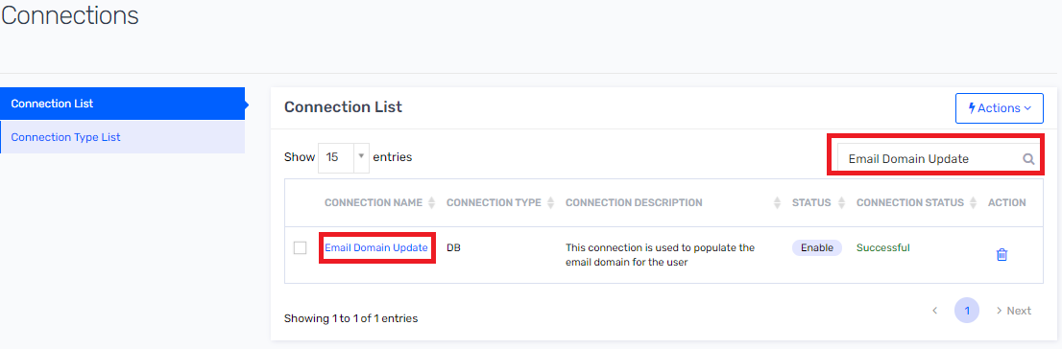

1. Search for “USERIMPORT” section.

Figure 58 : User Import JSON

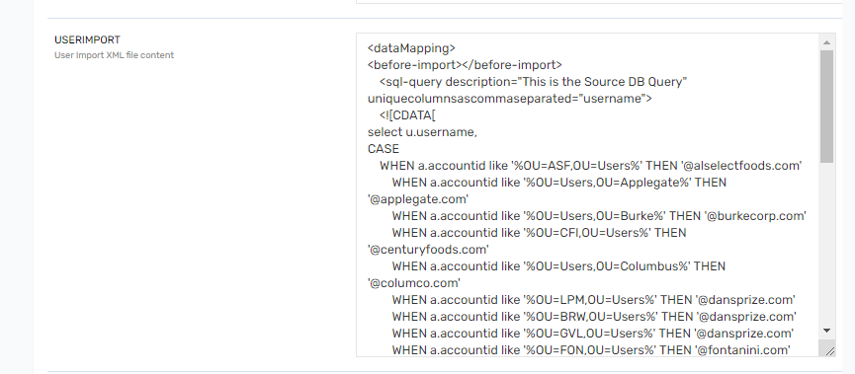

Figure 59 : Global Configuration

1. Suppose IAM Admin wants to add new email domain as “**XYZ**” and OU location as “**OU=Users,OU=XYZ**” then, update values field with following query.

|  |
| --- |
| <dataMapping>  <before-import></before-import>  <sql-query description="This is the Source DB Query" uniquecolumnsascommaseparated="username">  <![CDATA[  select u.username,  CASE  WHEN a.accountid like '%OU=ASF,OU=Users%' THEN '@alselectfoods.com'  WHEN a.accountid like '%OU=Users,OU=Applegate%' THEN '@applegate.com'  WHEN a.accountid like '%OU=Users,OU=Burke%' THEN '@burkecorp.com'  WHEN a.accountid like '%OU=CFI,OU=Users%' THEN '@centuryfoods.com'  WHEN a.accountid like '%OU=Users,OU=Columbus%' THEN '@columco.com'  WHEN a.accountid like '%OU=LPM,OU=Users%' THEN '@dansprize.com'  WHEN a.accountid like '%OU=BRW,OU=Users%' THEN '@dansprize.com'  WHEN a.accountid like '%OU=GVL,OU=Users%' THEN '@dansprize.com'  WHEN a.accountid like '%OU=FON,OU=Users%' THEN '@fontanini.com'  WHEN a.accountid like '%Cook%' THEN '@hfcpartners.com'  WHEN a.accountid like '%OU=Users,OU=JOTS%' THEN '@j-ots.com'  WHEN a.accountid like '%OU=Users,OU=Justins%' THEN '@justins.com'  WHEN a.accountid like '%OU=Users,OU=MegaMex%' THEN '@mmxfoods.com'  **WHEN a.accountid like '%OU=Users,OU=XYZ%' THEN '@xyz.com'**  ELSE '@hormel.com'  END as domain  from accounts a,users u where a.endpointkey='1' and a.STATUS in( 1,'Manually Provisioned') and a.name=u.username and u.customproperty3 is null  ]]> </sql-query>  <importsettings>  <zeroDayProvisioning>false</zeroDayProvisioning>  <userNotInFileAction>NOACTION</userNotInFileAction>  <checkRules>true</checkRules>  <buildUserMap>false</buildUserMap>  <userReconcillationField>username</userReconcillationField>  </importsettings>  <mapper description="This is the mapping field for SAviynt Field name">  <mapfield saviyntproperty="username" sourceproperty="username" type="character"></mapfield>  <mapfield saviyntproperty="customproperty3" sourceproperty="domain" type="character"></mapfield>  </mapper>  <after-import description="EMAIL,BATCH,SQL">  </after-import>  </dataMapping> |

**Note**: Verify a.endpointkey='1' value must be as per production environment before updating. This is unique ID for Active Directory endpoint.

1. One query is updated and then click on Save button.

Figure 60 : Save Connection



#### Add New Domain name for Improper email address domain analytic.

To find out improper email address domain for users following analytic is required to change.

1. Login into SSM as administrator
2. To search specific analytic report, navigate to Analytics and click on it.

Table 22 : Analytics

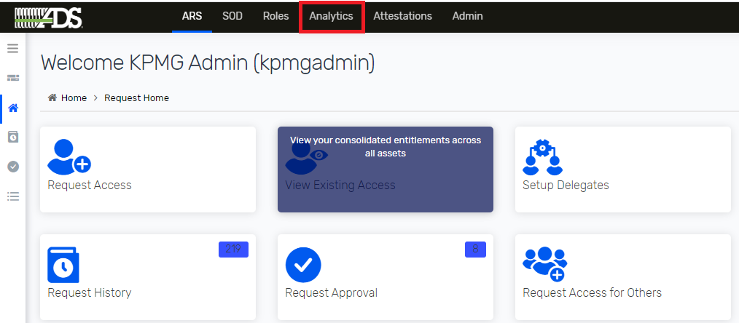

1. Search for Analytics Configuration List on toggle sidebar and click on it.

Figure 61: Analytics Configuration List

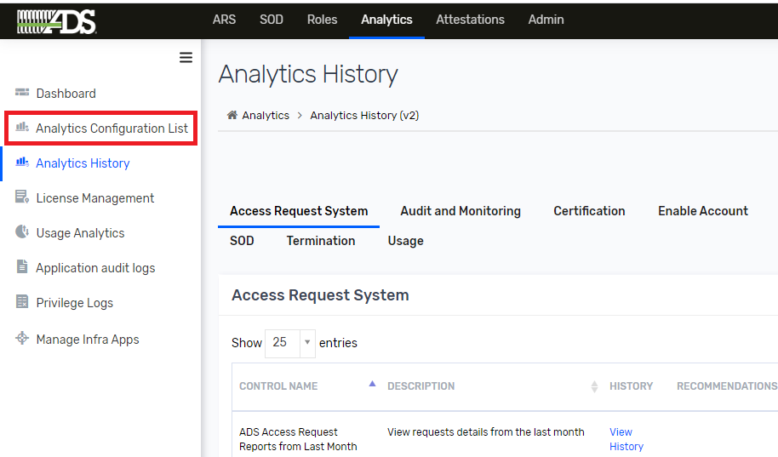

1. Search analytics using search text box, specify analytics name/Description such as ‘Hormel Users with Improper Email Address ‘ to search.

Figure 62: Advanced Analytics Page

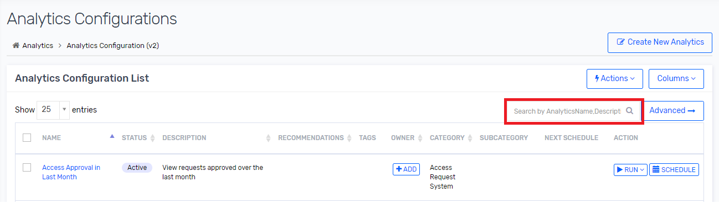

1. To edit analytic click on “Hormel Users with Improper Email Address” analytic.

Figure 63 : Analytic



1. Click on edit to update query.

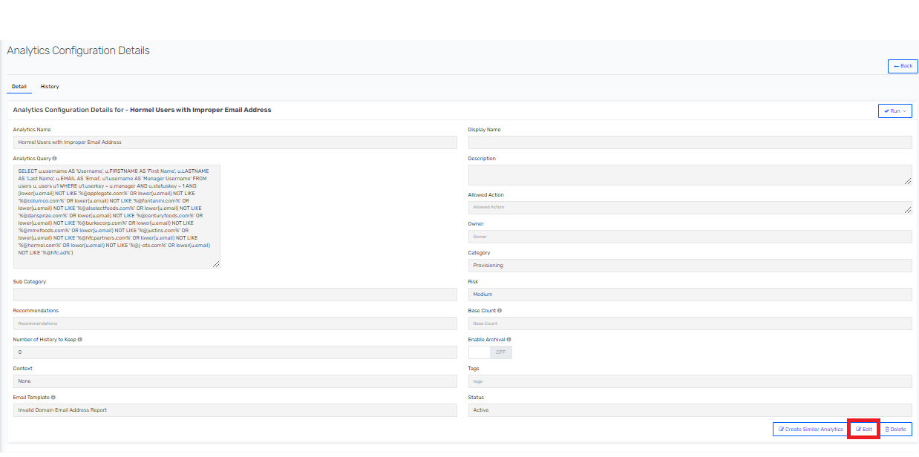

1. To add new domain as “xyz” then update below query.

|  |
| --- |
| SELECT u.username AS 'Username', u.FIRSTNAME AS 'First Name', u.LASTNAME AS 'Last Name', u.EMAIL AS 'Email', u1.username AS 'Manager Username' FROM users u, users u1 WHERE u1.userkey = u.manager AND u.statuskey = 1 AND (lower(u.email) NOT LIKE '%@applegate.com%' OR lower(u.email) NOT LIKE '%@columco.com%' OR lower(u.email) NOT LIKE '%@fontanini.com%' OR lower(u.email) NOT LIKE '%@alselectfoods.com%' OR lower(u.email) NOT LIKE '%@dansprize.com%' OR lower(u.email) NOT LIKE '%@centuryfoods.com%' OR lower(u.email) NOT LIKE '%@burkecorp.com%' OR lower(u.email) NOT LIKE '%@mmxfoods.com%' OR lower(u.email) NOT LIKE '%@justins.com%' OR lower(u.email) NOT LIKE '%@hfcpartners.com%' OR lower(u.email) NOT LIKE '%@hormel.com%' OR lower(u.email) NOT LIKE '%@j-ots.com%' OR lower(u.email) NOT LIKE '%@hfc.ad%' OR lower(u.email) NOT LIKE '%@**xyz**.com%') |

1. To execute analytic report, click on RUN button and select Run Now option.

Figure 64 : Analytics Configuration List



1. To view result of ‘Hormel Users with Improper Email Address’ report. Navigate to Analytic History and click on it.

Figure 65 : Analytics History

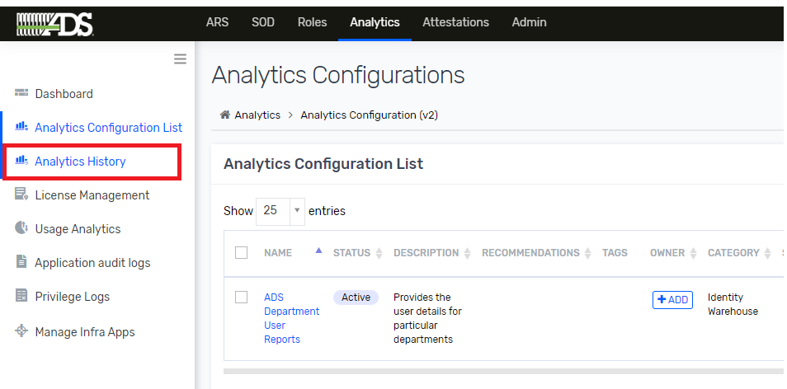

1. Search for Identity Warehouse tab and search for ‘Hormel Users with Improper Email Address’ in search box. And then click on ‘Hormel Users with Improper Email Address’ to view result.

Figure 66 : Analytics View

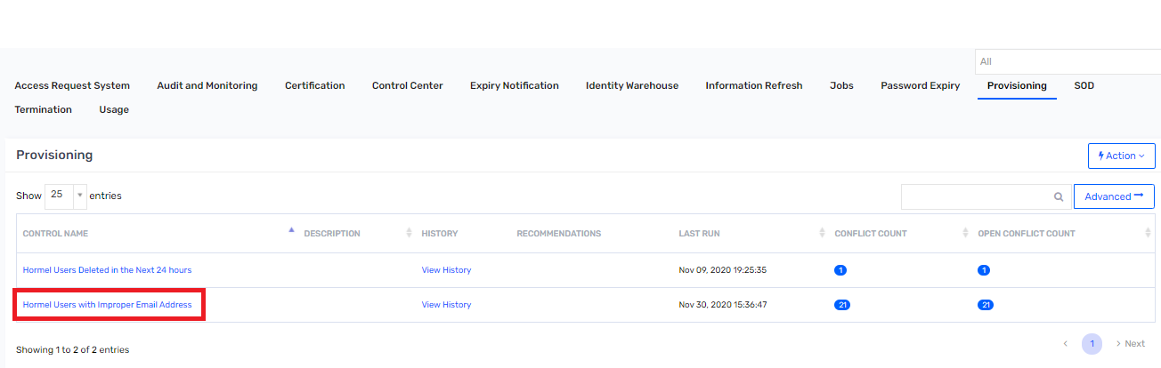

Figure 67 : Analytics Result

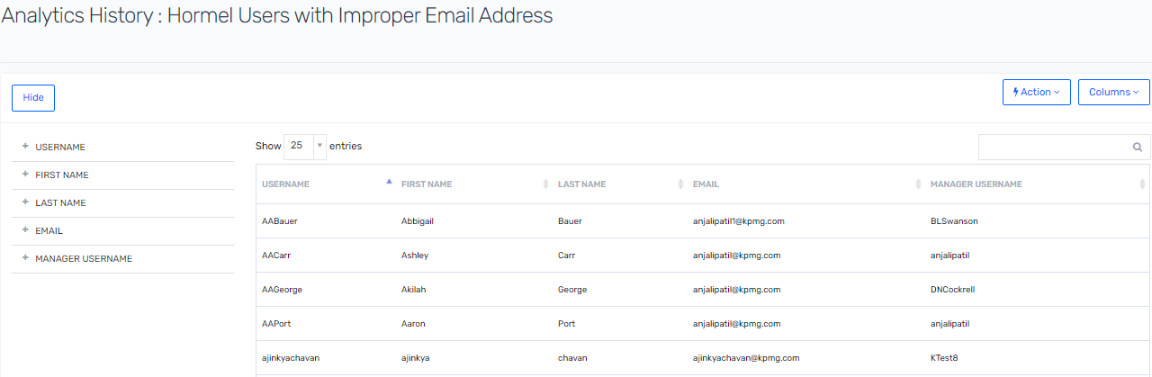

### Addition of New OU Location Name

If there is new requirement to map a new location with location OU in Active Directory then IAM Admin must perform following step to map a new location with location OU.

Suppose Hormel IAM team wants to add new location “XYZ” mapping with Active Directory Location OU as “OU=XYZ,OU=Users,OU=Hormel,DC=HFC,DC=AD”, then create a csv file with following attributes and values.

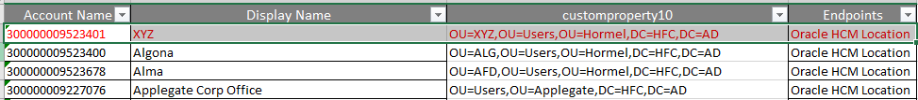

1. Login to SSM as IAM admin.
2. Go to Admin🡪 Accounts and click on it.

Figure 68 : Accounts

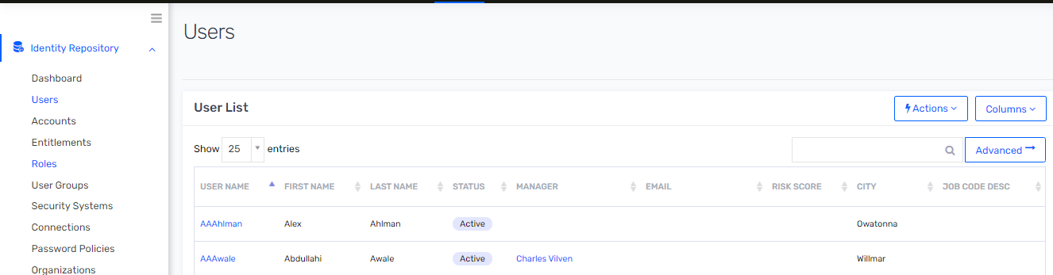

1. Click on 🡪 Actions and then select Upload Accounts

Figure 69 : Upload Accounts

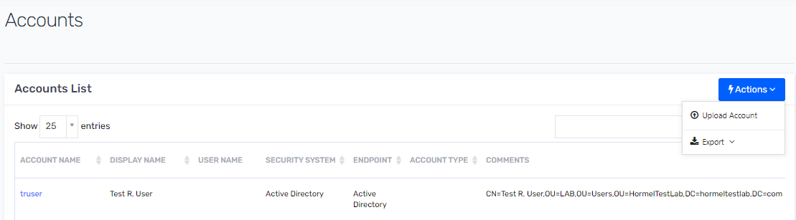

1. Select location csv file to upload and then select following highlighted field as shown in screen shot. Once all field are selected then click on Upload and preview button.

Figure 70 : Upload OU Location

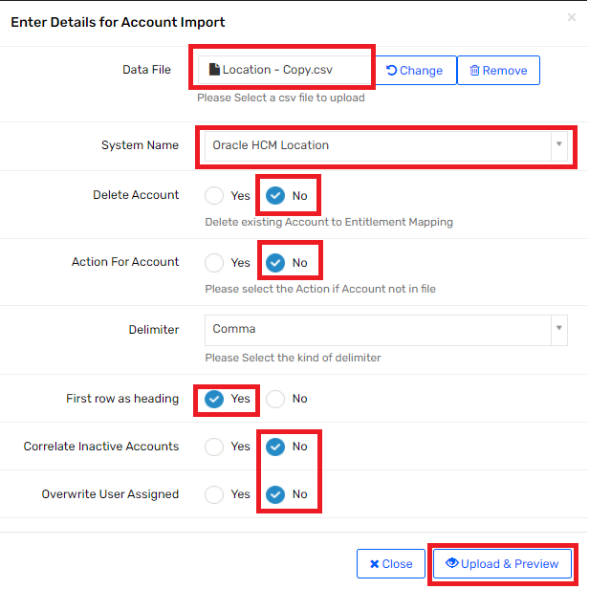

1. Make sure all header are set as below and then click on Import now. After successful import new Active Directory location OU will be mapped to location account which is imported from Oracle HCM location import job.

Figure 71 : Account Upload Preview

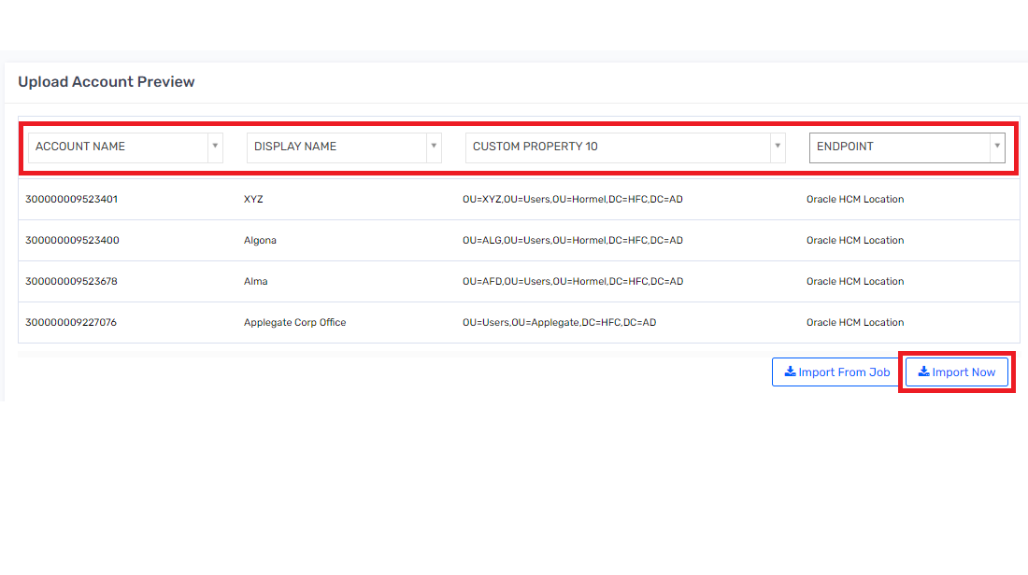

### Addition of new Active Directory group to retain access on user account disable.

If there is new requirement to add a new AD group to retain on user account disable in Active Directory then IAM Admin must perform following step to add new group in analytic.

1. Login into SSM as administrator
2. To search specific analytic report, navigate to Analytics and click on it.

Figure 23 : Analytics



1. Search for Analytics Configuration List on toggle sidebar and click on it.

Figure 72: Analytics Configuration List



1. Search analytics using search text box, specify analytics name/Description such as ‘Hormel Deprovision AD Group After Termination‘ to search.

Figure 73: Advanced Analytics Page



1. To view and edit analytic report, click on “Hormel Deprovision AD Group After Termination”.

Table 24 : Analytics Configuration List

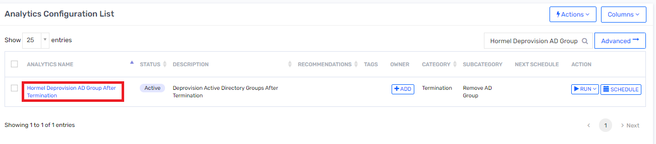

1. To edit analytic click on Edit button.

Figure 74 : Edit Analytic Edit

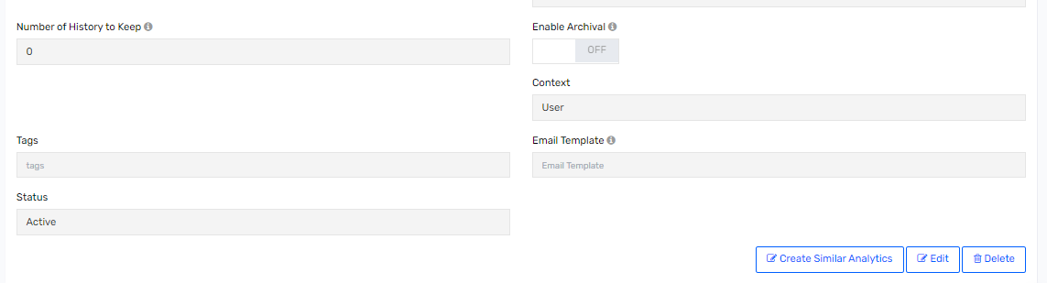

1. Suppose IAM admin wants to retain “XYZ” group then IAM must update following query.

|  |
| --- |
| SELECT U.USERNAME AS USERNAME,A.NAME AS ACCOUNTNAME,EV.ENTITLEMENT_VALUE as ENTITLEMENTVALUE,EV.ENTITLEMENT_VALUEKEY as entvaluekey,A.ACCOUNTKEY AS acctKey,u.userkey AS 'USERCONTEXT', 'Deprovision Access' AS Default_Action_For_Analytics FROM ACCOUNTS A,USER_ACCOUNTS UA,USERS U,ENDPOINTS EP,account_entitlements1 AE,entitlement_values EV  where UA.ACCOUNTKEY=A.ACCOUNTKEY  and AE.ACCOUNTKEY = A.ACCOUNTKEY  and U.USERKEY=UA.USERKEY  and EP.ENDPOINTKEY=A.ENDPOINTKEY  and EV.ENTITLEMENT_VALUEKEY = AE.ENTITLEMENT_VALUEKEY  and A.STATUS in (2,'Manually Suspended','Inactive')  AND U.STATUSKEY=0 AND EP.ENDPOINTNAME='Active Directory' AND (**EV.ENTITLEMENT_VALUE NOT like '%XYZ%'** or EV.ENTITLEMENT_VALUE NOT like '%NAMEDUSER_NO_RDP%' or EV.ENTITLEMENT_VALUE NOT like '%SERVICEACCOUNTS_NO_RDP%' or EV.ENTITLEMENT_VALUE NOT like '%zscaler%' or EV.ENTITLEMENT_VALUE NOT like '%office365%' or EV.ENTITLEMENT_VALUE NOT like '%Domain Users%' or EV.ENTITLEMENT_VALUE NOT like '%DomainNoAccess%') |

### Change New Hire Number of 14 Days Prior Criteria.

To change new hire number of days 14 days prior criteria, IAM admin must update following section.

#### Change in Initiate Provisioning Connection

1. Login to SSM as administrator.
2. Go to Admin🡪 Connections

Figure 75 : Connection List



1. Search for “Initiate Provisioning” and click on it to view connection details.

Figure 76 : Connection List

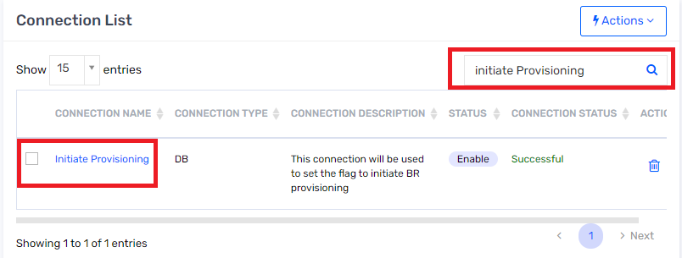

1. Search for “USERIMPORT” section.

Figure 77 : Global Configuration

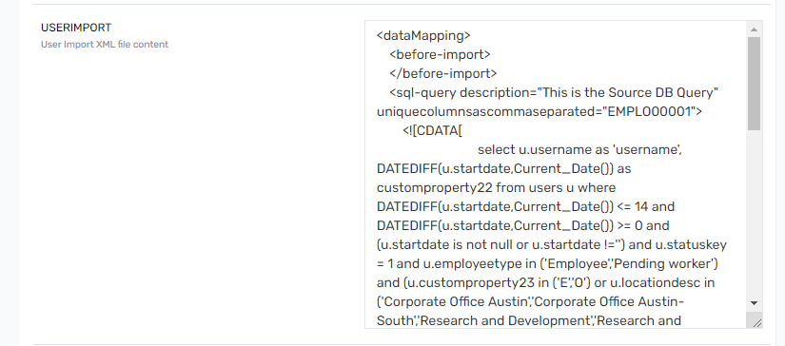

1. Suppose IAM Admin wants to change current 14 days criteria to 18 days for new hire, then update following SQL block.

|  |
| --- |
| <sql-query description="This is the Source DB Query" uniquecolumnsascommaseparated="EMPLO00001">  <![CDATA[  select u.username as 'username', DATEDIFF(u.startdate,Current_Date()) as customproperty22 from users u where **DATEDIFF(u.startdate,Current_Date()) <= 18** and DATEDIFF(u.startdate,Current_Date()) >= 0 and (u.startdate is not null or u.startdate !='') and u.statuskey = 1 and u.employeetype in ('Employee','Pending worker') and (u.customproperty23 in ('E','O') or u.locationdesc in ('Corporate Office Austin','Corporate Office Austin-South','Research and Development','Research and Development-Lab'))]]>  </sql-query> |

1. One query is updated and then click on Save button.

Figure 78 : Save Connection



#### Update Technical Rule

To change new hire number of days 14 days prior criteria, IAM admin must update following Technical Rule.

1. Login to SSM as administrator.
2. Go to Admin🡪 Polices and click on Technical Rules

Figure 79 : Technical Rule

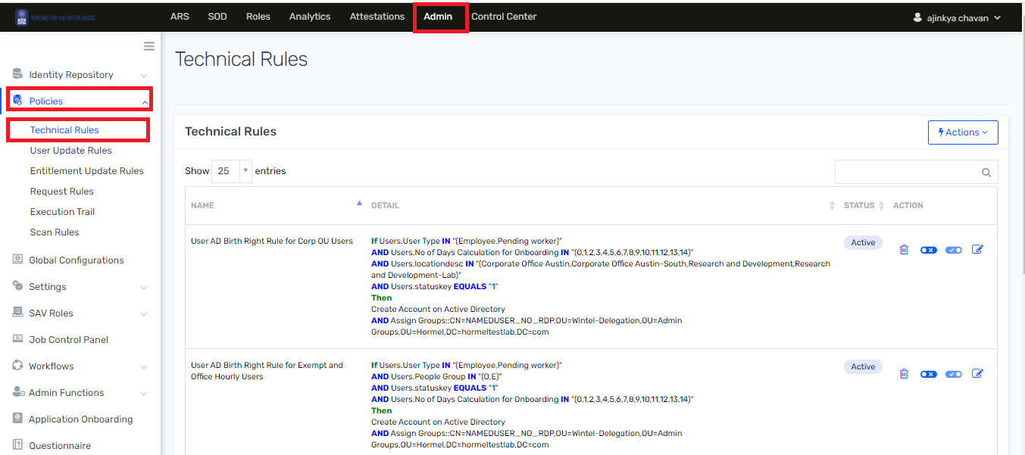

1. Click on Edit button

Figure 80 : Technical List

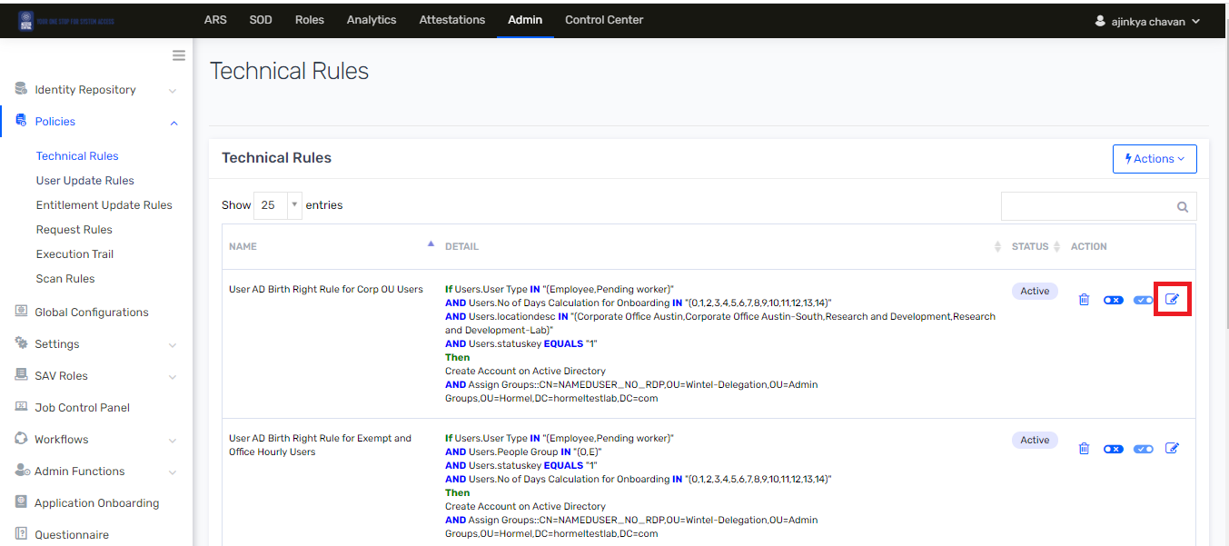

1. Search for Condition section and update “No of Days Calculation for Onboarding”

Figure 81 : Condition

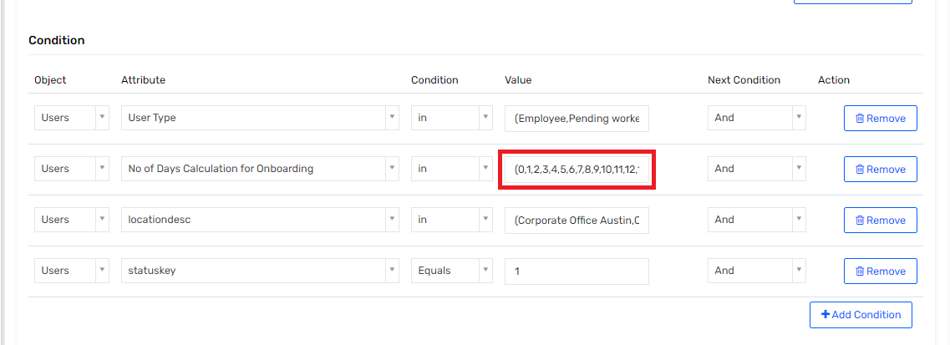

1. Similar as mention above update “No of Days Calculation for Onboarding” field in “User AD Birth Right Rule for Corp OU Users” and “User AD Birth Right Rule for Exempt and Office Hourly Users” technical rule.

#### Change Bright right for Mailbox Connection

To change new hire number of days 14 days prior criteria, IAM admin must update following [Birth Right for Mailbox](https://ssm-dev-hormel.ssmcloud.net/ECM/ecmConfig/addnewconnection/14).

1. Login to SSM as administrator.
2. Go to Admin🡪 Connections

Figure 82 : Connection List



1. Search for “[Birth Right for Mailbox](https://ssm-dev-hormel.ssmcloud.net/ECM/ecmConfig/addnewconnection/14)” and click on it to view connection details.
2. Search for USERIMPORT section and update SQL query to change No. of Days Calculation for Onboarding by updating values as mention below. Suppose IAM admin wants to add No. of Days Calculation for Onboarding to set till 18 days then update following query .

|  |
| --- |
| select u.username as userName,'YES' as Flag from users u,accounts a,user_accounts ua where  ua.userkey=u.userkey and ua.accountkey=a.accountkey and a.endpointkey=1 and a.status in( 1,'Manually Provisioned') and (u.customproperty24 is null or u.customproperty24 not in ('YES')) and u.employeetype in ('Employee','Pending worker') and (u.customproperty23 in ('E','O') or u.locationdesc in ('Corporate Office Austin','Corporate Office Austin-South','Research and Development','Research and Development-Lab')) and u.customproperty22 IN **(0,1,2,3,4,5,6,7,8,9,10,11,12,13,14,18)** and u.statuskey=1 and u.customproperty3 is not null |

#### Change in 14 days new hire criteria for Atom Feed.

To change new hire number of days 14 days prior criteria, IAM admin must update following [Birth Right for Atom](https://ssm-dev-hormel.ssmcloud.net/ECM/ecmConfig/addnewconnection/14) feed.

1. Login to SSM as administrator.
2. Go to Admin🡪 “Security Systems” then click on “Endpoints” and then click on “[Oracle HCM Atom Feed](https://ssm-dev-hormel.ssmcloud.net/ECM/endpoints/show/6?savmodule=)”.

Figure 83 : Atom Feed Endpoint

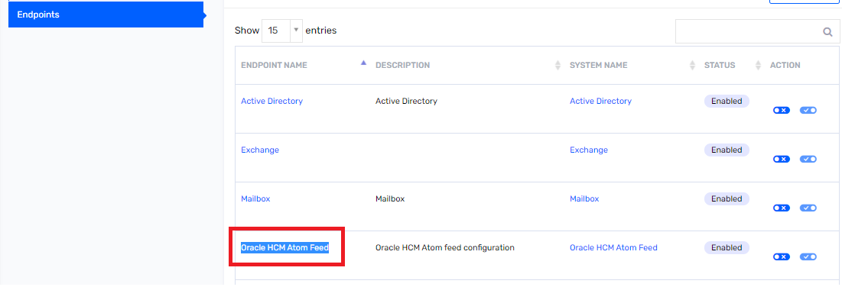

1. Navigate 🡪 “Other Attribute” and search for Custom Property 11 and change value to 15 and then click on 🡪 Update button.

Figure 84 : Oracle HCM Atom Feed

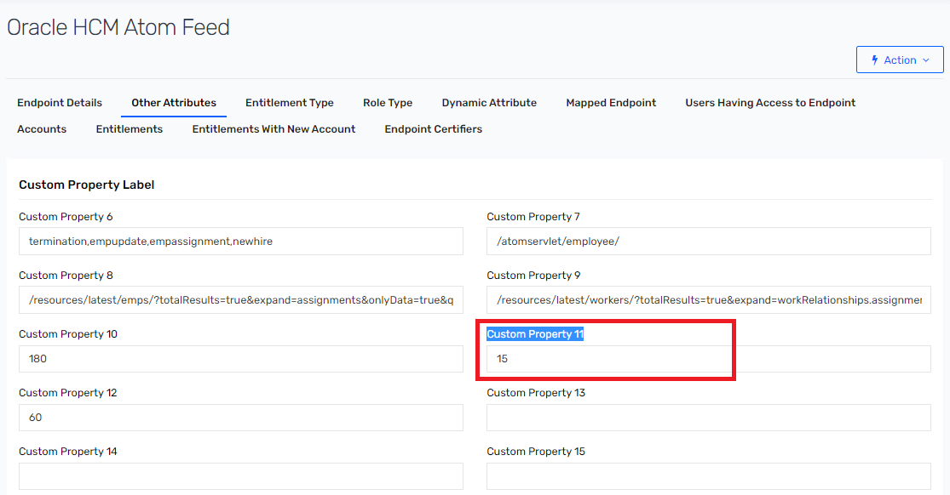

### Birthright Criteria changed for Active Directory

This section describes about changing birthright criteria for Active Directory. Suppose IAM admin wants to add following condition in existing Active Directory birthright.

* Add employee type as “Contingent worker”.
* Add location desc as “[Corporate Office Hangar](https://ssm-dev-hormel.ssmcloud.net/ECM/accounts/show/30)”.

To update above condition following section is required to updated.

#### Addition in Initiate provisioning Connection

1. Login to SSM as administrator.
2. Go to Admin🡪 Connections

Figure 85 : Connection List



1. Search for “Initiate Provisioning” and click on it to view connection details.

Figure 86 : Connection List



1. Search for “USERIMPORT” section.

Figure 87 : Global Configuration

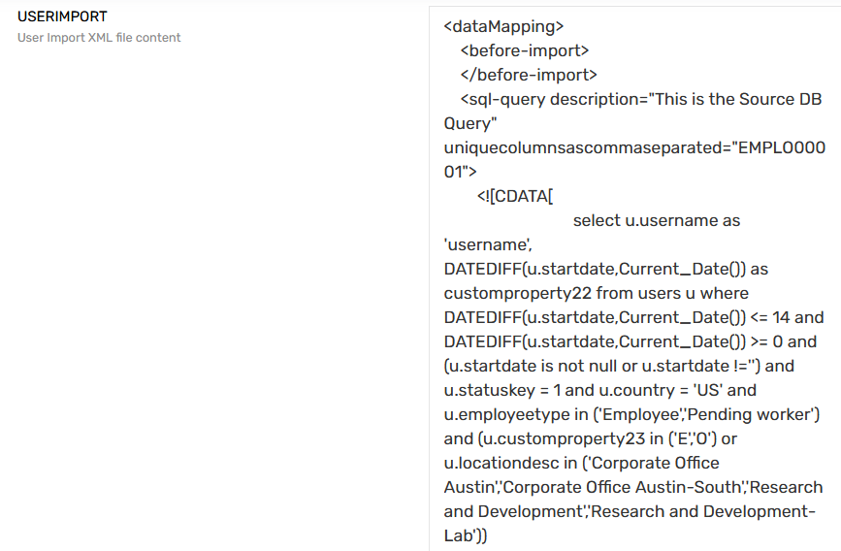

1. Suppose IAM Admin wants to add contingent worker and corporate office hangar for new hire, then update following SQL block.

|  |
| --- |
| select u.username as 'username', DATEDIFF(u.startdate,Current_Date()) as customproperty22 from users u where DATEDIFF(u.startdate,Current_Date()) <= 18 and DATEDIFF(u.startdate,Current_Date()) >= 0 and (u.startdate is not null or u.startdate !='') and u.statuskey = 1 and u.country = ‘US’ and u.employeetype in ('Employee','Pending worker',**’Contingent worker’**) and (u.customproperty23 in ('E','O') or u.locationdesc in ('Corporate Office Austin','Corporate Office Austin-South','Research and Development','Research and Development-Lab',’[**Corporate Office Hangar**](https://ssm-dev-hormel.ssmcloud.net/ECM/accounts/show/30)’))]]> |

1. One query is updated and then click on Save button.

#### Update Technical Rule

1. Login to SSM as administrator.
2. Go to Admin🡪 Polices and click on Technical Rules

Figure 88 : Technical Rule



1. Search for “User AD Birth Right Rule for Corp OU Users” section click on edit button.

Figure 89 : Technical List



1. Search for Condition section and add new “User Type” as “Contingent worker” and add “locationdesc” section as “[Corporate Office Hangar](https://ssm-dev-hormel.ssmcloud.net/ECM/accounts/show/30)”

Figure 90 : Condition

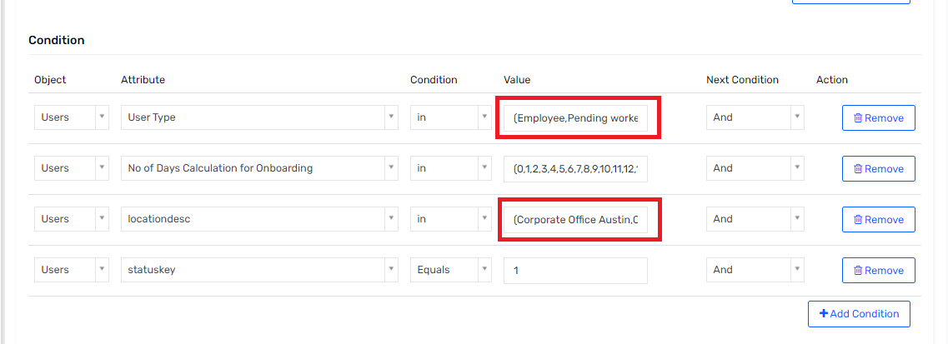

1. Similar as mention above update “No of Days Calculation for Onboarding” field in “User AD Birth Right Rule for Corp OU Users” and “User AD Birth Right Rule for Exempt and Office Hourly Users” technical rule.

### Birthright Criteria changed for Mailbox

This section describes about changing birthright criteria for Mailbox. Suppose IAM admin wants to add following condition in existing Active Directory birthright.

* Add employee type as “Contingent worker”.
* Add location desc as “[Corporate Office Hangar](https://ssm-dev-hormel.ssmcloud.net/ECM/accounts/show/30)”.

To update above condition following section is required to updated.

#### Addition in Bright right for Mailbox Connection

To add employee type and location desc , IAM admin must update following [Birth Right for Mailbox](https://ssm-dev-hormel.ssmcloud.net/ECM/ecmConfig/addnewconnection/14).

1. Login to SSM as administrator.
2. Go to Admin🡪 Connections

Figure 91 : Connection List

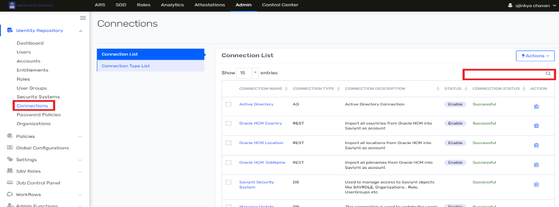

1. Search for “[Birth Right for Mailbox](https://ssm-dev-hormel.ssmcloud.net/ECM/ecmConfig/addnewconnection/14)” and click on it to view connection details.
2. Search for USERIMPORT section and update SQL query for employee type and location desc as mention below.

|  |
| --- |
| select u.username as userName,'YES' as Flag from users u,accounts a,user_accounts ua where  ua.userkey=u.userkey and ua.accountkey=a.accountkey and a.endpointkey=1 and a.status in( 1,'Manually Provisioned') and (u.customproperty24 is null or u.customproperty24 not in ('YES')) and u.employeetype in ('Employee','Pending worker',**’Contingent worker**’) and (u.customproperty23 in ('E','O') or u.locationdesc in ('Corporate Office Austin','Corporate Office Austin-South','Research and Development','Research and Development-Lab',’[**Corporate Office Hangar**](https://ssm-dev-hormel.ssmcloud.net/ECM/accounts/show/30)’)) and u.customproperty22 IN (0,1,2,3,4,5,6,7,8,9,10,11,12,13,14) and u.statuskey=1 and u.customproperty3 is not null |

#### Update Technical Rule

Suppose IAM admin wants to add new group to be provision as birthright for Mailbox then following steps is required to performed.

1. Login to SSM as administrator.
2. Go to Admin🡪 Polices and click on Technical Rules

Figure 92 : Technical Rule



1. Search for “User Mailbox Birth Right Rule” section click on edit button.

Figure 93 : Technical List

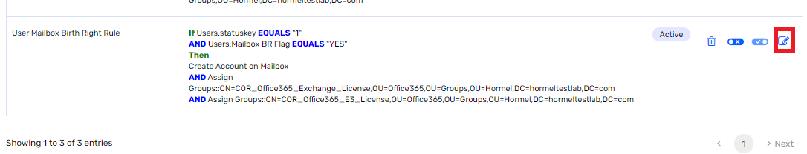

1. Search for Action section and click on Add Action button to add new group for birthright.

Figure 94 : Action

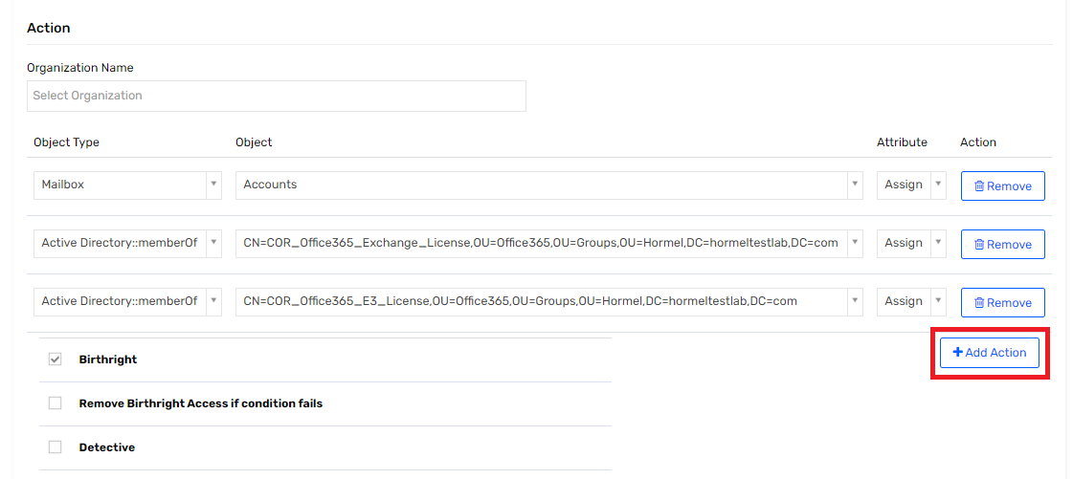

1. Select object type as “Active Directory :: Groups” then select object as “CN=Enterprise Key Admins,CN=Users,DC=hormeltestlab,DC=com”

Figure 95 : Object Type

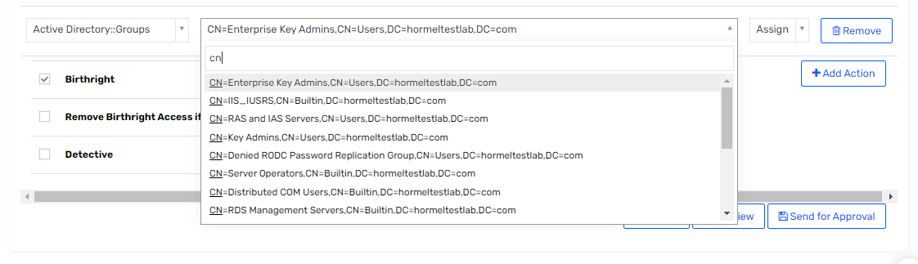

1. Then click on “Send for Approval” to save the details.

### New External OU addition

Suppose there is new requirement to add new external OU in Active Directory request form while requesting account. Then following section is required to update.

#### Change AD dynamic attribute

1. Login to SSM as administrator.
2. Go to Admin🡪 “Security Systems” then click on “Endpoints” and then click on “Active Directory”.

Figure 96 : Endpoint

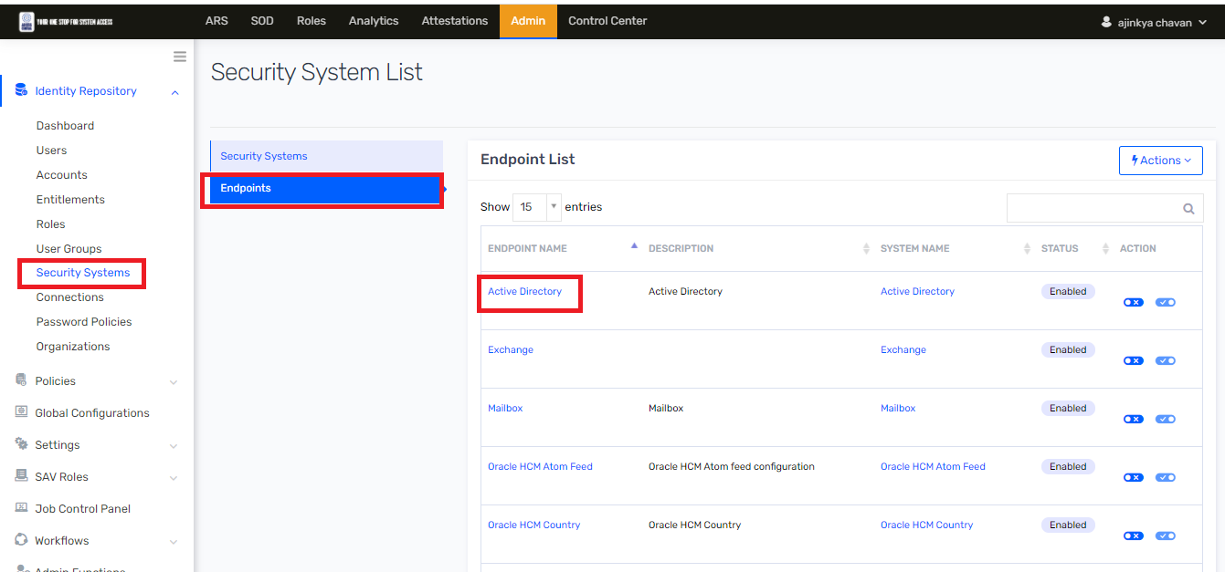

1. Click on “Dynamic Attribute” and search for “[externalOU](javascript:;)” attribute and click on it to edit.
2. Suppose IAM admin wants to add new external location as “Ohio” then update Values field in Update Attribute section.

Figure 97 : Update Attribute

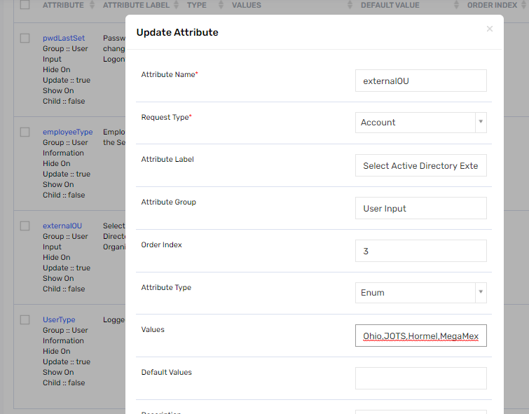

1. Once value is update then click on Update button.

#### Update AD OU update connection

1. Login to SSM as administrator.
2. Go to Admin🡪 Connections

Figure 98 : Connection List



1. Search for “[Active Directory OU Update](https://ssm-dev-hormel.ssmcloud.net/ECM/ecmConfig/addnewconnection/19)” and click on it to view connection details.

Figure 99 : Active Directory Update

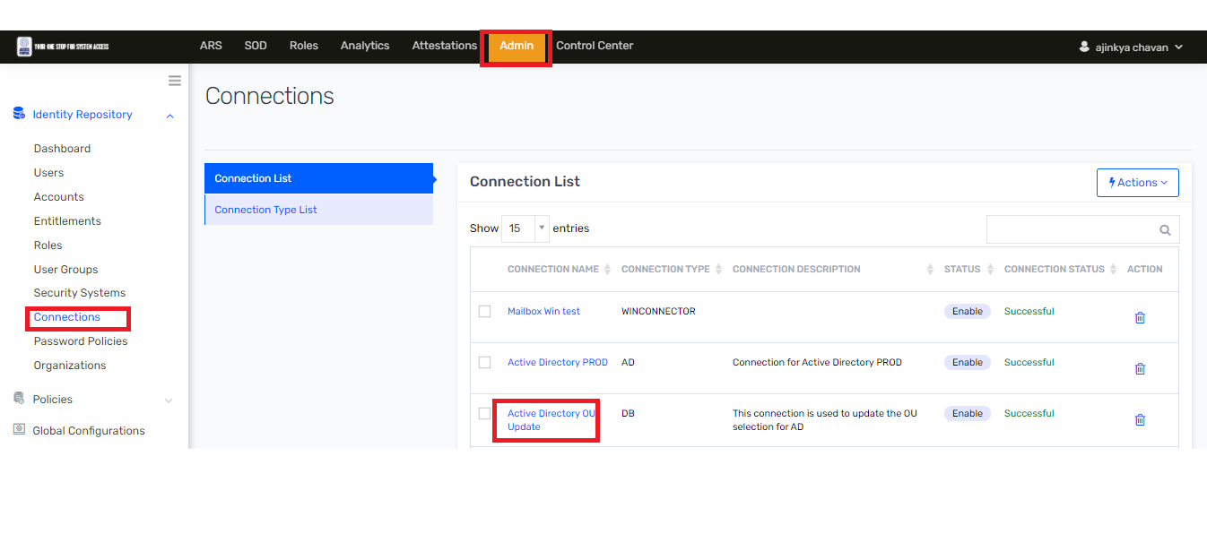

1. Search for USERIMPORT section and update SQL query to update new external OU as mention below.

|  |
| --- |
| select u.username,  CASE  **WHEN a.accountid like '%OU=External,OU=Users,OU=Ohio%' THEN Ohio**  WHEN a.accountid like '%OU=External,OU=Users,OU=JOTS%' THEN 'JOTS'  WHEN a.accountid like '%OU=External,OU=Users,OU=Hormel%' THEN 'Hormel'  WHEN a.accountid like '%OU=External,OU=Users,OU=MegaMex%' THEN 'MegaMex'  WHEN a.accountid like '%OU=External,OU=Users,OU=Columbus%' THEN 'Columbus'  ELSE 'Employee'  END as OU  from accounts a,users u where a.endpointkey='1' and a.STATUS in(1,2,'Manually Suspended','Inactive','Manually Provisioned','Active') and a.name=u.username |

1. Click on Save and Test connection button.

### New Birthright Groups Adding or Removing

This section describes about adding new and removing existing groups for birth right.

#### Change Endpoint

1. Login to SSM as administrator.
2. Go to Admin🡪 “Security Systems” then click on “Endpoints” and then click on “Active Directory”.

Figure 100 : Endpoint

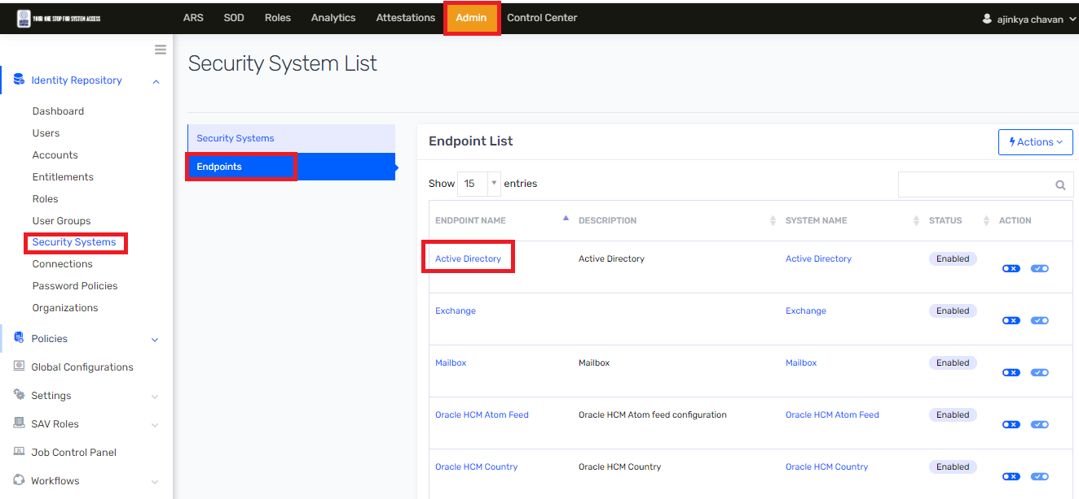

1. Navigate to Entitlement With New Account and click on Action then select 🡪 Add Entitlement.

Figure 101 : Entitlement with new account

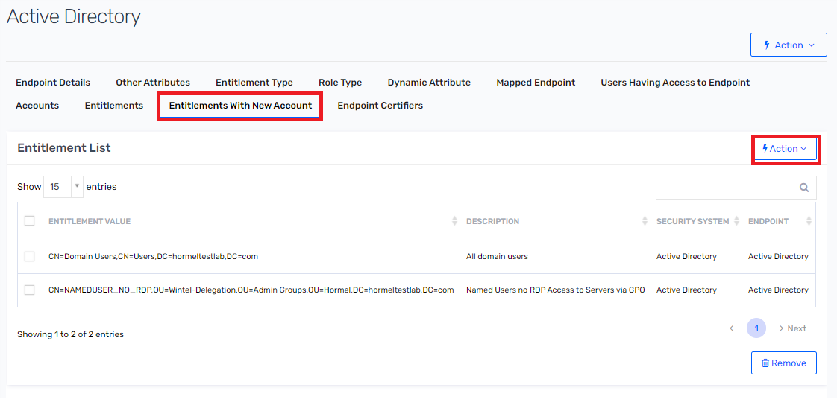

1. Search AD group to add as highlighted below and click on Save button.

Figure 102 : Add Entitlement

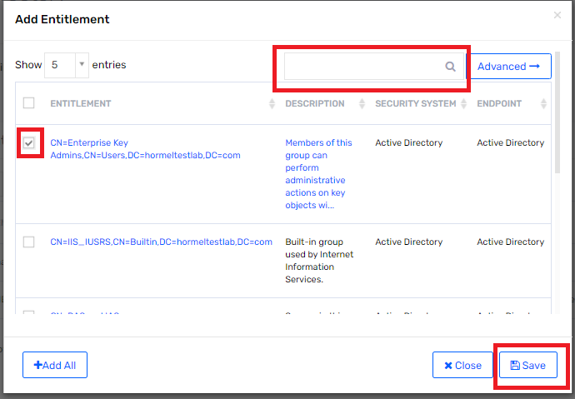

1. To remove existing group from endpoint, select checkbox on which group is required to remove and click on Remove button.

Figure 103 : Add Entitlement

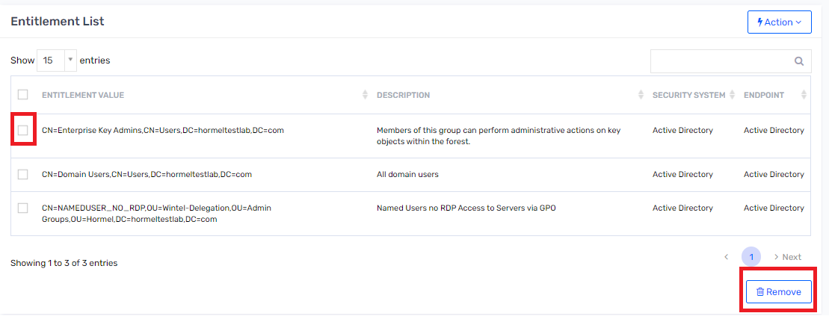

#### Change in technical rule

To add and remove group from birth right rule following section is required to update.

1. Login to SSM as administrator.
2. Go to Admin🡪 Polices and click on Technical Rules

Figure 104 : Technical Rule



1. Search for “User AD Birth Right Rule for Corp OU Users” section click on edit button.

Figure 105 : Technical List



1. Search for Action section and click on Add Action button to add new group for birthright.

Figure 106 : Action



1. Select object type as “Active Directory :: Groups” then select object as “CN=Enterprise Key Admins,CN=Users,DC=hormeltestlab,DC=com”

Figure 107 : Object Type



1. Then click on “Send for Approval” to save the details.
2. To remove group, click on remove button for which group needs to remove and then click on Send for Approval button.

### Delete Active Directory account after 30 days criteria change

This section describes how to change criteria for deleting Active Directory account after 30 days of inactive account. Following are the section that are required to update.

#### Change in analytic to delete account after 30 days

Suppose IAM admin wants to change criteria for deleting Active Directory account after 100 days. Then following analytic must be updated.

1. Login into SSM as administrator
2. To search specific analytic report, navigate to Analytics and click on it.

Figure 25 : Analytics



1. Search for Analytics Configuration List on toggle sidebar and click on it.

Figure 108: Analytics Configuration List



1. Search analytics using search text box, specify analytics name/Description such Hormel Remove AD Account After Expiration Date‘ to search.

Figure 109: Advanced Analytics Page



1. To view and edit analytic report, click on “[Hormel Remove AD Account After 90 Days](https://ssm-dev-hormel.ssmcloud.net/ECM/analyticsConfigES/show?id=287)”.
2. Click on edit to update query.

Figure 110 : Edit Analytic

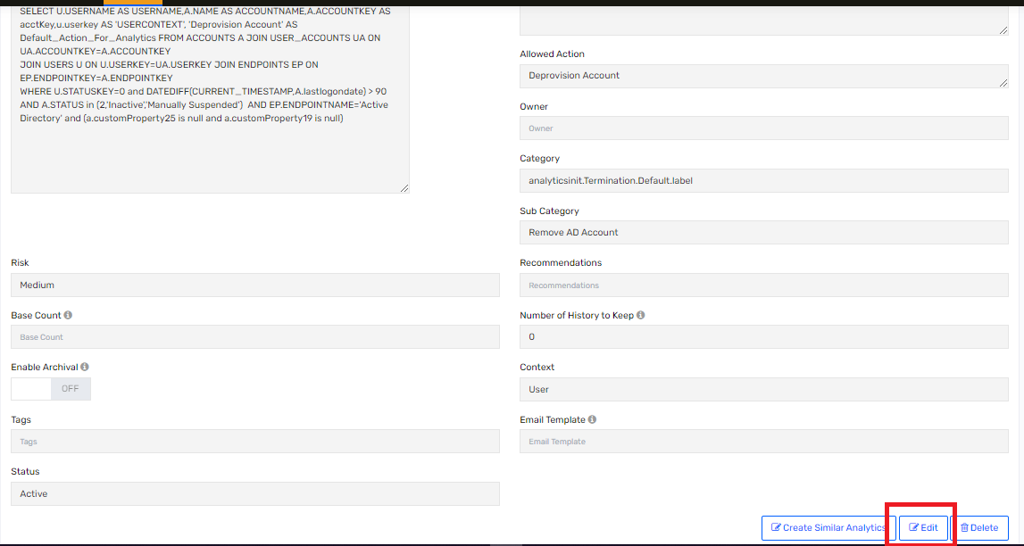

1. To change criteria to 100 days then update below query.

|  |
| --- |
| SELECT U.USERNAME AS USERNAME,A.NAME AS ACCOUNTNAME,A.ACCOUNTKEY AS acctKey,u.userkey AS 'USERCONTEXT', 'Deprovision Account' AS Default_Action_For_Analytics FROM ACCOUNTS A JOIN USER_ACCOUNTS UA ON UA.ACCOUNTKEY=A.ACCOUNTKEY  JOIN USERS U ON U.USERKEY=UA.USERKEY JOIN ENDPOINTS EP ON EP.ENDPOINTKEY=A.ENDPOINTKEY  WHERE U.STATUSKEY=0 and DATEDIFF(CURRENT_TIMESTAMP,A.lastlogondate) > **100**  AND A.STATUS in (2,'Inactive','Manually Suspended') AND EP.ENDPOINTNAME='Active Directory' and (a.customProperty25 is null and a.customProperty19 is null) |

Note: The criteria was changed on 4/6/21 to 30 days and also to compare to A.validthrough instead of A.lastlogondate. The name of the Analytic was changed to be more generic.

#### Change in analytic users deleting in next 24 hours

Suppose there is new requirement to change in criteria to check deleting user account in next 48 hours, then following analytic must be updated.

1. Login into SSM as administrator
2. To search specific analytic report, navigate to 🡪 Analytics and click on it.

Figure 26 : Analytics



1. Search for Analytics Configuration List on toggle sidebar and click on it.

Figure 111: Analytics Configuration List



1. Search analytics using search text box, specify analytics name/Description such as ‘Hormel Users Active Directory Group Removed in 24 Hours‘ to search.

Figure 112: Advanced Analytics Page



1. To view and edit analytic report, click on “Hormel Users Active Directory Group Removed in 24 Hours”.
2. Click on edit to update query.

Figure 113 : Edit Analytic



1. To change criteria to next 48 hours then update below query.

|  |
| --- |
| SELECT  u.username AS 'User Name',  ep.displayname AS 'Application Name',  ent.ENTITLEMENT_VALUE as 'Active Directory Group Removed'  FROM  arstasks art,  accounts a,  endpoints ep,  users u,  entitlement_values ent  WHERE  art.status IN (3)  AND art.TASKDATE > DATE_SUB(NOW(), INTERVAL 24 HOUR)  AND art.tasktype = 2  AND art.ENTITLEMENT_VALUEKEY is not null  AND art.accountkey = a.accountkey  AND art.endpoint = ep.endpointkey  AND u.userkey = art.userkey  AND ent.ENTITLEMENT_VALUEKEY = art.ENTITLEMENT_VALUEKEY  AND ep.endpointname = 'Active Directory'  and u.userkey in (  SELECT  u.userkey  FROM  arstasks art,  accounts a,  endpoints ep,  users u  WHERE  art.status in (3)  AND art.TASKDATE > DATE_SUB(NOW(), **INTERVAL 48 HOUR**)  AND art.accountkey = a.accountkey  AND art.endpoint = ep.endpointkey  AND u.userkey = art.userkey  AND ep.endpointname = 'Active Directory'  AND art.tasktype=14) |

### Oracle HCM Atom feed settings

This section describes about to change seating in Oracle HCM Atom feed. If there is any change in Oracle HCM URL or change in service account password following section is required to update.

#### Generate Encrypted key for Oracle HCM service account name

To generate encrypted key for Oracle HCM service account following steps needs to perform.

Note :To generate key “Encryption Key Generator” utility is required.

1. Open cmd terminal on Windows machine.
2. Navigate to location where Jar is placed.
3. Run following command to generate encrypted key.
4. java -cp "GenerateEncryptedKey.jar;lib/*" com.kpmg.generatekey.Encryption
5. Enter actual password.
6. Note down encrypted key.
7. To place encrypted key in Saviynt for Oracle HCM Atom Feed. Go to Admin🡪 “Security Systems” then click on “Endpoints” and then click on “[Oracle HCM Atom Feed](https://ssm-dev-hormel.ssmcloud.net/ECM/endpoints/show/6?savmodule=)”.

Figure 114 : Atom Feed Endpoint



1. Navigate 🡪 “Endpoint Details” and search for Custom Property 3 and paste generated key from utility and then click on 🡪 Update button.

Figure 115 : Oracle HCM Atom Feed

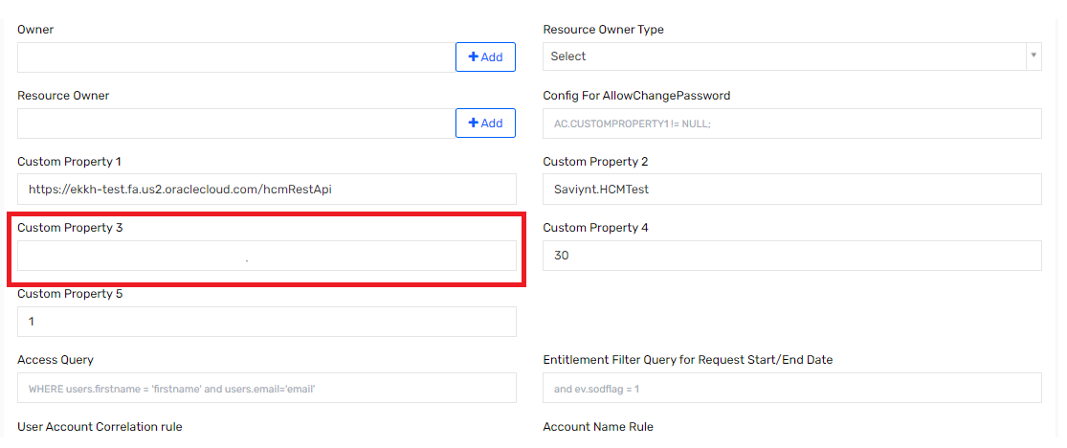

#### Change in Atom feed Page size, URL and General setting

This section describes about if there is change in Oracle HCM atom feed URL or changing general setting. Then IAM admin must change configuration as per below define table.

1. Login to SSM as administrator.
2. Go to Admin🡪 “Security Systems” then click on “Endpoints” and then click on “[Oracle HCM Atom Feed](https://ssm-dev-hormel.ssmcloud.net/ECM/endpoints/show/6?savmodule=)”.

Figure 116 : Atom Feed Endpoint



1. Navigate to “Endpoint Details” and “Other Attributes” to change value as per new requirement.

Figure 117 : Oracle HCM Atom Feed Configuration

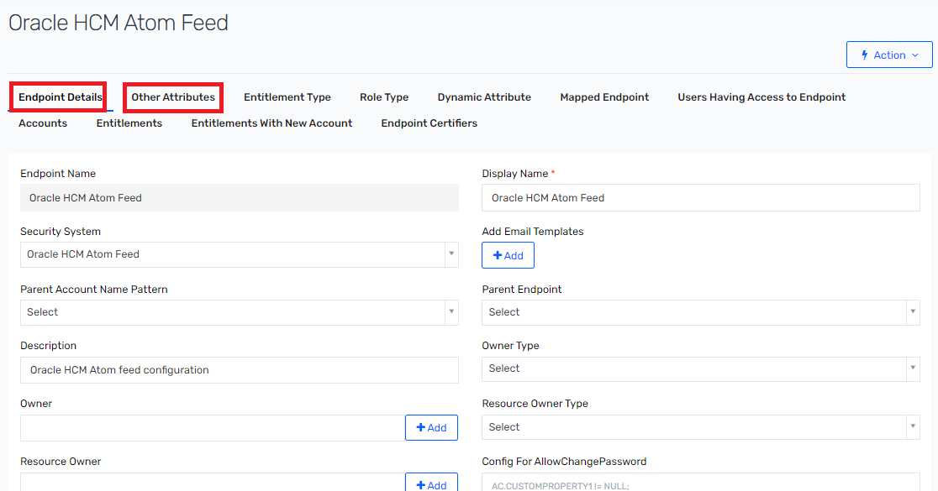

Note : If “customproperty10” value is blank then “customproperty5” value will take effect and then atom feed will fetch record from past one day records. And if “customproperty10” value is set then “customproperty5” value is ignored to fetch past one day record.

Table 27 : Oracle HCM Configuration Attributes and Values

|  |  |  |
| --- | --- | --- |
| Attributes | Purpose | Values |
| endpointname | Endpoint name is required to specific in "MODIFYUSERDATAJSON " Connection JSON | Oracle_HCM_User_Conf |
| customproperty1 | Oracle HCM URL | https://ekkh-test.fa.us2.oraclecloud.com/hcmRestApi |
| customproperty2 | Oracle HCM service account username | Saviynt.HCMTest |
| customproperty3 | Oracle HCM service account password in encrypted | <Encrypted Key> |
| customproperty4 | Define page size to fetch atom feed in one call | 30 |
| customproperty5 | Current date minus number of days. This is used to fetch atom feed record from past date. | 1 |
| customproperty6 | Operations | termination,empupdate,empassignment,newhire |
| customproperty7 | Oracle HCM Atom URL | /atomservlet/employee/ |
| customproperty8 | Query to filter employee record | /resources/latest/emps/?totalResults=true&expand=assignments&onlyData=true&q=PersonNumber= |
| customproperty9 | Query to filter worker record | /resources/latest/workers/?totalResults=true&expand=workRelationships.assignments.managers workRelationships.assignments.assignmentsDFF&onlyData=true&q=PersonNumber= |
| customproperty10 | Current time minus in minutes. This setting is used to fetch record from past 180 minutes. | 180 |
| customproperty11 | Future Hire | 15 |
| customproperty12 | Add 60 minutes in current date for ATOM FEED to fetch record for termination, empupdate, empassignment from Atom feed | 60 |

#### Running Oracle HCM Full Atom feed job for last day or more.

Suppose if there is down time for Oracle HCM/Saviynt application. In such case IAM admin must configure Oracle HCM Atom Full job to run user import job based on down time.

Suppose Oracle HCM or Saviynt application is down for 1 day then, IAM admin must configured Oracle HCM Atom Full job in Saviynt to fetch 1 day back all atom feed data into Saviynt.

1. Login into Saviynt as IAM Admin
2. Before configuring “Oracle HCM Atom Feed Full”, IAM admin must stop “Oracle HCM Atom Feed” which is schedule to be run for every 1 hour. Navigate to 🡪 Admin 🡪 Job Control Panel

Figure 118 : Job Control Panel

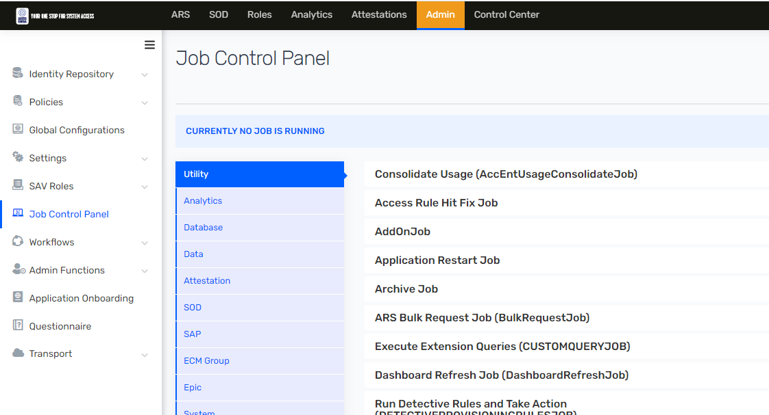

1. Then navigate to Utility and click on 🡪 Trigger Job.

Figure 119 : Utility

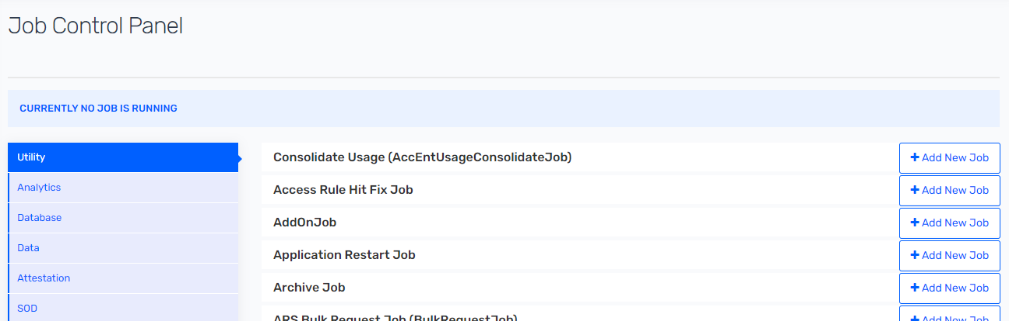

1. Click on 🡪 Edit Trigger button and then click on “Action” button of “ORACLE_HCM_USER_IMPORT”.

Figure 120 : Edit Trigger

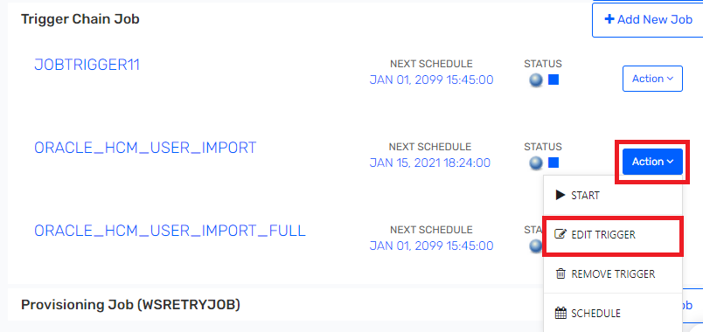

1. Click on 🡪 Next button to change scheduler timing.

Figure 121 : Job Details

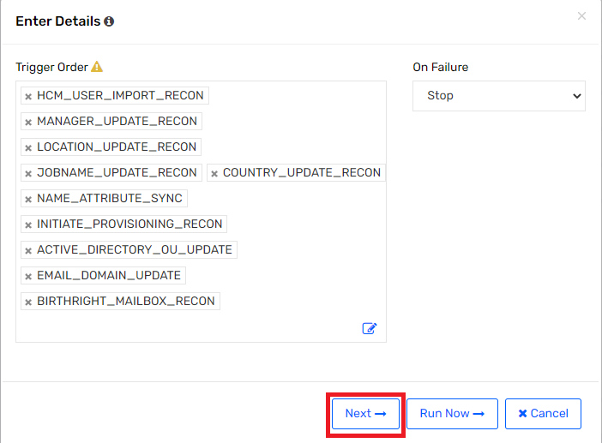

1. Click on 🡪 Cron Expression and enter “0 0 0 ? * * 2099”

Figure 122 : Cron Expression

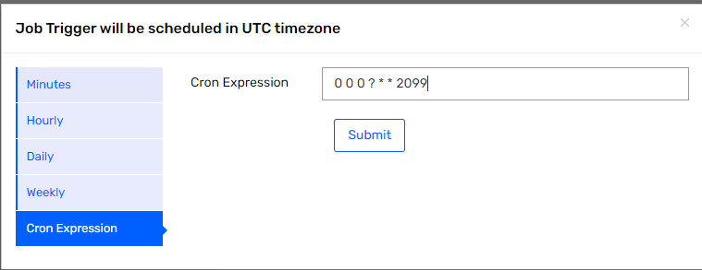

1. Verify 🡪 Next schedule timing is as per entered value.



1. Now to Configure “Oracle HCM Full Atom Feed” job. Navigate to Admin🡪 Security System 🡪 Click on “Endpoint“ 🡪 Click on “Oracle HCM Full Atom Feed”

Figure 123 : Endpoint

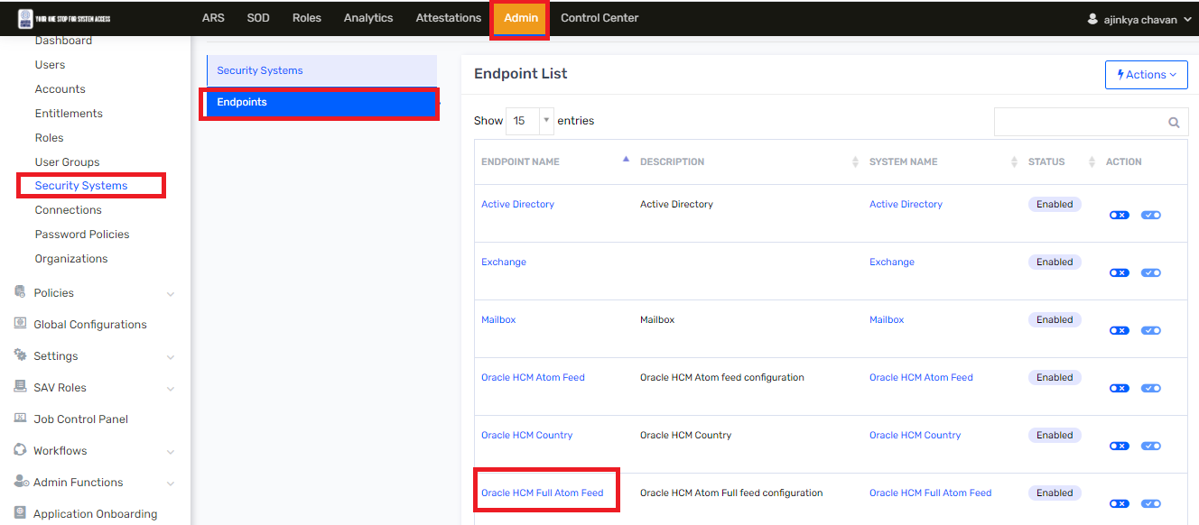

1. Search for “Custom Property 5” field in Endpoint Detail tab. Custom property 5 field represents as current date minus number of days. This is used to fetch atom feed record from past date. Set custom Property 5 as “1”. And click on “Update” button.

Figure 124 : Endpoint Details

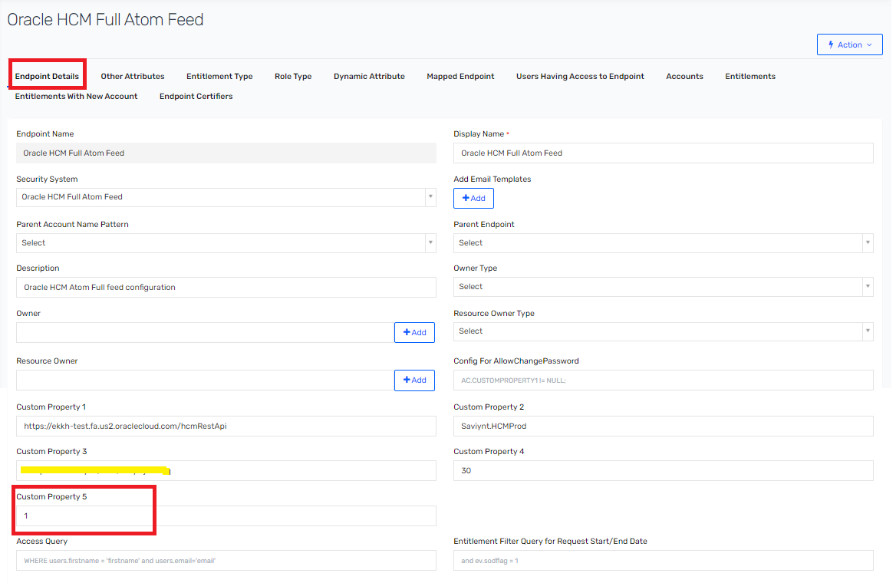

1. To run “Oracle HCM Full Atom Feed” job navigate to “Admin” 🡪 Job Control Panel 🡪 Click on Utility and search for “Trigger Chain Job” and click on it.

Figure 125 : Trigger Chain Job

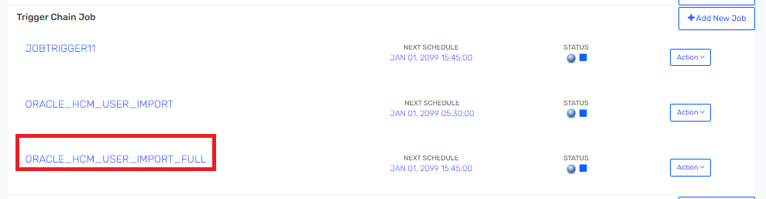

1. Click on 🡪 Actions 🡪 click Edit Trigger.

Figure 126 : Trigger Chain Job

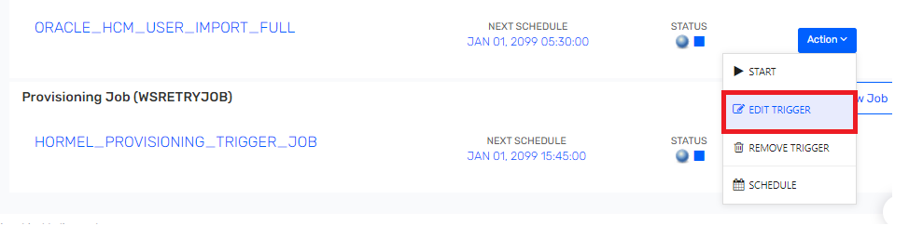

1. Click on “Run Now” to run Oracle HCM Full Atom Feed job.

Figure 127 : Trigger Chain Job

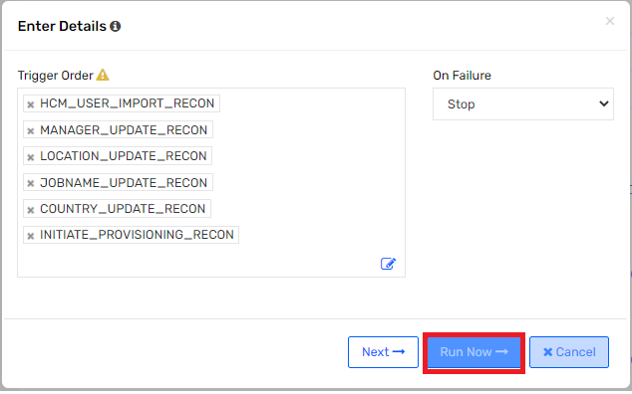

1. Once “Oracle HCM Full Atom Feed” job is completed, then re-schedule “Oracle HCM Atom Feed” for every 1 hour. Then navigate to Utility and click on 🡪 Trigger Job and click on “ORACLE_HCM_USER_IMPORT”.

Figure 128 : Job Control Panel



1. Search for “Oracle HCM User Import” job and click on 🡪 “Action” button and then click on 🡪 Edit Trigger.



1. Click on 🡪 “Next” button.

Figure 129 : Trigger Details

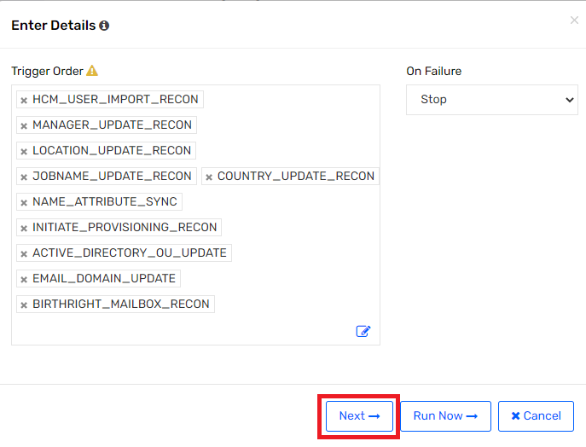

1. Click on Hourly and select Every to 1 hours and click on Submit button.

Figure 130 : Job Trigger Schedule

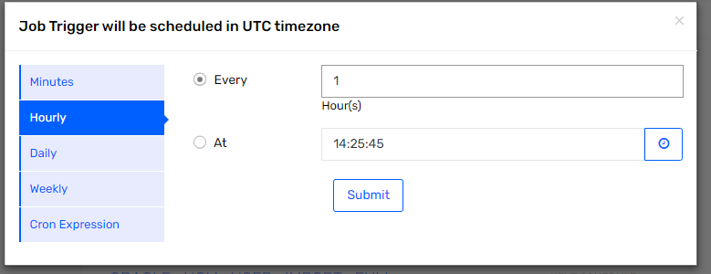

### Onboard existing contingent worker into Oracle HCM and Saviynt

Following step are required to perform to onboard existing contingent worker in Oracle HCM which are currently not present in Oracle HCM and manually/load CSV update their employee id into Saviynt.

Figure 131 : Incremental User Reconciliation



1. Identify contingent worker that needs to onboard into Oracle HCM.
2. Before identity is onboarded into Oracle HCM, Saviynt user import job needs to be stop.
3. Then load contingent worker into Oracle HCM.
4. Manually update person number into Saviynt in employee id field and then start user import job
5. After Saviynt user import is ran, then newly created contingent worker in Oracle HCM will be co-related with Saviynt identity.

Following are the step that is required to perform in Saviynt for on boarding existing Contingent worker process.

1. Before all Contingent worker loading into Oracle HCM. Oracle HCM Atom Feed job must be stop.
2. Navigate to 🡪 Admin 🡪 Job Control Panel

Figure 132 : Job Control Panel



1. Then navigate to Utility and click on 🡪 Trigger Job.

Figure 133 : Utility



1. Click on 🡪 Edit Trigger button and then click on “Action” button of “ORACLE_HCM_USER_IMPORT”.

Figure 134 : Edit Trigger



1. Click on 🡪 Next button to change scheduler timing.

Figure 135 : Job Details



1. Click on 🡪 Cron Expression and enter “0 0 0 ? * * 2099”

Figure 136 : Cron Expression



1. Verify 🡪 Next schedule timing is as per entered value.



1. Now contingent worker should be onboarded on Oracle HCM application, Once record is created into Oracle HCM. Then take newly created person number of user and then search user into Saviynt with username and update person number into Employee Id field of Saviynt.
2. Following are steps to update person number into Saviynt. Navigate to 🡪 Admin 🡪 click on Identity Repository 🡪 Users

Figure 137 : Users

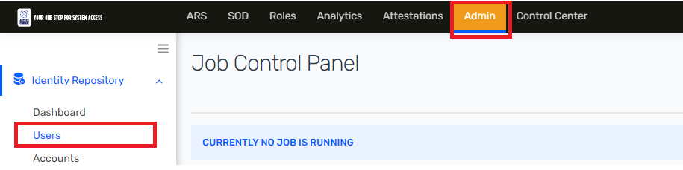

1. Suppose new existing contingent worker is onboarded into Oracle HCM as “KelyPenkiny”. Then search user in user list with username as “KelyPenkiny”. And then click on username.

Figure 138 : User List

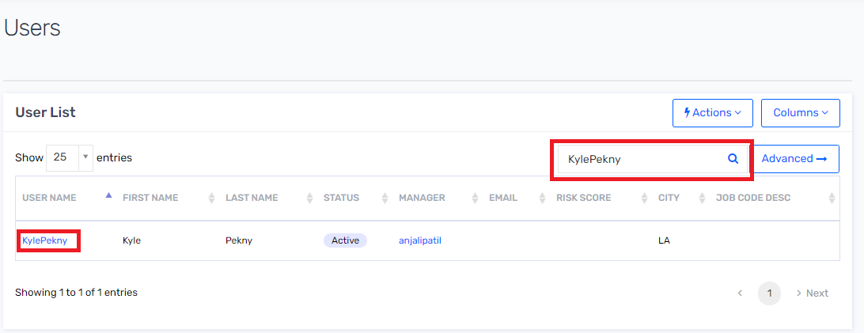

1. Search for Employee ID field on user profile. And manually enter newly created contingent worker user’s person number into Employee ID field and then click n Update button.

Figure 139 : Profile

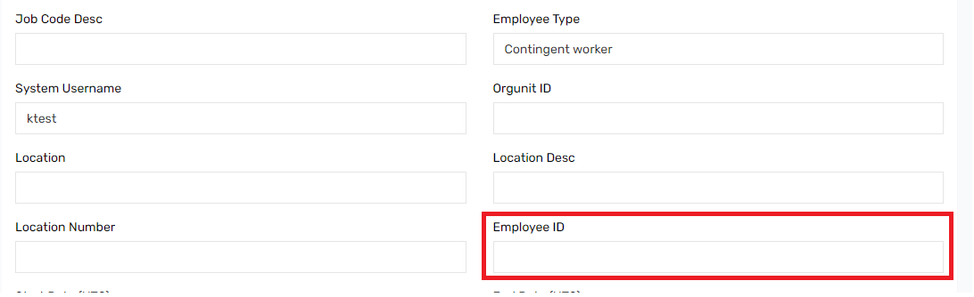

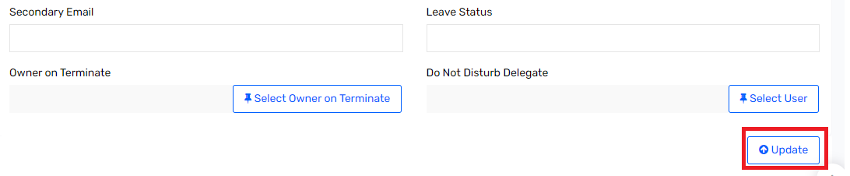

1. Now schedule Oracle HCM Atom feed. Then navigate to Utility and click on 🡪 Trigger Job and click on “ORACLE_HCM_USER_IMPORT”.

Figure 140 : Job Control Panel



1. Search for “Oracle HCM User Import” job and click on 🡪 “Action” button and then click on 🡪 Edit Trigger.



1. Click on 🡪 “Next” button.

Figure 141 : Trigger Details



1. Click on Hourly and select Every to 1 hours and click on Submit button.

Figure 142 : Job Trigger Schedule



### Change in First name, Last name, Display name and Username.

Suppose user request HR to change their first name and last name in system. Whenever HR change first name and last name in Oracle HCM then first name and last name will sync Saviynt and Active Directory, but user’s Display name and system username will not be able sync in Saviynt.

To sync display name and system username in Active Directory, then display name and system username must be updated manually in Saviynt. Once display name and system username is updated in Saviynt it will get sync to Active directory and update user’s CN and display name.

Suppose user “Alex Ahlman” wants to change his last name to “Wall” .Then IAM admin must to perform following steps to update Display name and System username in Active Directory.

1. Login into Saviynt as IAM admin
2. Navigate to Admin 🡪 Identity Repository 🡪 click on 🡪 Users

Figure 143 : Job Control Panel



1. Navigate to search bar. Then search user in user list with username as “AAAhlman”. And then click on username.

Figure 144 : User List

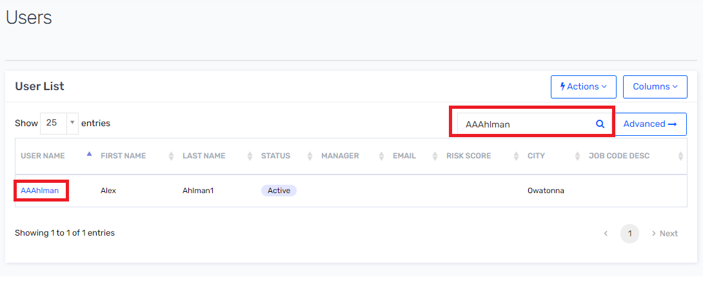

1. Search for Display Name field. And update last name as “Wall” in display as “Ahlman_**Wall**_A”.

Figure 145 : User Profile

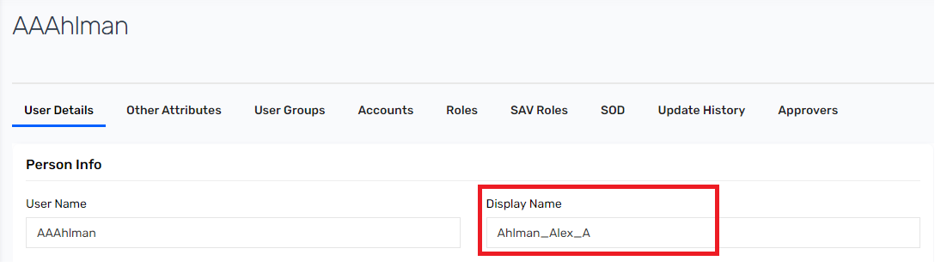

1. Search for System Username field. And update system username as “**Wall**” in system user name as “Ahlman_**Wall**_A”. And the click on Update button.

Figure 146 : User Profile

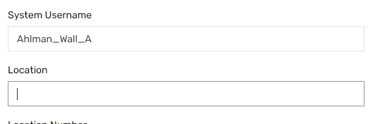

### Updating UPN address in Saviynt

Suppose user request HR to change their first name and last name in system. Whenever HR change first name and last name in Oracle HCM then first name and last name will sync Saviynt and Active Directory, but user’s first name and last name in “UPN” field will not be able update for existing user’s UPN.

To sync user’s UPN in Active Directory, UPN field must be updated manually in Saviynt. Once UPN is updated in Saviynt it will get sync to Active directory and update user’s userPrincipalName field in Active Directory.

Suppose user “Alex Ahlman” wants to change his last name to “Wall” .Then IAM admin must to perform following steps to update UPN in Active Directory.

1. Login into Saviynt as IAM admin
2. Navigate to Admin 🡪 Identity Repository 🡪 click on 🡪 Users

Figure 147 : Job Control Panel



1. Navigate to search bar. Then search user in user list with username as “AAAhlman”. And then click on username.

Figure 148 : User List



1. Click on Other Attributes.

Figure 149 : User Profile

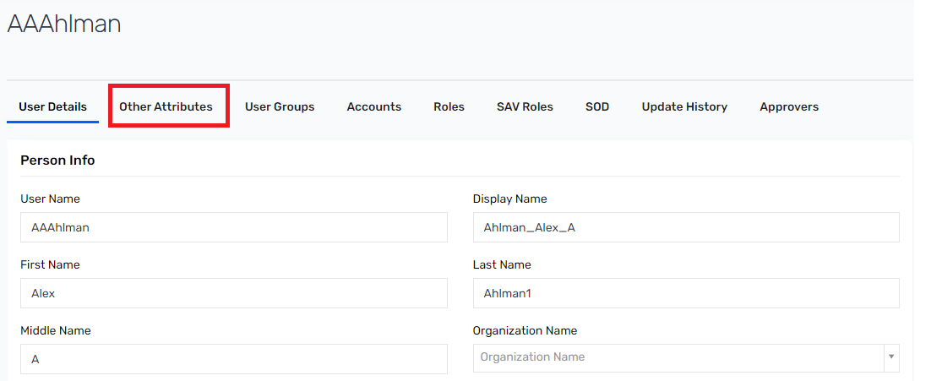

Search for **UPN** field. And update last name as “Wall” in UPN as “AhlmanWall@hormel”. And the click on Update button.

Figure 150 : User Profile

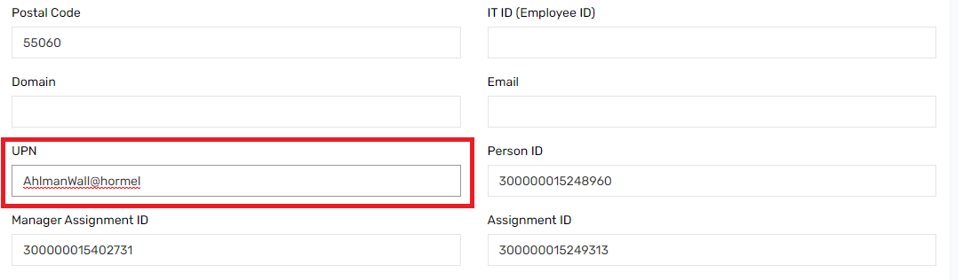

### Manage Remove and Disable account in Pending task

This section describes how to manage Remove and Disable task which are in Pending task.

1. Navigate to ARS and click on Tasks. Select Pending task.

Figure 151 : Pending Task

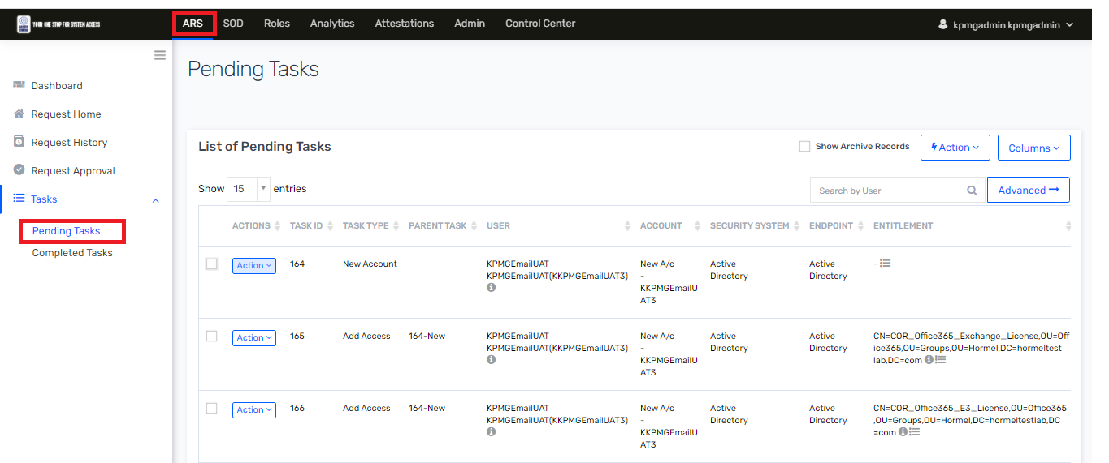

1. Review all remove and disable task that are genuine or not, If tasks are not genuine then Click on Action button of that task and click on 🡪 Discontinued option

Figure 152 : Pending Task

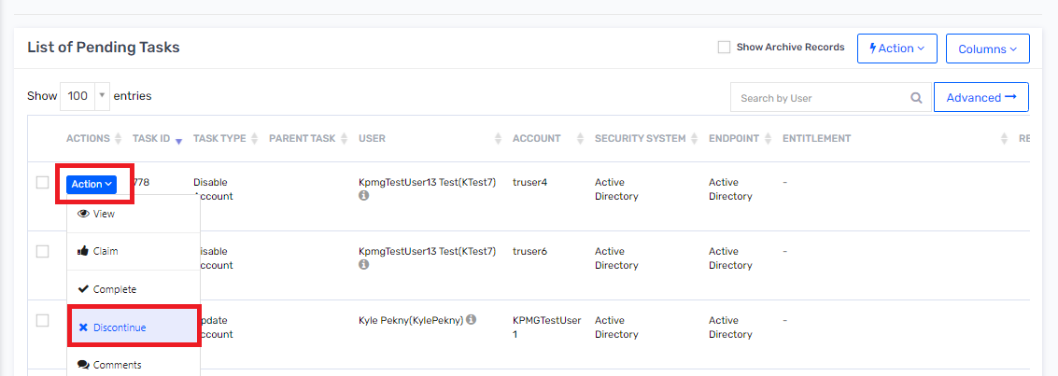

1. After discontinuing non- genuine task, then Navigate to Admin 🡪 Job Control Panel 🡪 Click on 🡪 Utility.

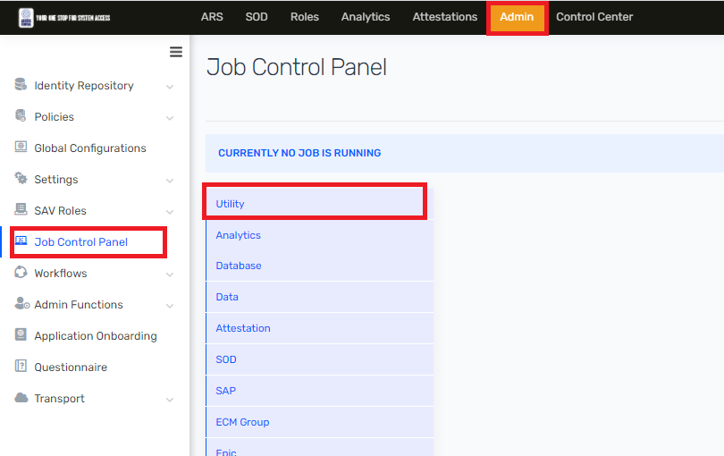

1. Then search for “Hormel Provisioning Job” in Provisioning Job section. And then click on 🡪 Action button and then select 🡪 Start button.

Figure 153 : Provisioning Job

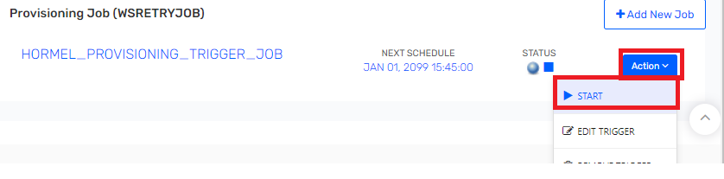

1. Select Active Directory in System and then select Remove Account and Disable Account and then click on Submit button.

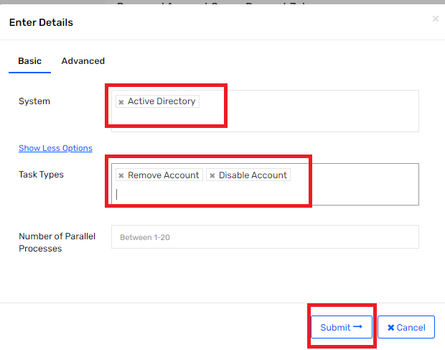

1. Once provisioning job is completed then all pending remove and disable account task will be completed.

### Technical Rule

This rule is mainly used to provision birthright access to US Employees and Other User joining company based on specified conditions. The technical rule is executed when:

* Users are created from Oracle HCM import and the condition matches.
* Existing user is updated and the condition in the rule matches when it is run as part of re-running the provisioning rule

 To modify a rule, perform the following steps:

1. Go to ADMIN 🡪 Policies 🡪 Technical Rule.

Figure 154 : Technical Rule



1. Click Edit. And make appropriate changes as per business logic. Refer Saviynt Updating technical rule document [<https://saviynt.freshdesk.com/support/solutions/articles/43000434356-updating-technical-rules>] to understand functionality.

Figure 155 : Technical Rule Condition

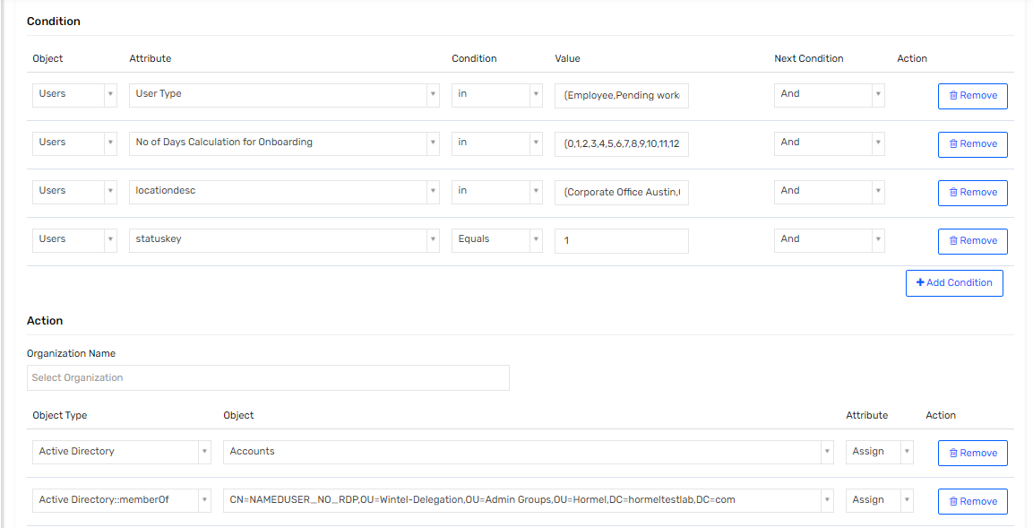

1. Update the values in Rule details page and click Send for Approval.

**Note** : The values in the parameters marked with an asterisk (*) are mandatory.

### User Update Rule

User Update Rule is mainly used when there is any change to user attribute values. Common use cases or scenarios where user update rule is triggered are:

1. User attributes is changed for user

* street is updated
* locationdesc is updated
* Owner is updated
* Title is updated
* Employee ID is updated
* HCM Employee Type is updated
* First Name is updated
* lastname is updated
* middlename is updated
* Department Name is updated
* state is updated
* city is updated
* enddate is updated
* country is updated
* systemUserName is updated
* companyname is updated
* Postal Code is updated
* E-Mail is updated
* UPN is updated
* displayname is updated

1. An employee gets disable or enable.

**User Update Rule** - Triggered when an existing user attribute is changed for a user or an existing user is terminated. There will be a task generated for the selected action. Once the task is completed, the specified action is triggered and completed.

To update a user update rule, perform the following steps:

1. Login into SSM as IAM Admin
2. Go to Admin 🡪 Policies  🡪 User Update Rules

Figure 156 : User Update Rules

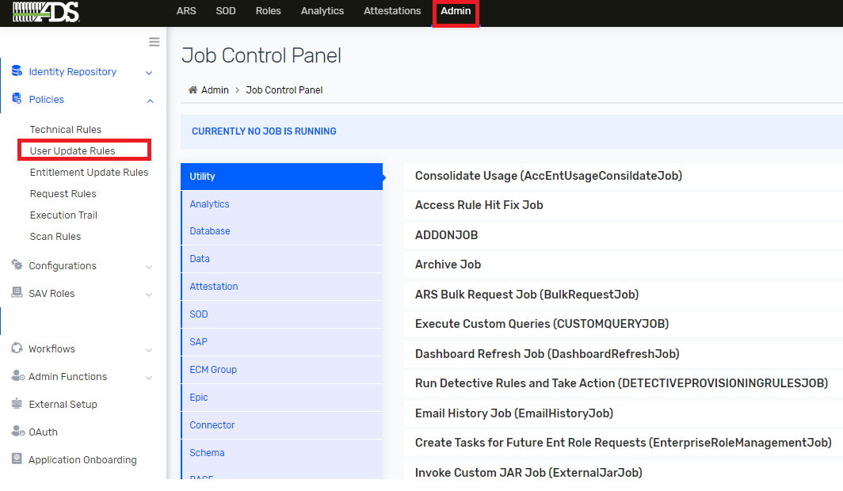

1. Search for user update rule to be updated in search box.

Figure 157 : User Update Rule Search

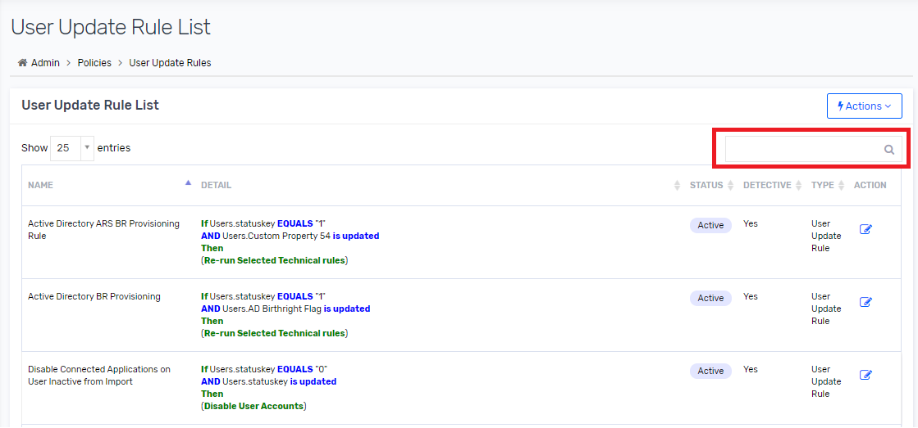

1. Click on 🡪 Edit icon in action column and click on it.

Figure 158 : User Update Rule List

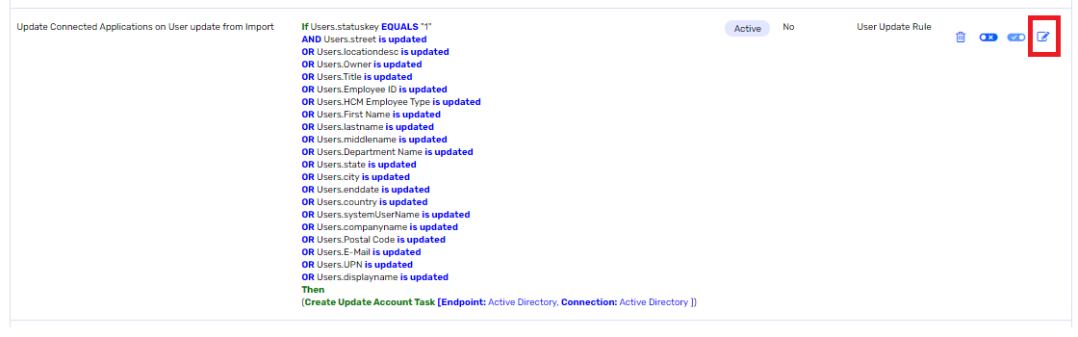

1. And make appropriate changes as per business logic. Refer Saviynt User Update Rule document [<https://saviynt.freshdesk.com/support/solutions/articles/43000431681-creating-user-update-rules>] to understand functionality.
2. Update the values in rule details page and click on 🡪 Send for Approval.

Figure 159 : User Update Rule Condition

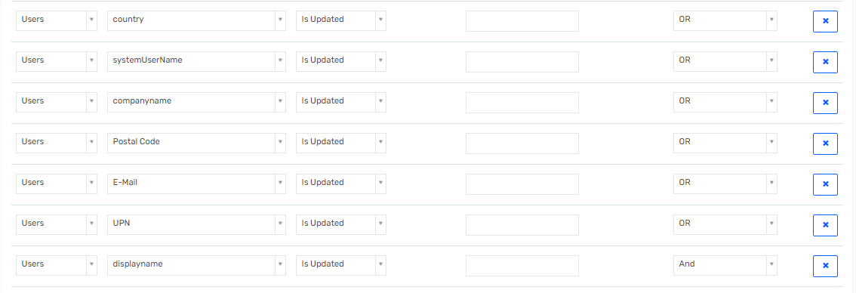  
**Note** : The values in the parameters marked with an asterisk (*) are mandatory.

## Access Request Operation

In the enterprise, the IDM solution provides a centralized platform for access requests. SSM’s access request system is leveraged for request workflow. SSM enables users to raise access requests for following types of access:

1. Application Accounts
2. Application Entitlements

The following steps provide additional details on the user experience of a typical request for application.

Following applications user can raise a request.

1. Active Directory
2. Mailbox

**Note** : Depending upon what is requested, the user experience may differ on the number of details to be provided.

### Request Access

1. Users logs in to Saviynt Security Manager using their credentials and click on “Request Access for Others” tile on ARS Dashboard.

Figure 160: Request Access

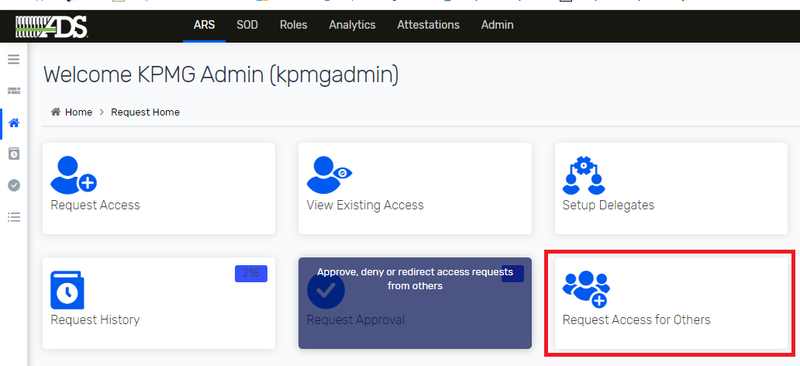

1. User search for beneficiary from the User List and click on the Next button.

Figure 161: User Search

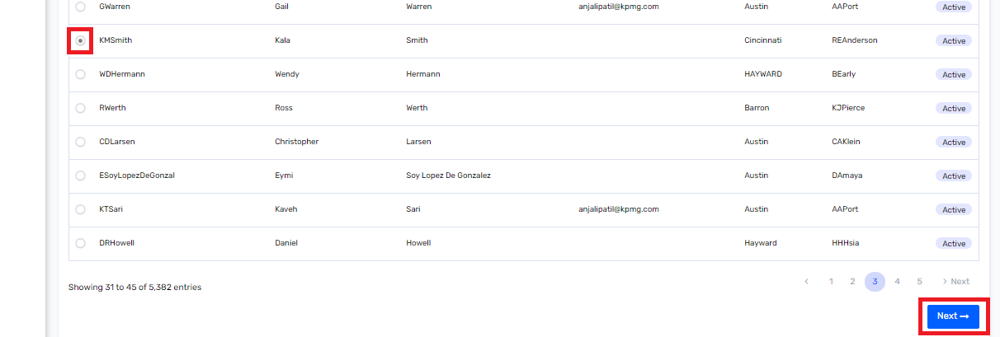

1. Users can select the appropriate application to add to the cart and click on the Checkout button.

Figure 162: Add to Cart

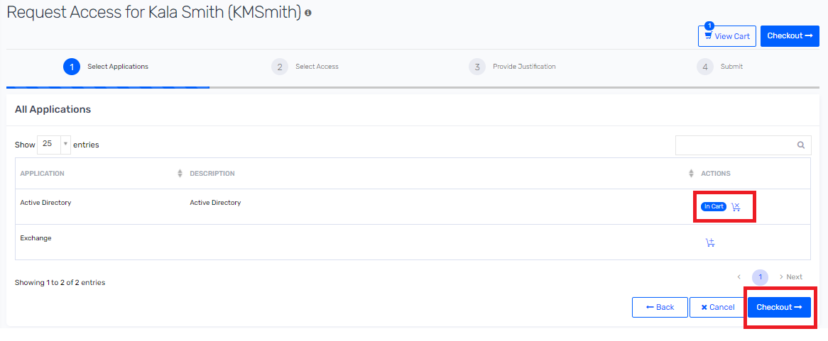

1. Users can select the appropriate access and click on the Next button. User must provide the Business Justification and Comments then submit the request.

Figure 163: Add Business Justification

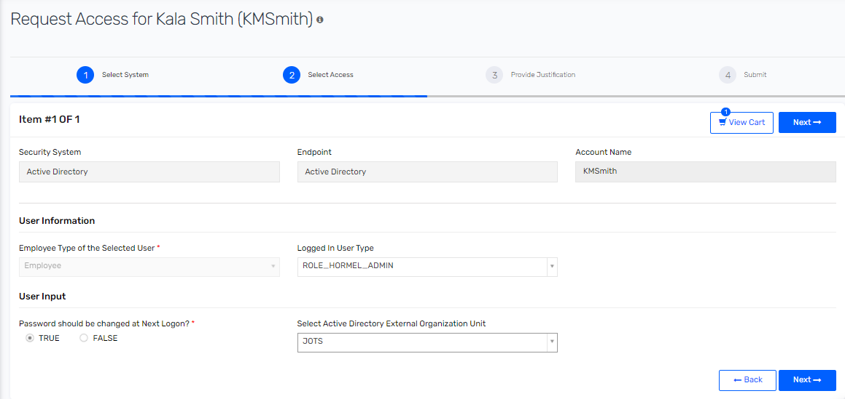

#### Sec Admin Request Active Directory Access for Sec Admin for Employee

This section describes about Sec admin raising request for employee type. Sec admin must follow below steps to request access for end user.

1. Sec admin receives CAS request to add access for Employee type.
2. Sec admin logs in to Saviynt Security Manager using their credentials and click on “Request Access for Others” tile on ARS Dashboard.

Figure 164: Request Access



1. Sec admin search for user from the User List and click on the Next button.

Figure 165: User Search

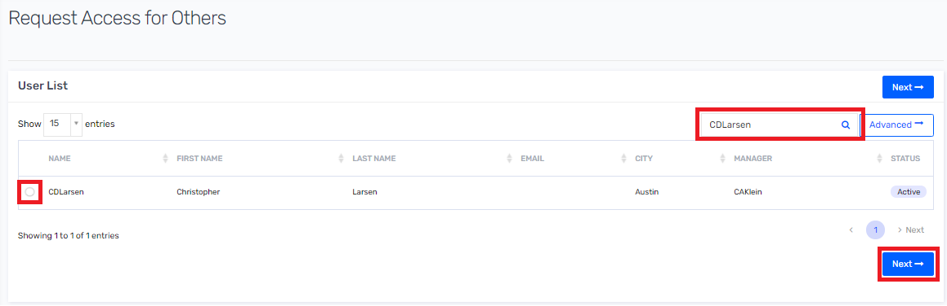

1. Sec admin must select the Active Directory application to add to the cart and click on the Checkout button.

Figure 166: Add to Cart

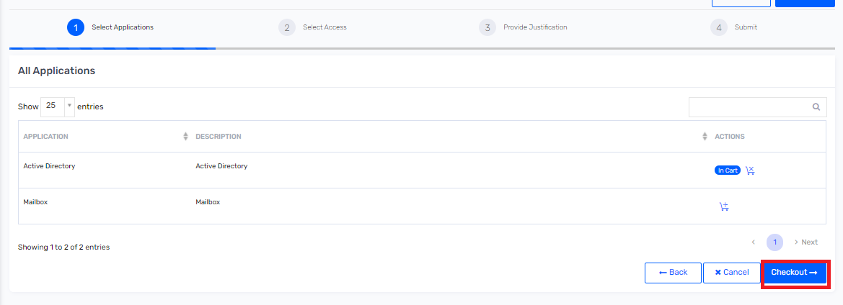

1. Sec admin can select the appropriate access and click on the Next button.

Figure 167: Add Business Justification

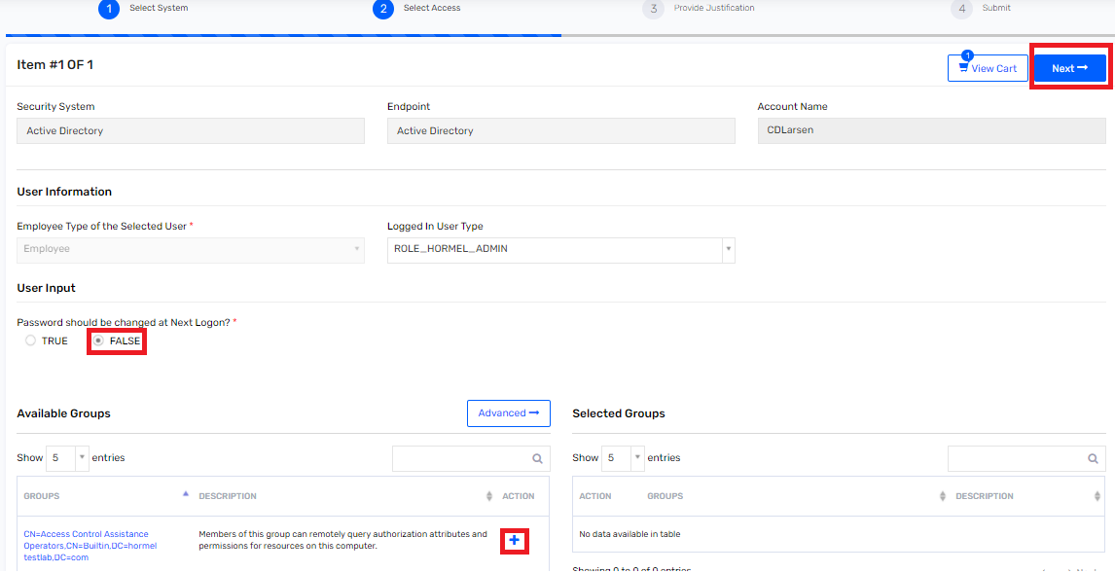

1. Sec admin must provide the Business Justification and Comments then submit the request.

Figure 168 : Access Request Details

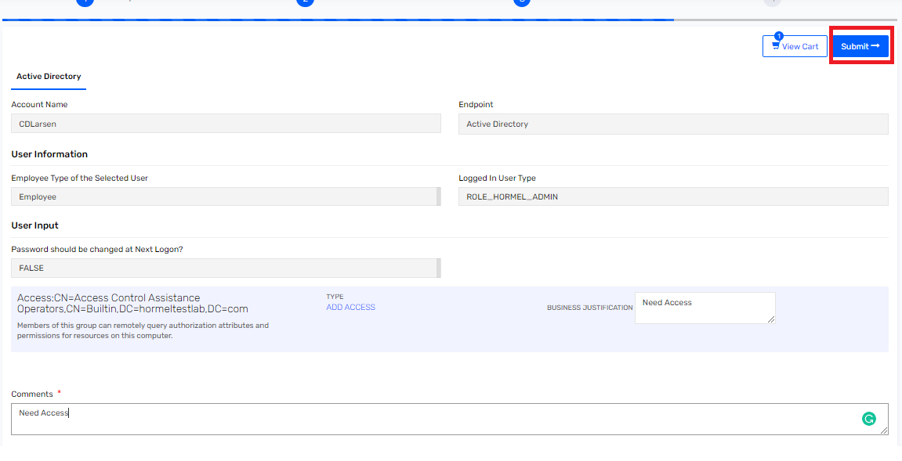

#### Sec Admin Request Active Directory Access for Sec Admin for Contingent Worker

This section describes about Sec admin raising request for contingent worker type. Sec admin must follow below steps to request access for contingent worker user.

1. Sec admin receives CAS request to add access for contingent worker type.
2. Sec admin logs in to Saviynt Security Manager using their credentials and click on “Request Access for Others” tile on ARS Dashboard.

Figure 169: Request Access



1. Sec admin search for user from the User List and click on the Next button.

Figure 170: User Search



1. Sec admin must select the Active Directory application to add to the cart and click on the Checkout button.

Figure 171: Add to Cart



1. Sec admin can select the appropriate access and click on the Next button.

Figure 172: Add Business Justification

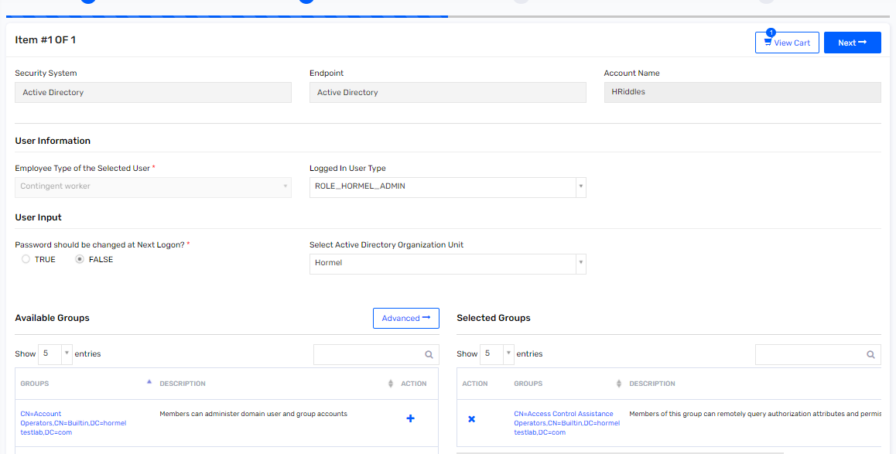

1. Sec admin must provide the Business Justification and Comments then submit the request.

Figure 173 : Access Request Details

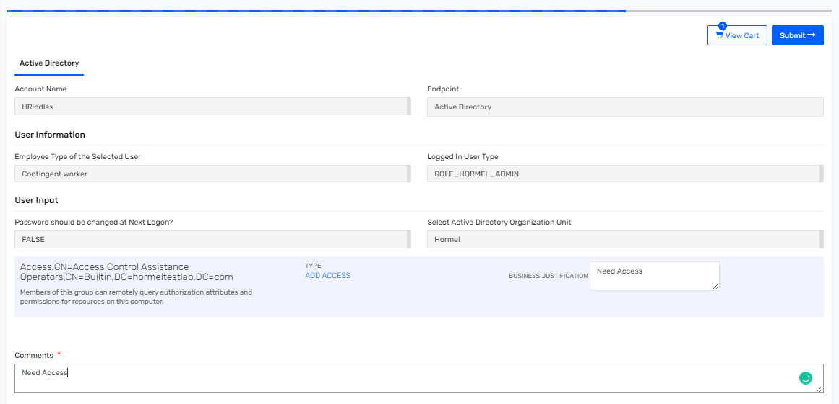

### Remove Access

End users can remove their access, while Managers can remove their active reportee's access and Sec administrators can remove any active user account access at any point in time.

1. User logs in to Saviynt Security Manager using their credentials.
2. Click on the ARS dashboard.

Figure 174: Remove Access – ARS

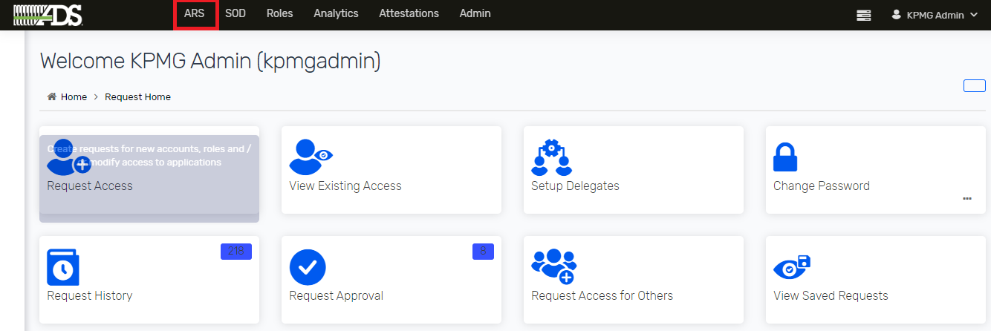

1. Click on “Request Access for Others” title from the ARS tab.

Figure 175: Remove Access – Request Access for Others

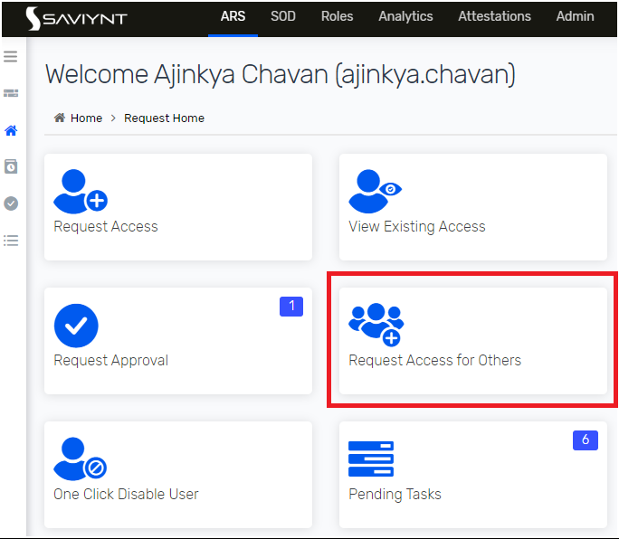

1. Search intended user from the User List and click on the Next button.

Figure 176: Remove Access – Search Users

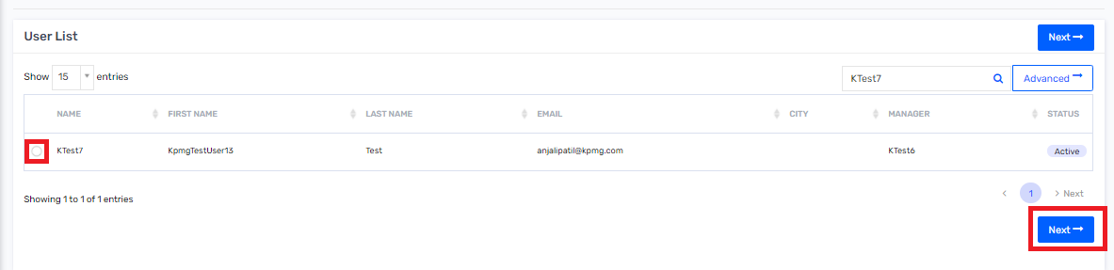

1. Click on the [X] to remove individual access.

Figure 177: Remove Access from Cart

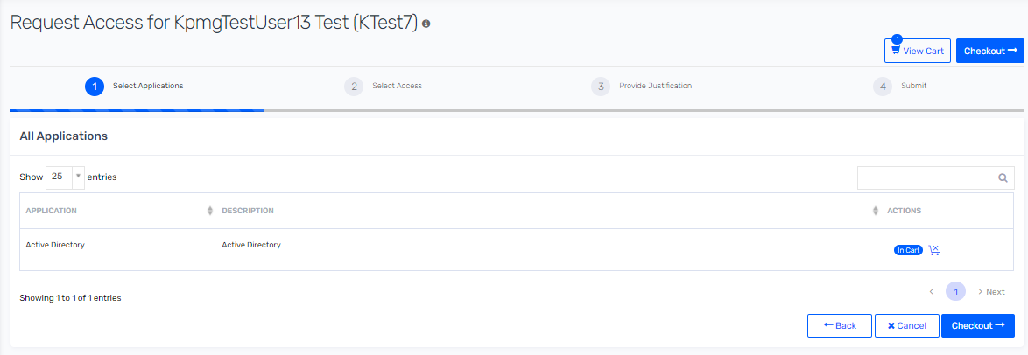

1. Click on the Remove button, if prompted.

Figure 178: Remove Account

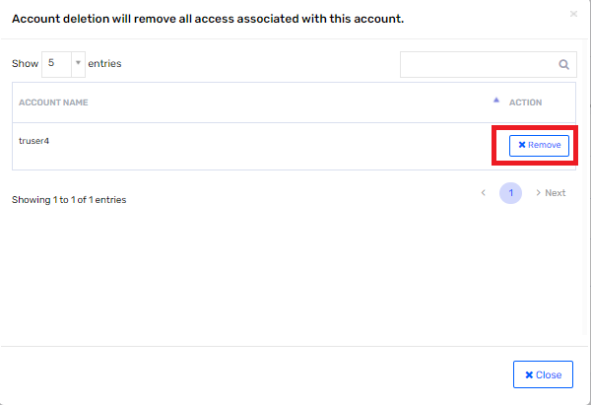

1. Provide the comments then submit the remove access request.

Figure 179: Remove Access – Submit

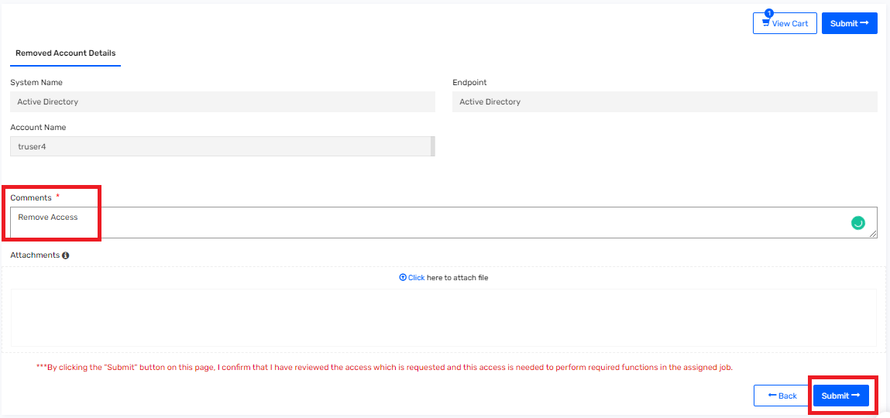

## Request Approval

### Request History

This section describes about details about request history. To view request history, perform following steps.

1. Navigate to 🡪 ARS on menu and click on it.

Figure 180 : ASR

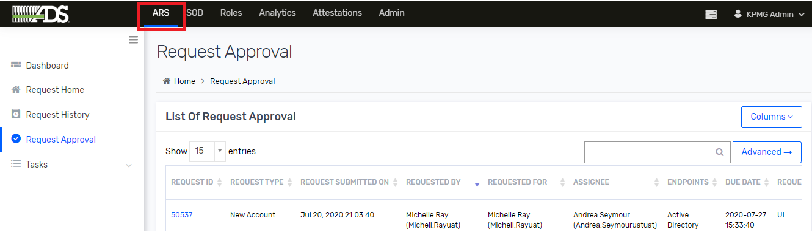

1. Click on Request History on toggle sidebar.

Figure 181 : Request History

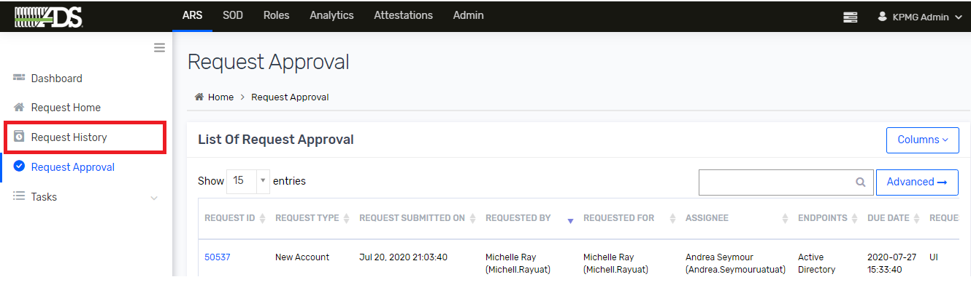

1. Click on RequestID to view more detail.

Figure 182 : List of Request History



1. Go to Task History to view task details for the request.

Figure 183 : Task History

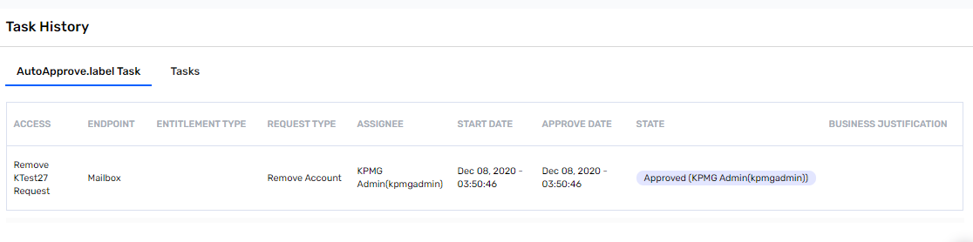

### Request Approval

This section describes about approving/rejecting request by approval. To approve or reject assignee must perform following steps.

1. Approver receives an email-based notification once the request is assigned to approver.
2. Approver Logs on to Saviynt and clicks on Request Approval tile or Request Approval tab on the left pane from ARS tab.

Figure 184: Request Approval tab

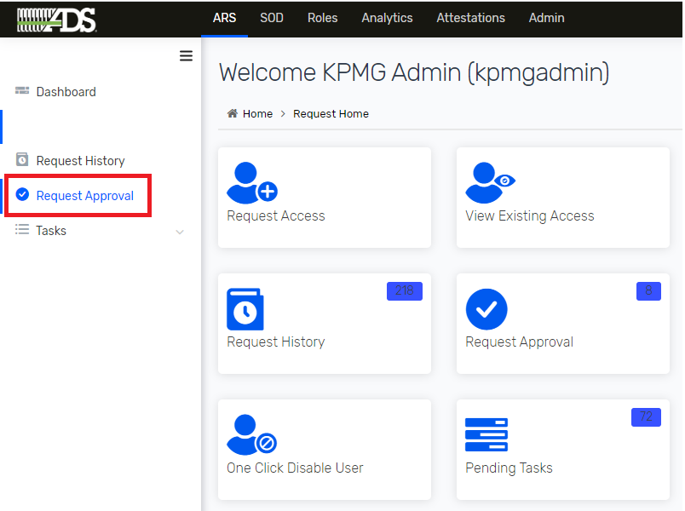

1. Select the Request ID to view the request details.

Figure 185: User Request ID

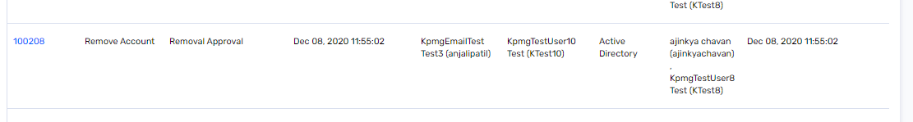

1. View details of request and select on Accept or Reject access detail.

Figure 186: Accept/Reject Request

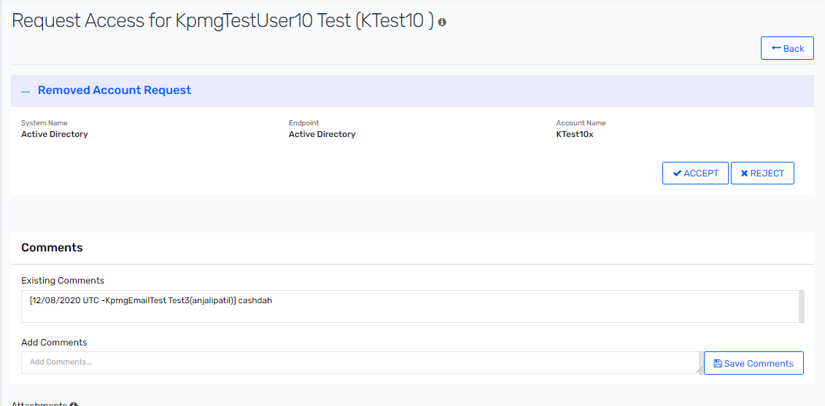

1. Enter the comments and click on submit.

Figure 187: Add Comment and Submit

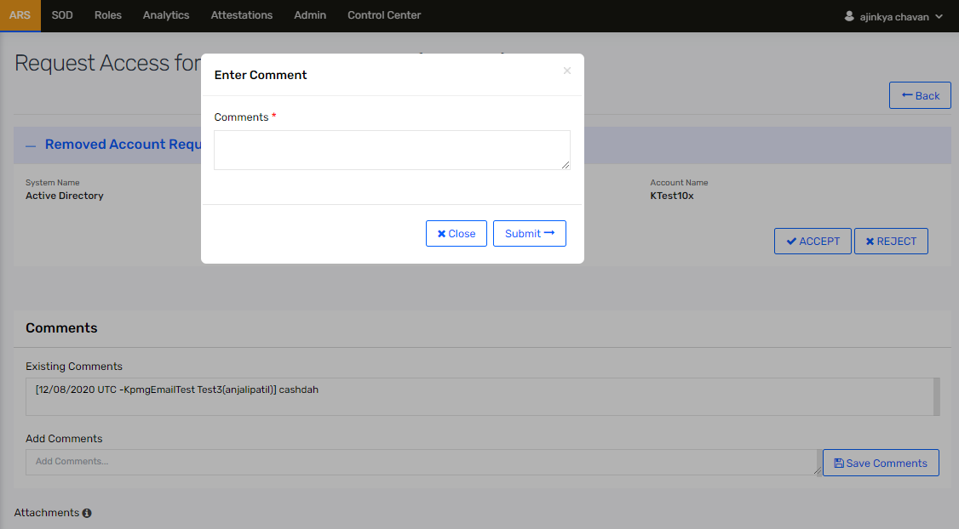

1. Approverconfirms the request by clicking on the Confirm button.

Figure 188: Confirm Request

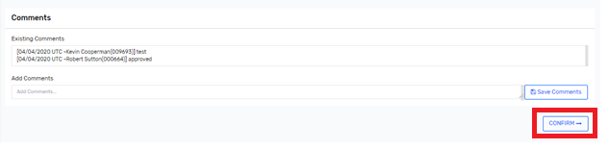

1. Once the request is confirmed then the message will pop on top right of screen as Request completed.

Figure 189: Request Completed

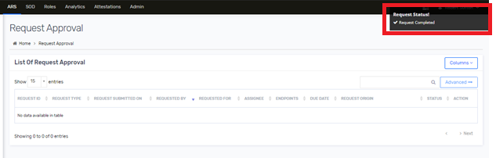

## Password Management

### Helpdesk Assisted Password Reset

Administrators can log in to SSM and reset the user’s account passwords. SSM provides this functionality through the “Change Password” tile of ARS Tab.

1. Click on “Change Direct Reportee Password” in “Change Password tile”.

Figure 190: Change Password

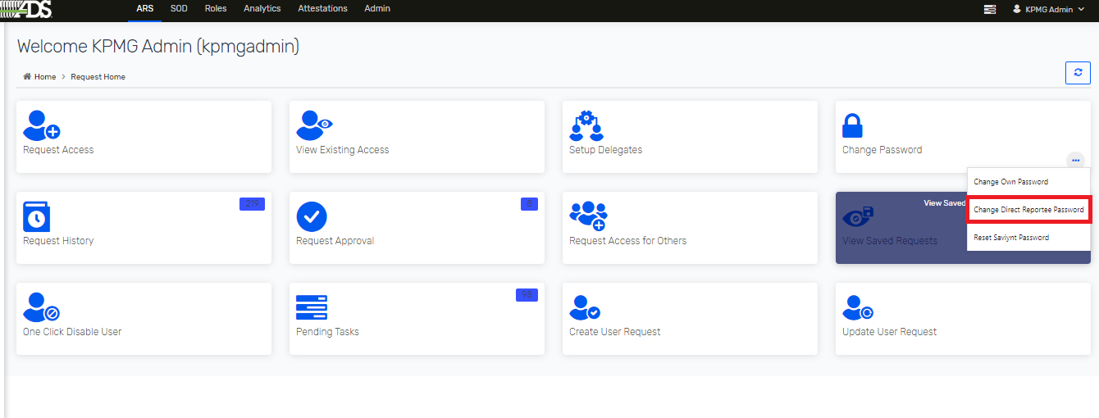

1. Administrators can search and select the user to change password.

Figure 191: Helpdesk Assist - Reset Password

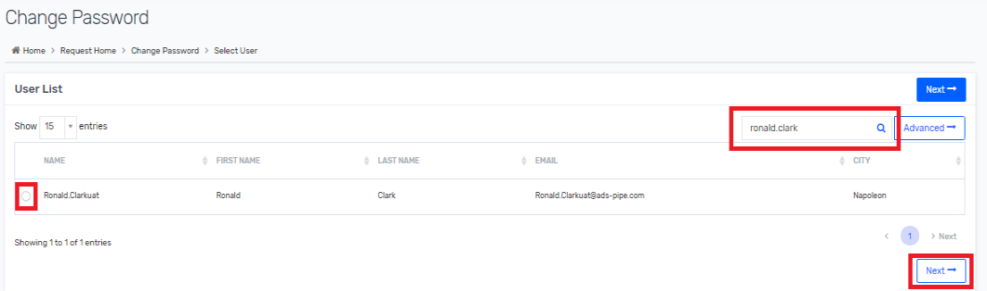

1. Click on Cart icon to add application to reset password and click on Checkout button.

Figure 192 : Change Password

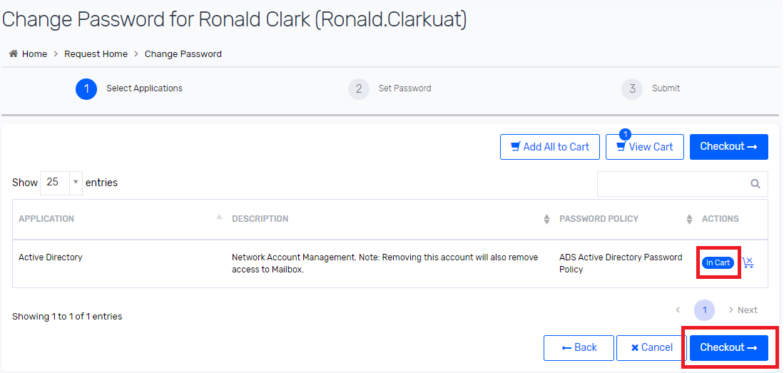

1. Click on Checkbox to select user and then click on Change Password button.

Figure 193 : Set Password

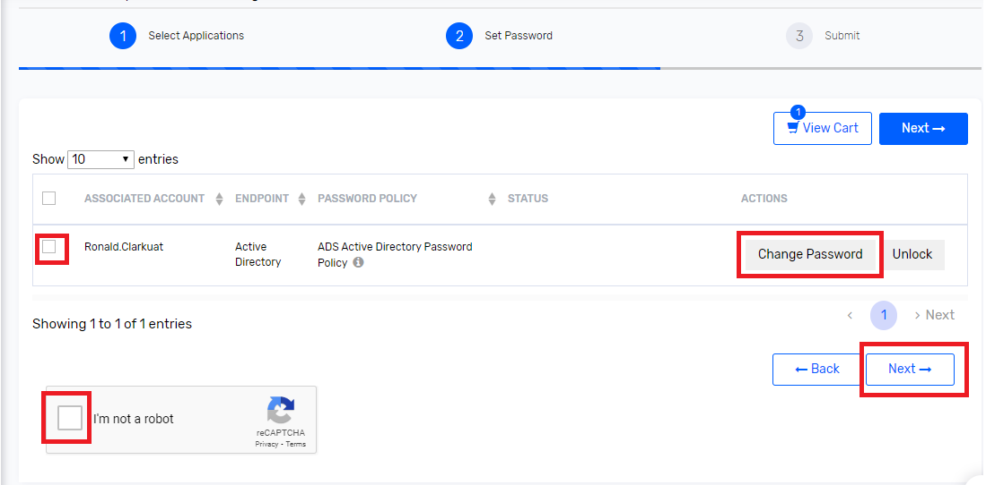

1. Click on Type New Password and enter appropriate password complying to password restrictions mentioned on screen to set a temporary password as per policy. And click on ‘Use Password’ button.

Figure 194 : Type New Password

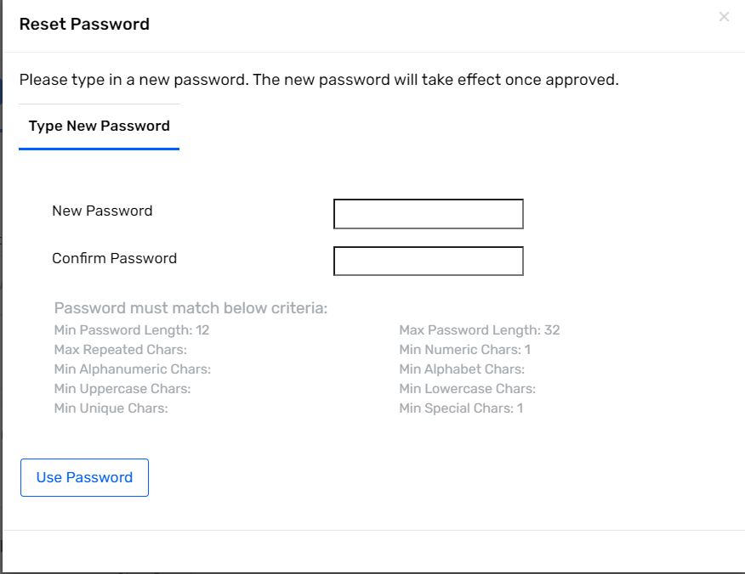

1. After setting user password click on Next button.

Figure 195 : Change Password

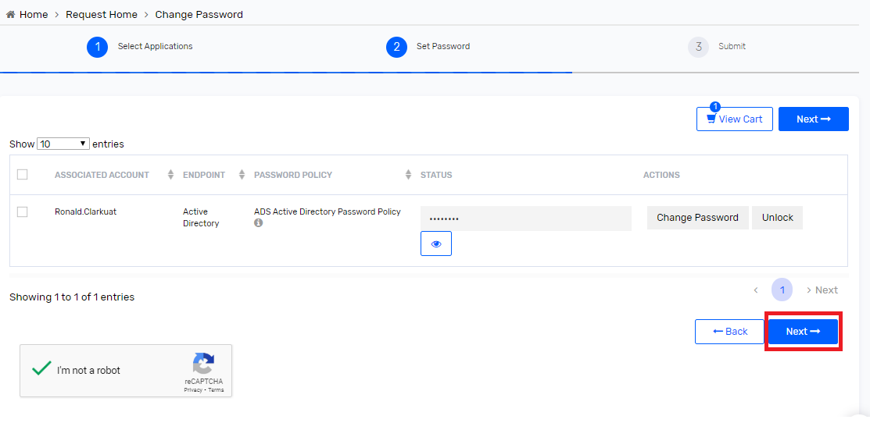

1. Password change request will successfully be submitted, and change password task will generate.

Figure 196 : Change password submit

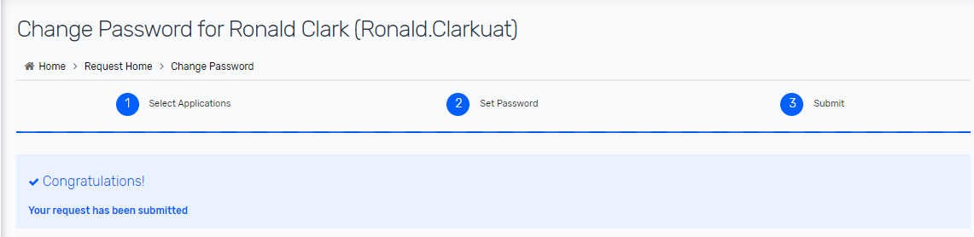

1. The new password will have to be communicated to the user by admins. On the next login, end-users will be required to change their temporary password.

### Unlock User Account

The user requests the Hormel Helpdesk team to unlock their Active Directory account if the account is locked.

1. Helpdesk personnel logs into SSM and selects “Change Direct Reports Password” option from “Change Password” tile.

Figure 197: Unlock User Account- 1

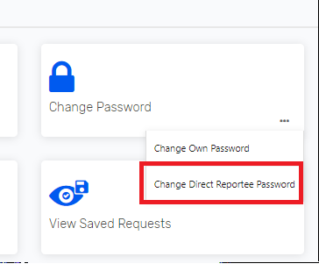

1. Helpdesk personnel searches the user whose account need to be unlocked.

Figure 198: Unlock User Account- 2

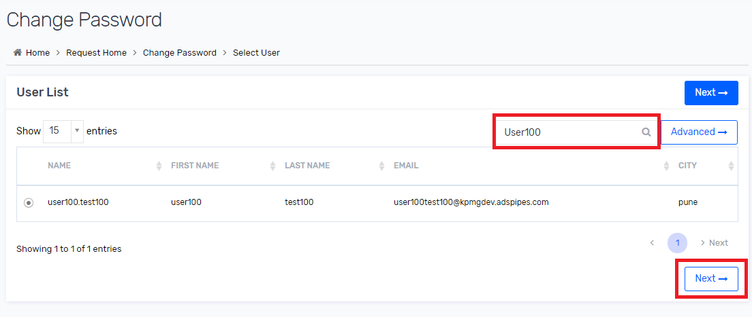

1. Helpdesk selects Active Directory endpoint in the cart and selects Checkout.

Figure 199: Unlock User Account- 3

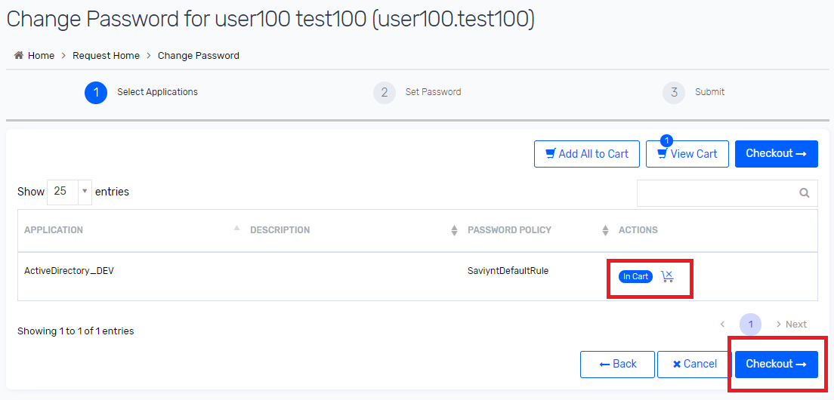

1. Helpdesk selects user and Select unlock button and click on Next.

Figure 200: Unlock User Account- 4

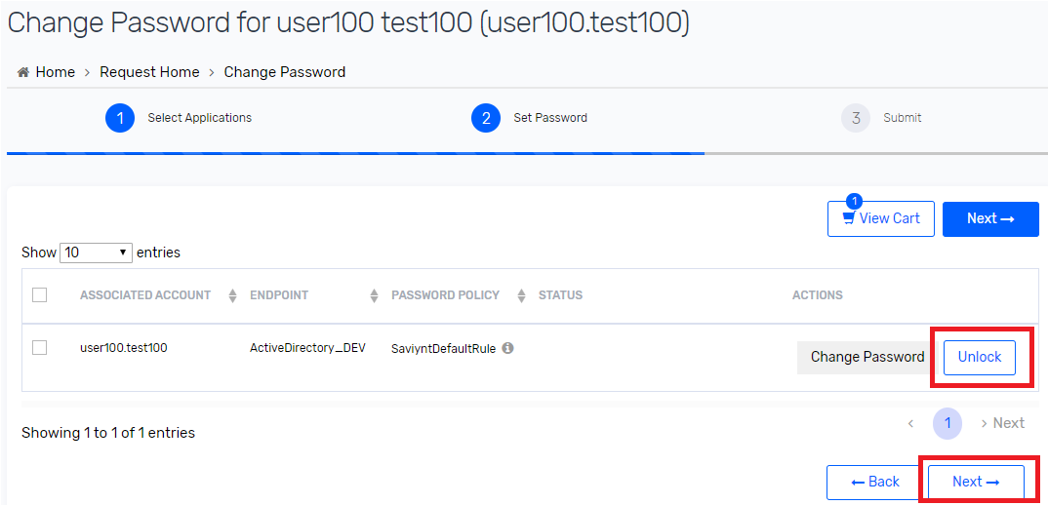

1. Request will successfully be submitted, and the user account will be unlocked on Active Directory.

Figure 201: Unlock User Account - 5

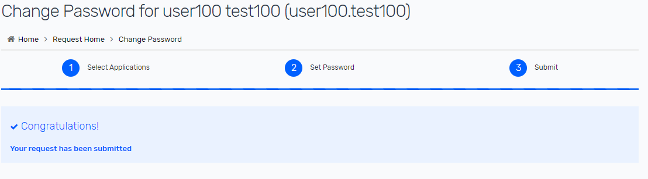

## Connections

Connections are used in Saviynt to connect Trusted and Target source to perform CRUD operation. This section is required to update if any updates is required in CRUD operation or User import operation.

Connection parameters are different for different connection types. Connections are the subset of the connection type that means one connection type may have one or more connections.

To Update Connection JSON perform following steps.

1. Navigate to 🡪 Admin 🡪 Identity Repository 🡪 Click on 🡪 Connections

Figure 202 : Connections

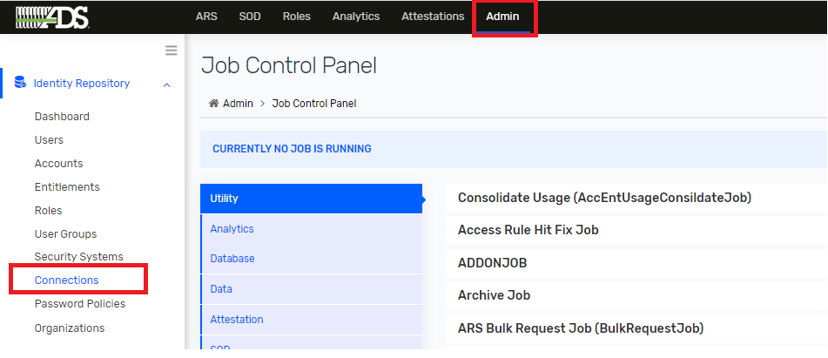

1. Search for connection that needs to update and click on it to view details. After update JSON as per business needs click on 🡪 update button.

Figure 203 : Connection List

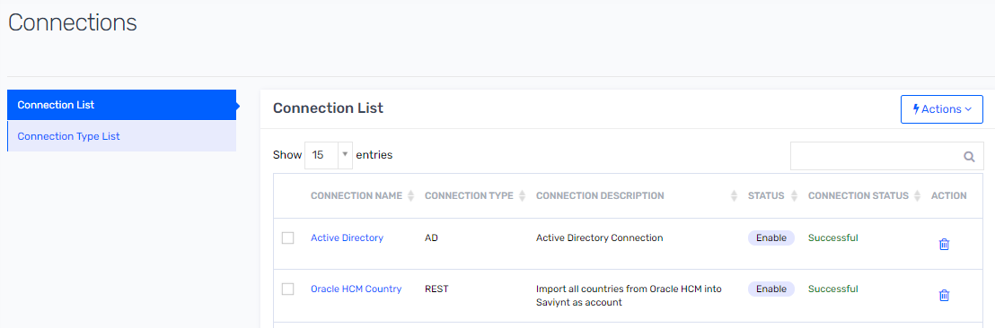

**Note** : If JSON is updated with incorrect then Provisioning and Reconciliation functionality will might affect.

### Oracle HCM

Saviynt’s REST connector enables you to create an integration with Oracle HCM application.

To update Oracle HCM connection section kindly refer 7.3.1 Oracle HCM Atom Feed Configuration section in Configuration Guide and refer Saviynt Oracle HCM guide for more details

Link: [<https://saviynt.freshdesk.com/support/solutions/articles/43000485541-oracle-erp-cloud-connector-guide#OracleERPCloudConnectorGuide-OverviewandArchitecture>]

**Note:** For trusted reconciliation from Oracle HCM into Saviynt, a custom Oracle HCM data filter utility jar file is deployed on Saviynt Security Manager cloud for data transformation.

### Active Directory

Saviynt’s Active Directory connector enables you to create an integration with Active Directory and perform operations on a single domain level only.

Active Directory stores information about objects on the network and makes this information easy for administrators and users to find and use. An object is a single element, such as a user, group, application or device, such as a printer. Active Directory stores objects in a hierarchical structure.

To update Active Directory connection section kindly refer 7.1.1 Active Directory section in Configuration Guide and refer Saviynt Active Directory Connector guide for more details

Link: [<https://saviynt.freshdesk.com/support/solutions/articles/43000578581-active-directory-ad-connector-guide>]

### Mailbox

Saviynt’s REST connector enables you to create an integration with Exchange Mailbox.

To update Mailbox connection section kindly refer 7.2.1 Mailbox section in Configuration section in Configuration Guide and refer Saviynt Oracle HCM guide for more details

Link: [<https://saviynt.freshdesk.com/support/solutions/articles/43000480321-microsoft-exchange-connector-guide>]

## Email Template

This section provides you information about an updating email templates in Saviynt Security Manager(SSM).These templates can be used for notifying beneficiary, managers, or administrators about the status of requests or tasks. Email templates are configured using the email parameters available in SSM.

To edit an existing email template, edit it from the Email Template List by performing the following steps:

1. Select Admin 🡪 Configurations 🡪 Email Templates.

Figure 204 : Email Template

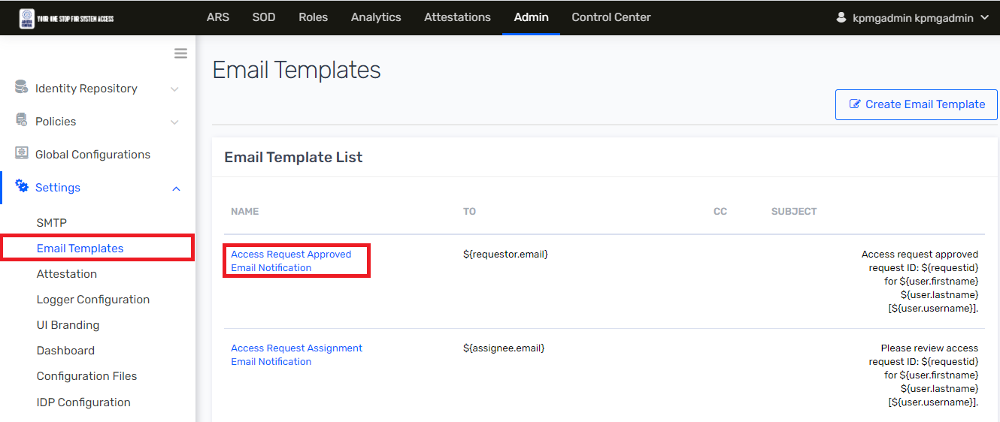

1. Click the email template to be edited from the Email Template List. Select the template wanted to edit. And click on it.
2. Click Edit, available on the Template Detail page

Figure 205 : Template Detail

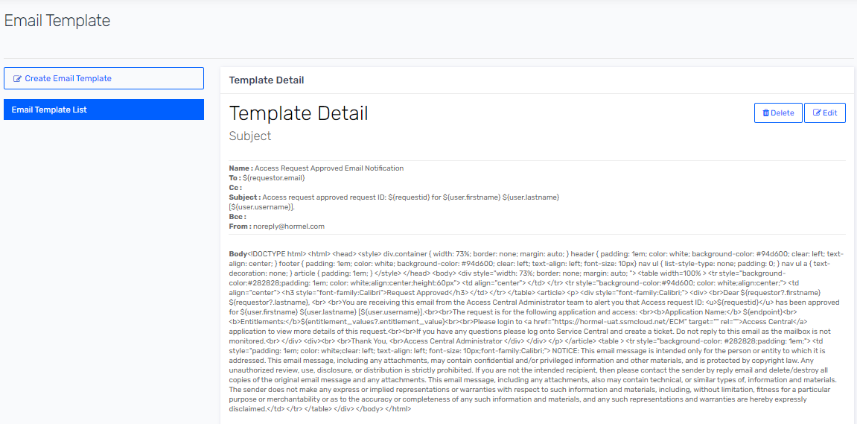

1. Edit template with suitable values, by selecting additional email parameters, you can also edit the body of the email template and click Update. You can view an updated template from the Email Template List.

# Saviynt UI

This section describes different functionalities of Saviynt that we can navigate through with administrator privileges. This is helpful for administrators to easily understand each functionality and use them for debugging as well as development or enhancement purposes.

## Analytics

Analytics enable us to search the user information based on the numerous aspects. These searches can be used to determine the user status, employee type, location, user activity, request Information etc. Search results can be saved for reuse or saved as reports. In some cases, we can save the results as interesting populations of identities. When we save a search as a report, we can schedule the search on continuous basis for monitoring and tracking purposes.

Following are list of analytics reports:

1. Hormel Active Directory Change Password Task Report
2. Hormel Active Directory Failure Task
3. Hormel Deprovision AD Group After Termination
4. Hormel Mailbox Failure Task
5. Hormel Name Mismatch Report
6. Hormel Reconciliation Failure
7. Hormel Remove AD Account After 90 Days
8. Hormel SAV Role User Report
9. Hormel Users Active Directory Group Removed in 24 Hours
10. Hormel Users Deleted in the Next 24 hours
11. Hormel Users Deleted Today
12. Hormel Users with Improper Email Address

### View and Execute Analytic Reports

The Analytics module of Saviynt Security Manager (SSM) allows you to create reports using inbuilt queries. You can also create custom reports using SQL and Elasticsearch queries based on the data stored and accessible from the SSM database and the Elasticsearch server. In addition, you can use logs stored in these locations to generate reports.

1. Login into SSM as administrator
2. To search specific analytic report, navigate to Analytics and click on it.

Figure 206: Analytic



1. Search for Analytics Configuration List on toggle sidebar and click on it.

Figure 207: Analytics Configuration List

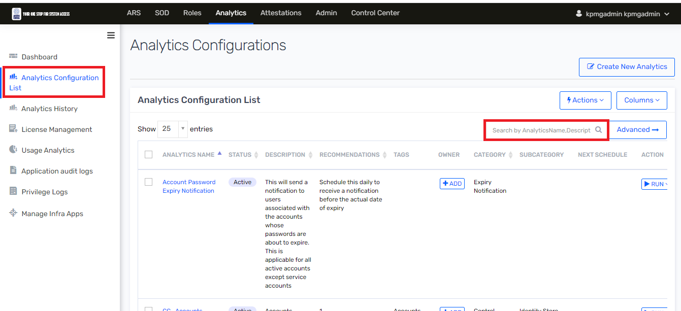

1. Search analytics using search text box, specify analytics name/Description such as ‘Hormel Active Directory Change Password Task Report‘ to search.

Figure 208: Advanced Analytics Page



1. To execute analytic report, click on RUN button and select Run Now option.

Figure 209 : Analytic Configuration List

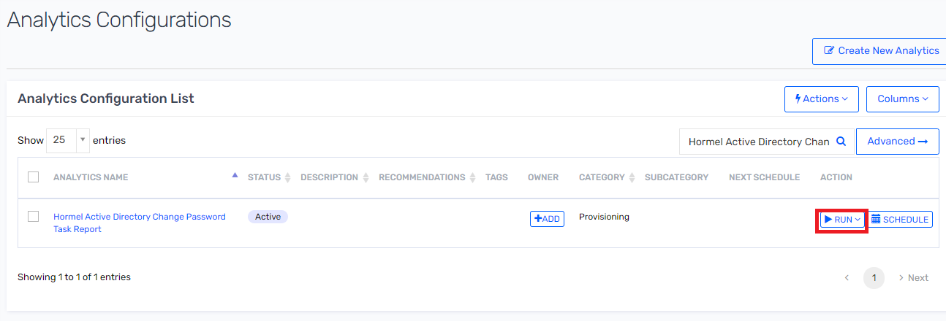

1. To view result of ‘Hormel Active Directory Change Password Task Report’ report. Navigate to Analytic History and click on it.

Figure 210 : Analytic History



1. Search for Identity Warehouse tab and search for ‘Hormel Active Directory Change Password Task Report’ in search box. And then click on ‘Hormel Active Directory Change Password Task Report’ to view result.

Figure 211 : Analytic Result

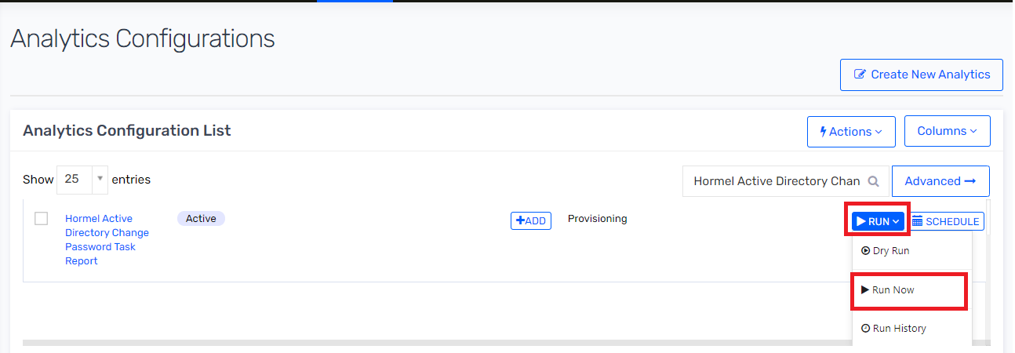

1. Following is Analytic result

Figure 212 : Analytic Result

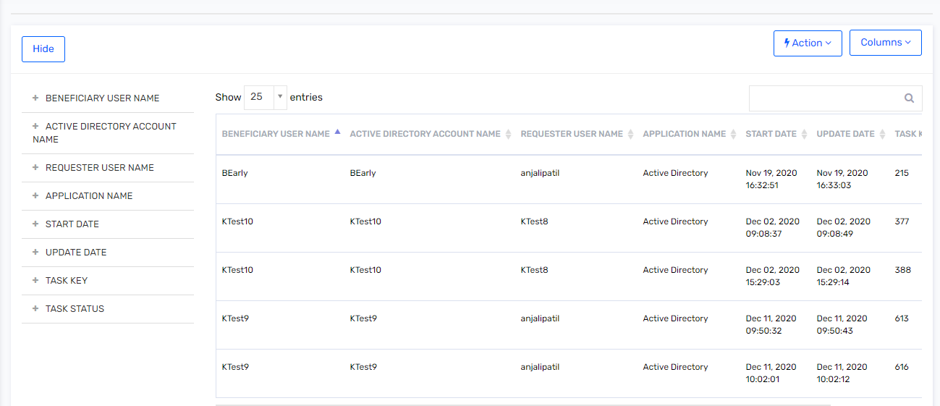

### User Activity in Saviynt

To view user activity in Saviynt. IAM administrator must execute following analytic on Saviynt.

1. Login into SSM as administrator
2. To search specific analytic report, navigate to Analytics and click on it.

Figure 213: Analytics



1. Search for Analytics Configuration List on toggle sidebar and click on it.

Figure 214: Analytics Configuration List



1. Search analytics using search text box, specify analytics name/Description such as ‘Hormel Active Directory Change Password Task Report ‘ to search.

Figure 215: Advanced Analytics Page



1. Click on Run Now to run the analytics.

Figure 216: Analytic Configuration List



1. To view result of ‘Hormel Active Directory Change Password Task Report’ report. Navigate to Analytic History and click on it. And then click on Audit and Monitoring tab.

Figure 217: Analytic History

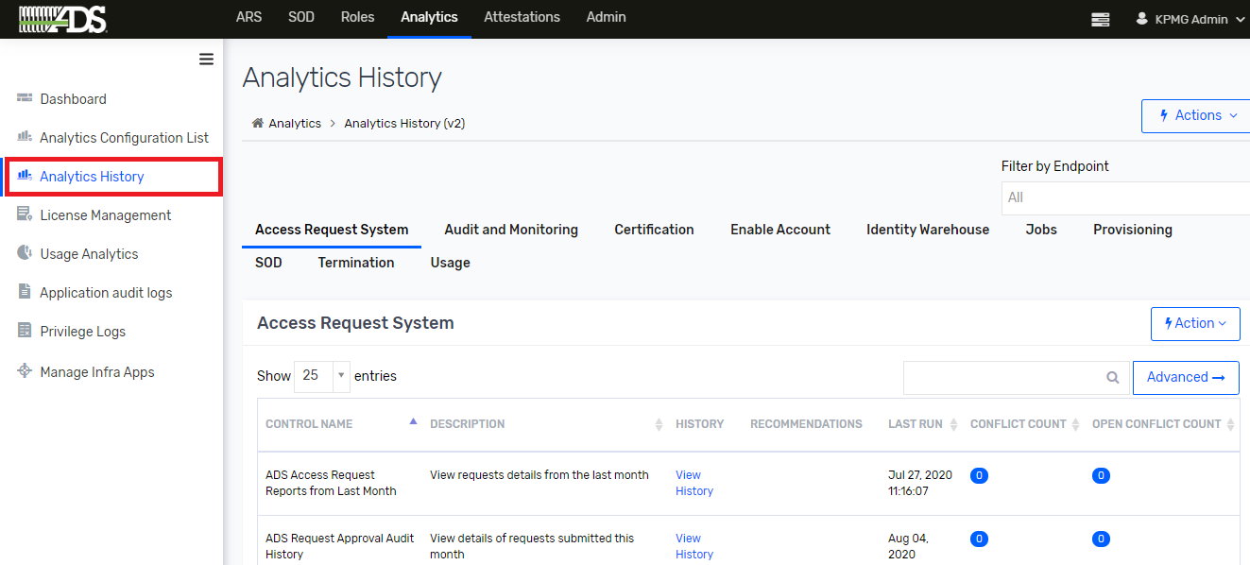

1. Click on “Hormel Active Directory Change Password Task Report” to view result.
2. User Activity in Saviynt will be displayed.

Figure 218 : Anaytic Result

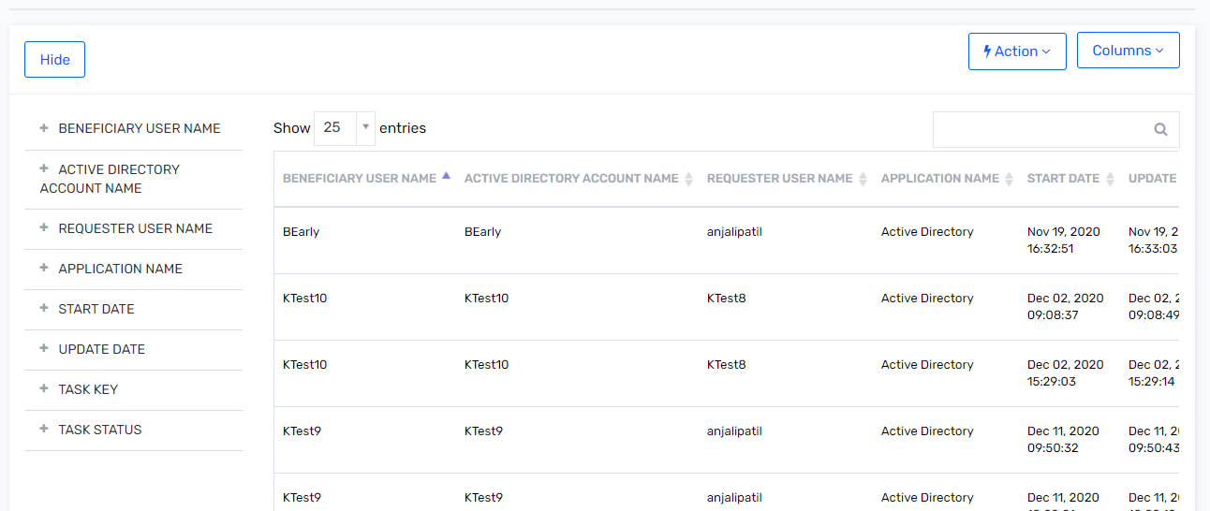

### Schedule Analytics

To schedule analytics periodically, IAM administrator must perform following steps.

1. Login into SSM as administrator
2. To search specific analytics report, navigate to Analytics and click on it.

Figure 219: Analytics



1. Search for Analytics Configuration List on toggle sidebar and click on it.

Figure 220: Analytics Configuration List



1. Search for analytic report which you wanted to schedule and click on Schedule button.

Figure 221 : Schedule Analytic

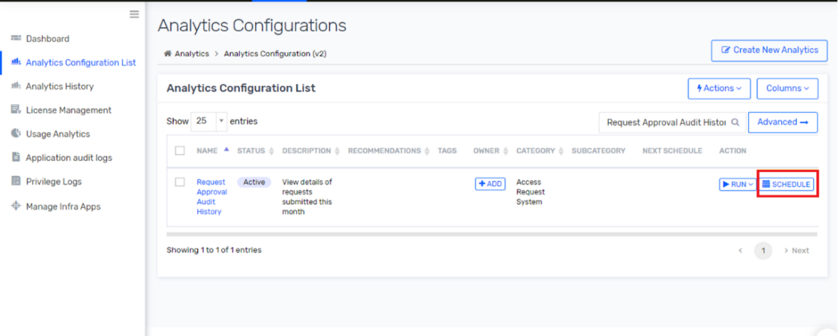

1. Schedule time internal of Job to be executed and then click on submit.

Figure 222 : Schedule the Job

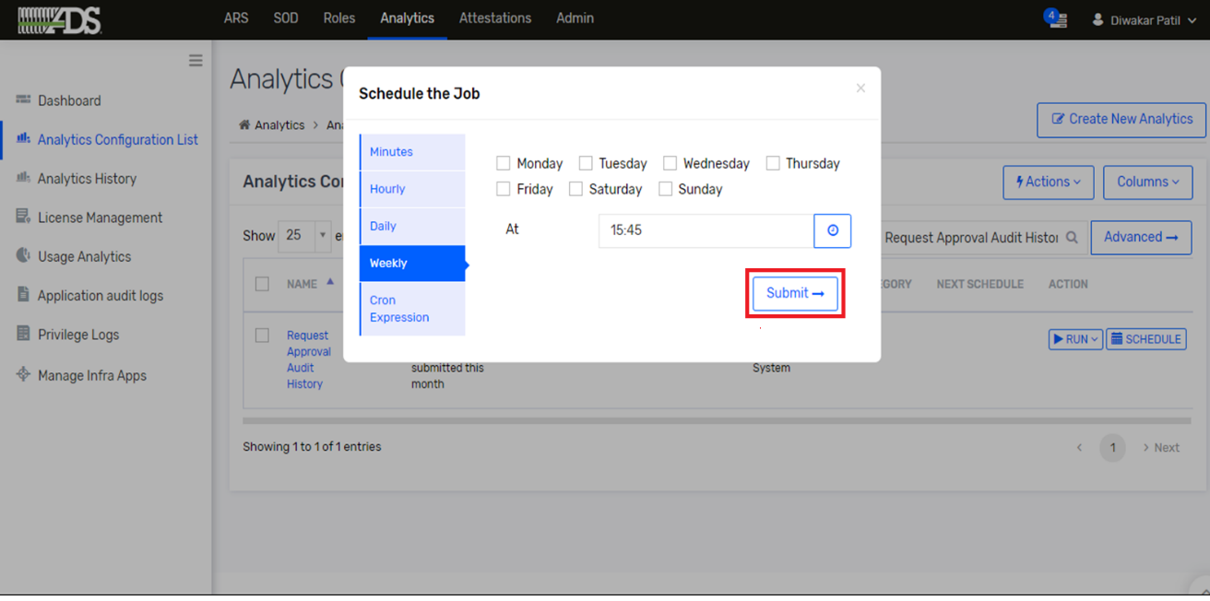

## Identity Correlation

Users already available in SSM can be mapped with the accounts being imported to SSM using the User Account Correlation Rule. Each application has separate configuration (User correlation Rule) for user/identity correlation in Saviynt.

To view exiting application User correlation rule definition. IAM administrator must perform following steps.

1. Navigate to 🡪 Admin 🡪 Identity Repository 🡪 Security Systems 🡪 Endpoints

Figure 223 : Endpoint

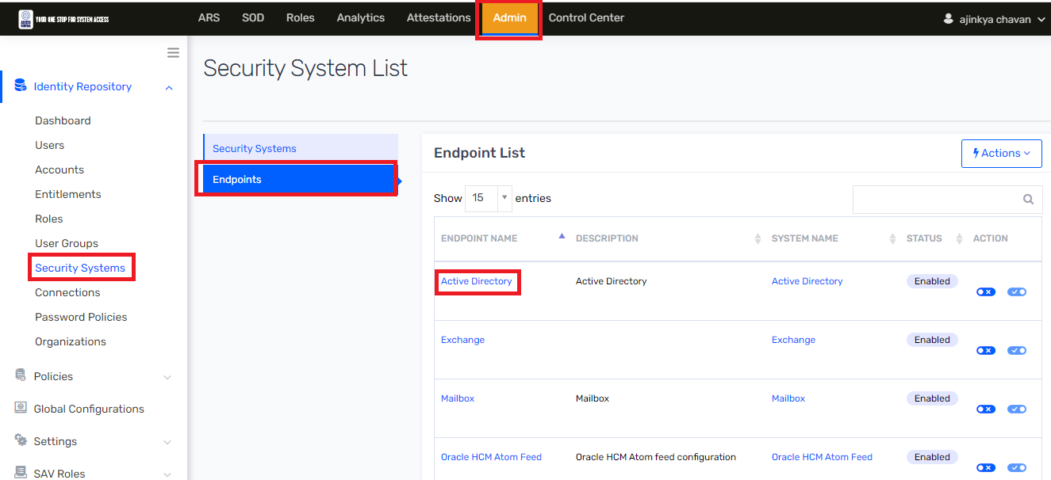

1. Click on Endpoints (Active Directory) and select Endpoints Details.

Figure 224 : Endpoint Details

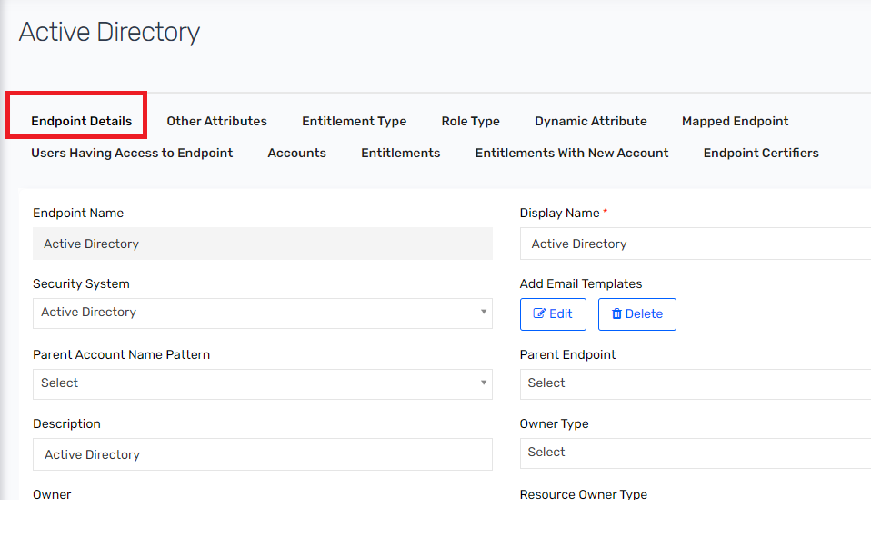

1. Search for User Account Correlation field and Click on “Edit” User Account Correlation Rule

Figure 225 : Correlation Rule

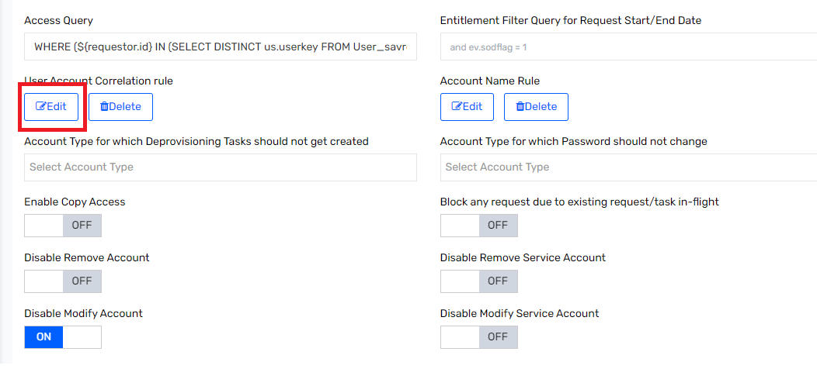

1. Select User Property and Account Property as following

For Active Directory: user 🡪 username = Account 🡪 name

Figure 226 : Rules

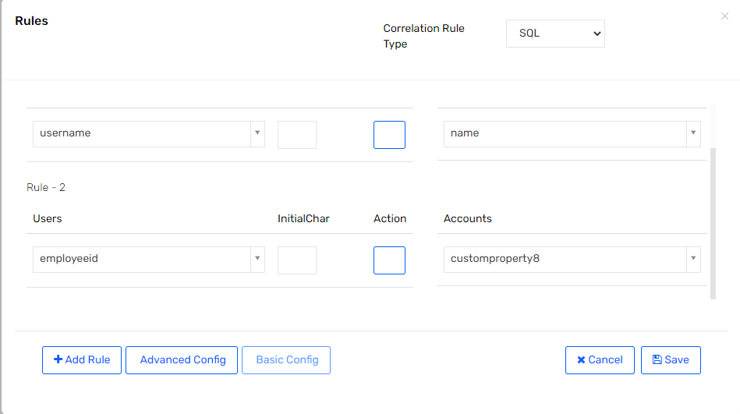

For other Application (Endpoints). Refer below table.

Table 28 : User Correlation Rule for Other Application

|  |  |  |
| --- | --- | --- |
| Application Name (Endpoint Name) | User Property | Account Property |
| Mailbox | Username | name |

## Workflows

In SSM workflows contains a sequence of steps or activities and each step can perform one or more actions. Moving from one step to another is called a transition and transitions can be conditional based on the results of prior actions.

Workflow customization and construction usually involves a combination of GUI and XML. Some customization activities can be managed through the graphical process editor included in the product.

To access the workflow process editor page from the navigation menu bar.

1. Go to Admin 🡪 Click on Workflow List.

Figure 227: Workflow List

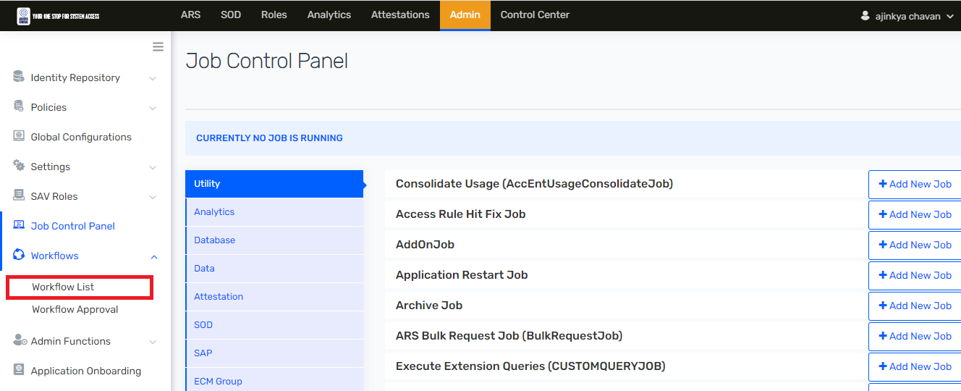

The workflow process editor user interface makes it easy to create a basic workflow. The following workflow components and their connection points are available to create one or more workflows using the JBPM Workflow Editor in the SSM application. The functionality of each of these is listed in the table below.

Table 29: Workflow Component Details

|  |  |
| --- | --- |
| Workflow Component | Usage |
| Start | Use this component to start the workflow. This defines the start of the workflow, just like any other flow diagram. Every workflow must start with this component. |
| Action Event | Use this component when you wish to execute any java class and method upon satisfying certain conditions. For example, to call a class 'notifyApp.class' with method 'notify', you need to specify notifyApp in 'Enter Java Class Name and in the Method Name specify 'notify'.  Ensure that the class and the method you want to call, are readily available in the Jar file. Copy the JAR file at the location: /tomcat/webapps/ECM/WEB-INF/lib. |
| TASK: Access Approval | Assign one or any of the list or all entitlement owners to approve access for certain entitlements. |
| TASK: Access Approval Required | This could be used if any approval step is mandatory. |
| TASK: Access Approval Not Required | This could be used if there is a non-mandatory approval step. |
| TASK: Managers Manager Approval | Navigate the workflow to manager’s manager in case manager is unavailable for more than set time limit. This is useful in escalation use cases. |
| TASK: Manager Approval | This predefined block will navigate the request to the manager. |
| TASK: Custom Assignment | This block provides you the flexibility to navigate the workflow based on any user property, or account property, or entitlement value, or even dynamic attribute value, and assign the request to any user group, or even any user etc. This comes in handy at a lot of situations like value-based user group selection scenarios. |
| TASK: Resource Owner Approval | This is a predefined task for navigating the request approval process to resource owners for approval. |
| TASK: Owners Manager Approval | Navigate the workflow to approver’s manager in case approver is unavailable for more than set time limit. This is useful in escalation use cases. As of now, this block can be used for escalating Access Approval and Resource Owner Approval. |
| CONDITION : If Else | Like any other programming language, this is a conditional block to decide if you plan to select route A or B based on certain events or values. The left node is the ‘True’ outlet, and the right node is ‘False’. |
| Activity: Rejected Access | When any approver decides to reject the request, workflow should be navigated to reject access block for relevant actions like sending rejection email to the requester. |
| Activity: Grant Access | When any approver decides to approve the request, workflow should be navigated to the next stage/condition, if any and ultimately shall perform final actions through grant access block. You can choose to send approval email through this. This block will also create a provisioning task in pending tasks list to implement new access or modify existing access or may be remove/disable access based on the approved request by all the required approvers. |
| Escalation | This block is used to decide on when to trigger escalation event. |
| End | Like any other flow chart, this indicates the end of the workflow. Every workflow must end with this component. |

Figure 228: Workflow Designer

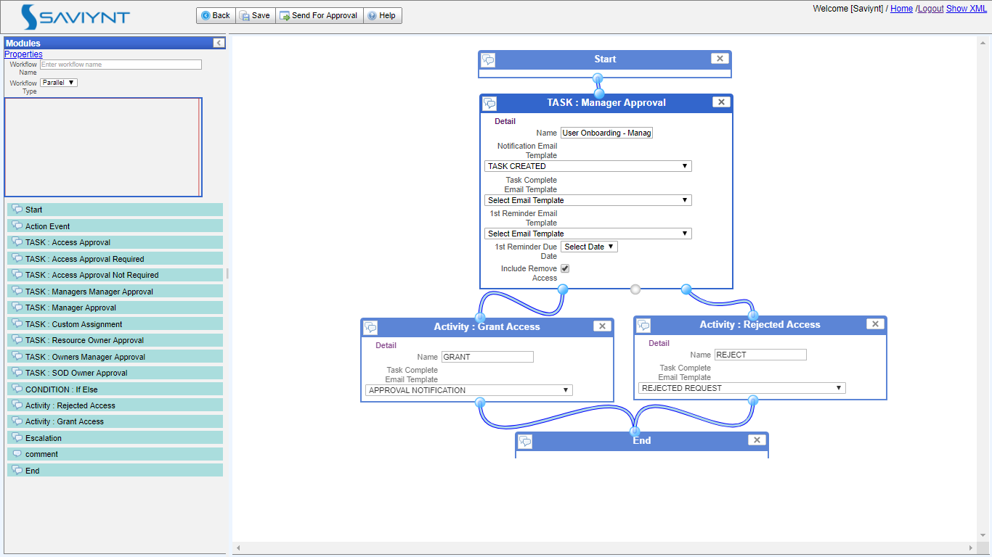

## Global Configuration

### SMTP Configuration

SMTP stands for Simple Mail Transfer Protocol, a protocol for sending e-mail messages between servers. Most e-mail systems that send mail over the Internet use SMTP to send messages from one server to another; the messages can then be retrieved with an e-mail client using either POP or IMAP.

1. In SSM, to access the SMTP configuration then navigation to Admin 🡪 Configuration🡪 SMTP.

Figure 229 : SMTP

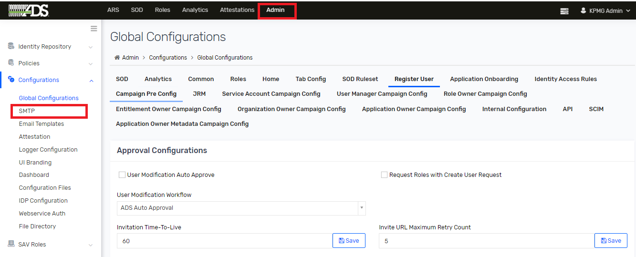

1. Below is SMTP mail configuration, which is required to be updated in SSM, if any changes are updated in SMTP server.

Figure 230: SMTP Configuration

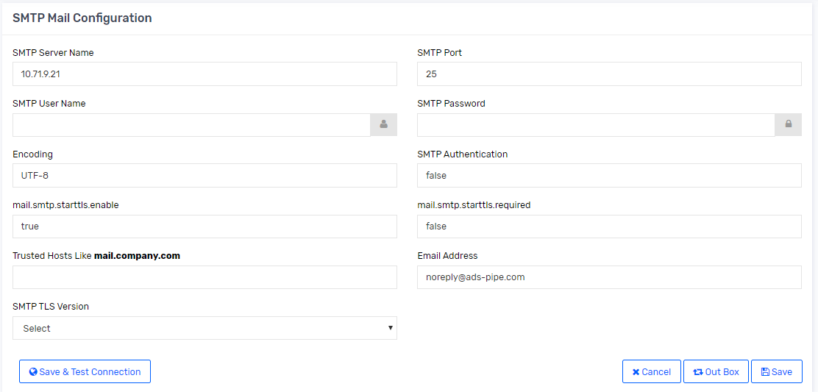

1. Following are the parameters need to be specified for SMTP setup

Table 30 : SMTP Component

|  |  |
| --- | --- |
| Parameter | Description |
| SMTP Server Name | Specify the SMTP Server name as per the Email client mail service you are using. |
| SMTP Port | Specify the SMTP port number as per the SMTP server selected. The recommended port to configure the SMTP server is 587. |
| SMTP User Name | Specify the username using which you want to send the email to users. |
| SMTP Password | Specify the password of the username using which you want to send the email to users. |
| Encoding | Specify the Encoding as SMTP server. |
| SMTP Authentication | Enter the SMTP authentication as True. |
| mail.smtp.starttls.enable | To use TLS (Transport Layer Security) secured email service, set this to True. |
| mail.smtp.starttls.required | Specify the value required as True. |
| TrustedHosts like **mail.company.com** | Specify the SMTP Server name for the client mail service you are using. |
| Email Address | Specify the username using which you want to send the email to users. |

1. Click Save & Test Connection for saving and testing the connection.
2. Ensure that you schedule the EmailHistoryJob, which is used to send the emails from SSM to users. Refer section 5.3 to schedule job.

#### PROD SMTP Configuration

To view STMP server details in PROD environments IAM administrator must follow following steps.

1. Navigate to 🡪 Admin🡪 Configurations then 🡪 SMTP

Figure 231: PROD SMTP Configuration

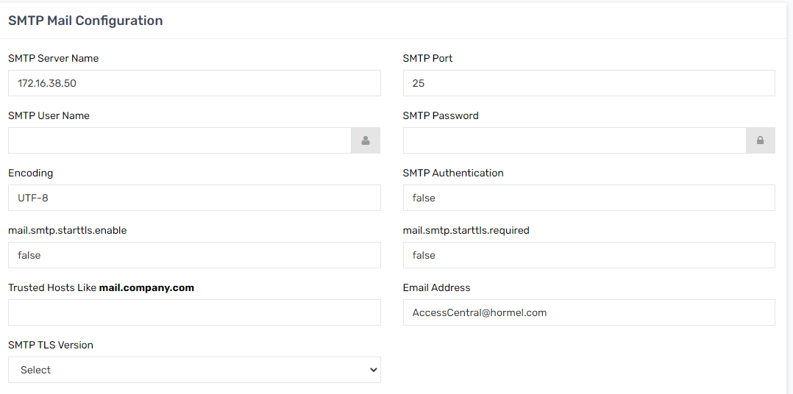

#### DEV/UAT SMTP Configuration

To view STMP server details in Dev environments, IAM administrator must follow following steps.

1. Navigate to 🡪 Admin🡪 Configurations 🡪 SMTP

Figure 232: SMTP Configuration

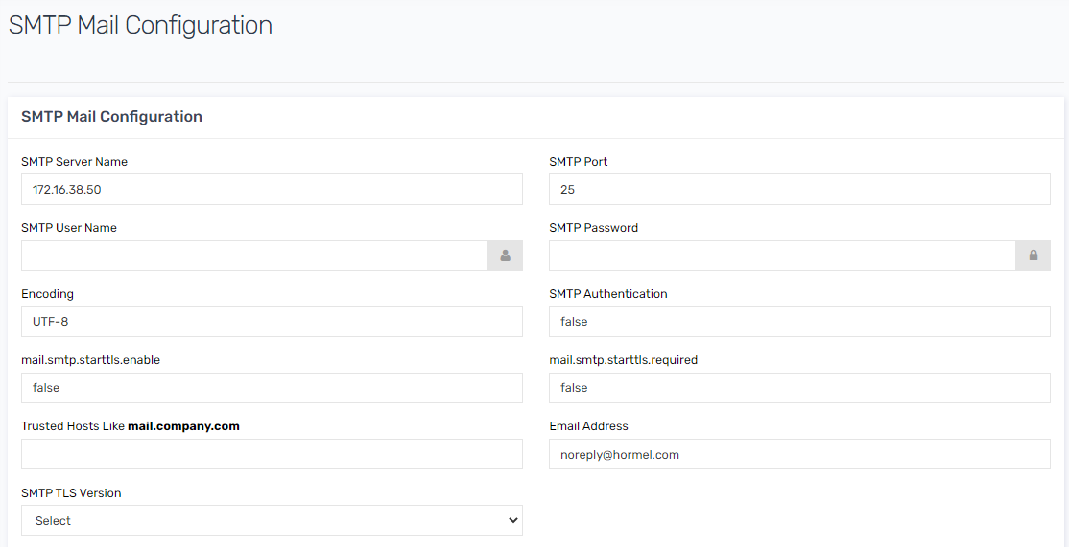

## Tasks

The tasks on ARS page shows detail about pending and completed task related events for all JML use cases for US Employees and Other Users.

IAM administrators can track provisioning status for each task and check the status of completion and failure in detail for triggered task or raised requests.

### Pending Task

This section explains the options available to access pending tasks in Saviynt Security Manager (SSM).

1. To view pending task, navigate to ARS and click on Tasks. Select Pending task.

Figure 233 : Pending Task



### Managing Pending Tasks

This section provides you information about the pending tasks and actions performed by task owners on those pending tasks manually.

To manage pending tasks from ARS, perform the following steps:

1. Navigate to ARS.
2. Select Tasks 🡪 Pending Tasks. Pending Tasks page appears with the list of pending tasks and action options.

Figure 234 : Pending Tasks



1. To search for one or more tasks using the Search icon or Advanced Search option. The List of Pending Tasks table is displayed based on your search parameters with the following default columns.

Figure 235 : Pending Task Column

|  |  |
| --- | --- |
| Column | Description |
| Actions | The following options are individually available for each of the listed pending tasks from the Actions column:   * + View   + Claim or Unclaim   + Complete   + Discontinue   + Comments |
| Task ID | The task ID created and assigned to a task by the application. |
| Task Type | Describes the type of tasks. The following task types are available:   * + Add Access: Task submitted for adding access.   + Remove Access: Task submitted for removal of access.   + New Account: Task submitted for the creation of a new account.   + Change Password: Task submitted for change of password.   + Update Account: Task submitted for updating an account.   + Claim Account: The task for the owner claiming an account for approving the request submitted by the user.   + Update User: Task submitted for updating the user attributes.   + Unlock Account: Task submitted to unlock an account.   + Lock Account: Task created, when request to lock an account is approved   + Enable Account: Task submitted to enable an account.   + Disable Account: Task submitted to disable an account.   + Update Access End Date: Task submitted to update the access end date. |
| Parent Task | The parent task id, if the task is created from another parent task along with other appropriate details. |
| User | The user name requested for access along with other details about the user. |
| Account | The account name for which the request is raised. |
| Security System | The security system for which the request is raised. |
| Endpoint | The endpoint (target system) name on which the provision must be performed. |
| Entitlement | The requested entitlements and attributes detail for provisioning. |
| Request ID | The request identification number associated with the task. |
| Owner | The associated owner details. The owner's name is displayed in Owner Display Name(Owner Username) format. |
| Creation Date | The task creation date. |
| Update User | The last updated details of the user such as modifications in the user name or date. |
| Provisioning Comments | The provisioning comments provided if any, during the request approval stage. This column also displays the successResponse and unsucessResponse.  For example, if the tasks are triggered by REST provisioning, then the system displays the successReponse and unsuccessResponse of the provisioning tasks. This helps to troubleshoot errors, if any. |
| Provisioning Metadata | The provisioning metadata include the user attributes available on the target system, required to provision new requests. This metadata is fetched from the target system and is displayed in the pending tasks table. |
| Requested By | The name of the requester. |

### Viewing Tasks Details

The task detail page provides more detailed information about the pending task.

To view the details of the task, perform the following steps:

1. Select ARS 🡪 Tasks 🡪 Pending Tasks. The list of pending tasks is displayed.

Table 31 : View Task Details



1. Click Action in line with the pending task, under Actions column.

Figure 236 : View Task Details

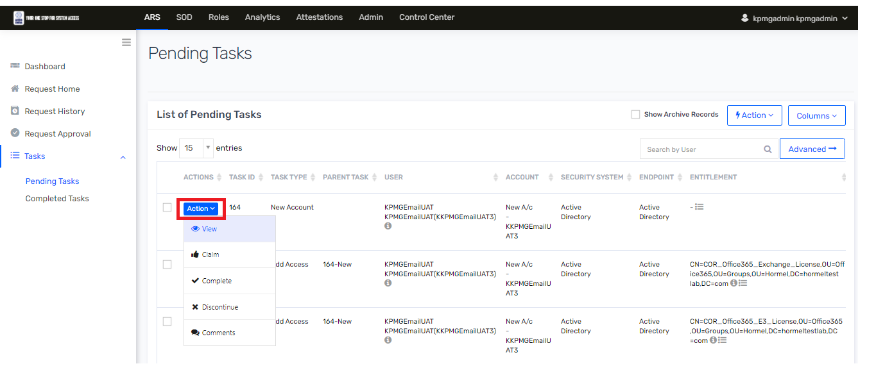

1. Select View option to view the pending task details. The detailed view of the task is shown as a pop-up window. The pop-up displays different tabs such as Task Detail, Request Detail, Approval History, Complete Task, or User Details.

Figure 237 : View

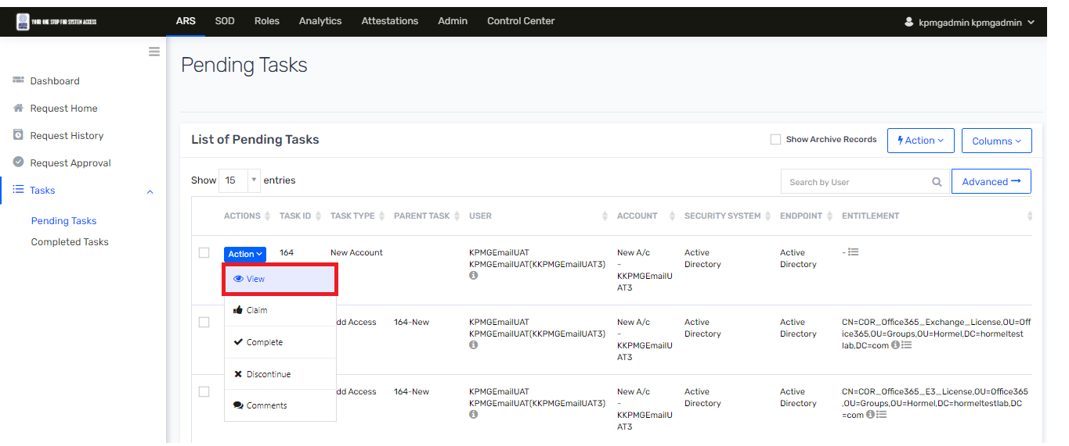

1. When you click the View option, the following pop-up appears. The subpages in this window are read-only (not editable).

Figure 238 : Detail View of Task

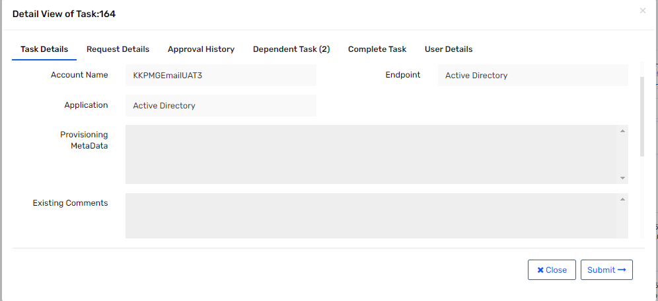

1. The Task Detail view of a pending task also displays the following fields:

Table 32 : Pending Task Details

|  |  |
| --- | --- |
| Task Detail Tabs | Description |
| Task Type | Describes the task type. For example, New Account or Add Access. |
| Username | Username of the account |
| Account | Account name. |
| Endpoint | Endpoint name |
| Application | The name of the security system. |
| Provisioning Metadata | The metadata related to the provisioning of the task. |
| Existing Comments | The existing comments in the task. |
| Provisioning Comments | The comments related to the provisioning of the task. |
| No | of Tries for Provisioning: The number of times the provisioning task has been executed until the task is provisioned. |
| Comments | The field where you can enter any additional comments. |

**Note:** In the List of Pending Tasks, suppose there is an exception in provisioning, you can view the error details by hovering the mouse over the icon under the Provisioning Comments column.

Figure 239 : Provisioning Comments

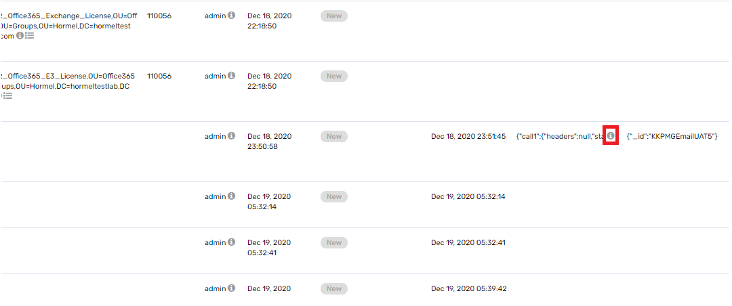

### Discontinuing Selected Pending Tasks

To discontinue the selected pending tasks, perform the following steps:

1. Navigate to ARS 🡪 Tasks 🡪 Pending Tasks 🡪 List of Pending Tasks. Follow section 6.5.3 till point 3.
2. Click the Actions arrow and select Discontinue Selected Tasks option. The Are You Sure? dialog box appears.

Figure 240 : Discontinued

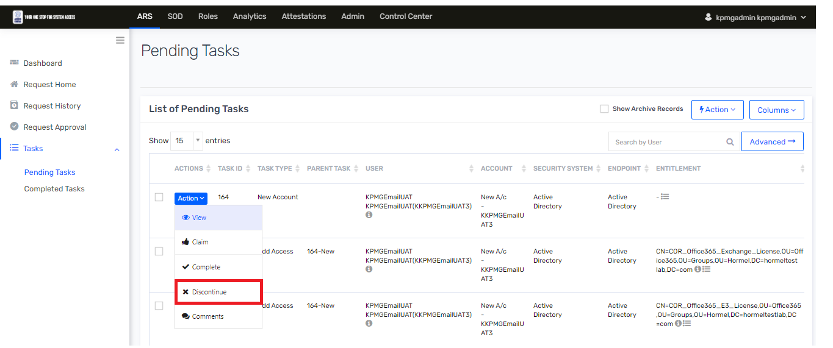

1. Select Yes to discontinue selected pending tasks. And task will get discontinued.

Figure 241 : Confirm Discontinue

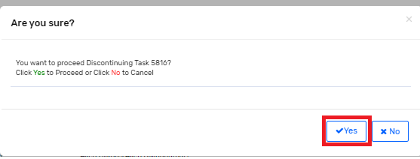

Note: Tasks should not be discontinued unless there is a business reason for it and is approved by IAM team.

### Completed Tasks

The tasks that have completed provisioning or manually marked as completed (without provisioning) get listed under the Completed Tasks submenu.

1. This section explains how you can manage the completed tasks from **ARS 🡪 Tasks 🡪 Completed Tasks**.

Figure 242 : Completed Tasks

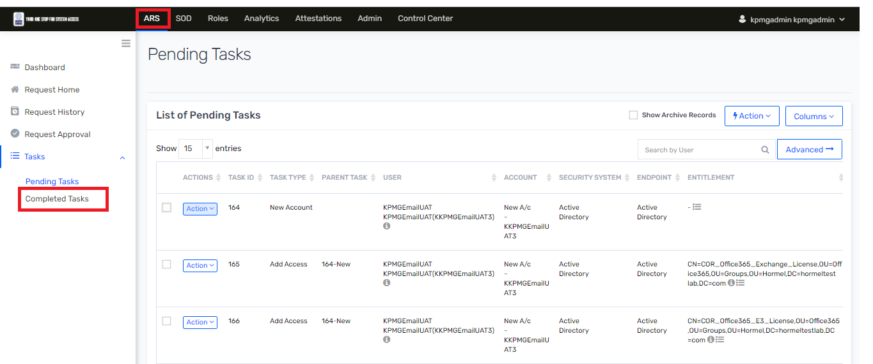

1. Click Action from the Action column in line with the task and select one of the following options to view details.

View - Displays task details, request details, approval history, dependent tasks, and user details displayed in different tabs.

Comments - Displays a pop-up window for adding comments for the completed task after provisioning the request

Figure 243 : View Task details



# Saviynt Security Manager Troubleshooting

This section describes troubleshooting steps and guidelines.

## Logging

Logging is very important for troubleshooting issues on day to day operations. There are various components and logging mechanism differs depends on the components.

Using log files, admins can keep track of each activity that happens in an application on daily basis. So that if any issue or error occurs, these log files can be checked to determine when, how, and what error has occurred which will save lot of time for resolving any issue. There can be different log levels set for gathering date:

* **Debug**: used to store debug logs. This will provide detailed logs for debugging purpose.
* **Error**: used to store error logs only. This will provide error trace if any error occurs.
* **Warn**: used for storing both errors and warning in log files.

logs are used for troubleshooting any issue is occurred during processing task or operation. Following are some operation where IAM admin team must investigate log files.

* Task failed in Pending Task
* Task failed with error status in Completed Task.
* Scheduling job is failed.
* Reconciliation job is failed.

### Application Log Details

Application logs are used for logging all the activities that happens in SSM servers for processing daily IDM related activities. This is helpful to track any issues that may occur in the environment.

The “Application Logs” feature in SSM allows you to view and download application logs with various log options and number of lines.

Perform the steps below to view and download Application Logs:

1. To view Application logs IAM administrator must login into SSM and navigate to 🡪 Admin tab.
2. Click Admin 🡪 Admin Functions 🡪 Application Logs.

Figure 244 : Application Logs

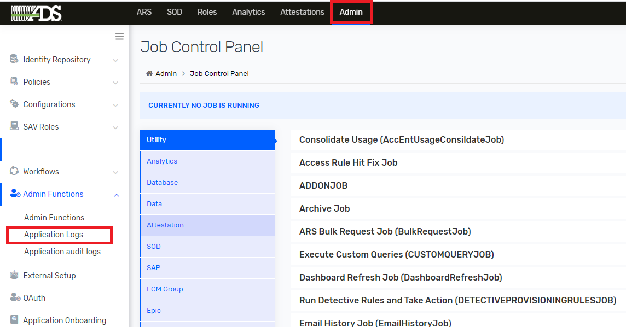

1. Click Log File and choose a type of log. Type the number of lines to be displayed in the Number of Lines. Click Get Logs to display the logs or to refresh the results.

Example: To filter and display only the last 100 lines, specify '100' in Number of Lines.

Figure 245 : Application Logs

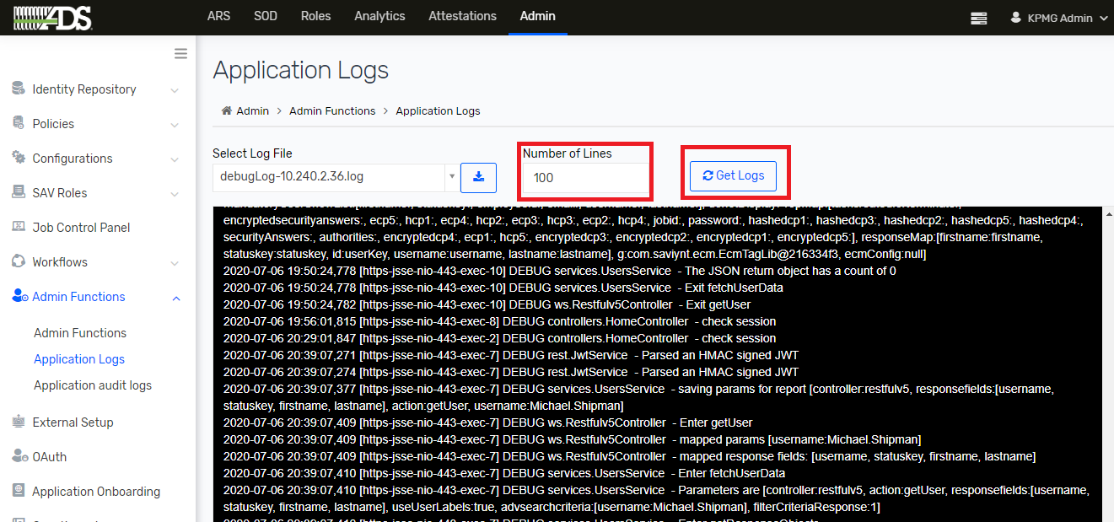

1. Click Download to download the displayed logs. Choose Download Full File or Download Selected Line as per your requirement from the dialog box.

The following screenshot illustrates the steps provided in this procedure:

Figure 246 : Download Log File

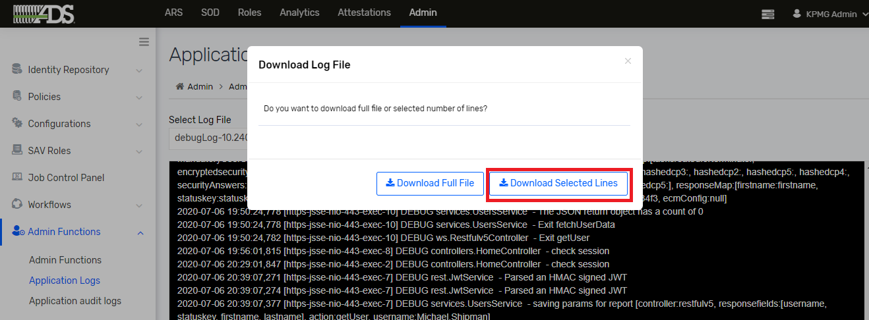

### Application Audit Log Details

Audit logs enable you to track who changed what and when on the SSM interface. All actions performed by a user such as create, update, delete, and show are recorded for each Object Type (referred as 'type of access' in DB) and Object Name (referred as 'ObjectKey' in DB) in the userlogin_access table.

#### Viewing the Audit Logs

All actions performed by SSM user are recorded which can be viewed and downloaded using Application Audit Log page. SSM supports the object-based entries with the action taken for that object.

Log entries include OBJECT-TYPE, OBJECT NAME, ACTION, ACCESS BY, ACCESS TIME, IP ADDRESS, MESSAGE, and DATA. Default list of logs is displayed for the changes made by logged-in user.

To filter the audit logs using the following Object Types :

* Role
* Organization
* SAV Role
* Analytics
* Email Template
* Entitlement Value
* Security System
* Endpoint
* Global Configurations
* UI Branding
* Entitlements
* User Groups
* Accounts
* Connections

For more information about each Object Type, click the 🡪 Icon and Expanding each cell by clicking the pop-up window to display the complete content until you dismiss it.

#### Filter the Logs

To filter the logs entries, perform the following steps:

1. Go to ADMIN > Admin Function > Application Audit Logs.
2. Select the filter criteria based on your requirements.
3. Object Type: Select the name of the object or module from the dropdown.
4. Object Name: Specify the value or name of the selected object type.
5. Action: Select any of the following action performed for the selected object type. For example:
   * Create
   * Update
   * Delete
   * Show
   * Analytics Action (V2) (You can configure more actions from the userlogin_access table.)
6. **Access By**: Select the username who performed the action for the selected object.
7. **Time Range**: Select the date range to filter the log using **From** and **To** options
8. Click **Apply**. The results are displayed the **Show Entries** table in the following columns and the default sorting is in the ascending order of the date and time of the action.
9. OBJECT TYPE: Displays the selected object type such as Global Configurations, Security System.
10. OBJECT NAME: Displays the object name that has been actioned.
11. ACTION: Displays the action performed to the object such as Create, Update, and Delete.
12. IP ADDRESS: Displays the IP address of a system that is used to perform the operation.
13. ATTRIBUTE: Displays the attribute for which the action is performed.
14. OLD VALUE: Displays the old value of an attribute. In case of create action, this column does not display any value.
15. The object change is captured in the Old Value and New Value column after updating Email Templates, Global Configurations, Security System, and Endpoint objects.
16. NEW VALUE: Displays the updated value or a new value of an attribute. In case of Delete action, this column does not display any value.
17. DATA (Optional): Displays the old value of attributes when any update is done. In case of create action, this column does not display any value.

Figure 247 : Application Audit Log Page

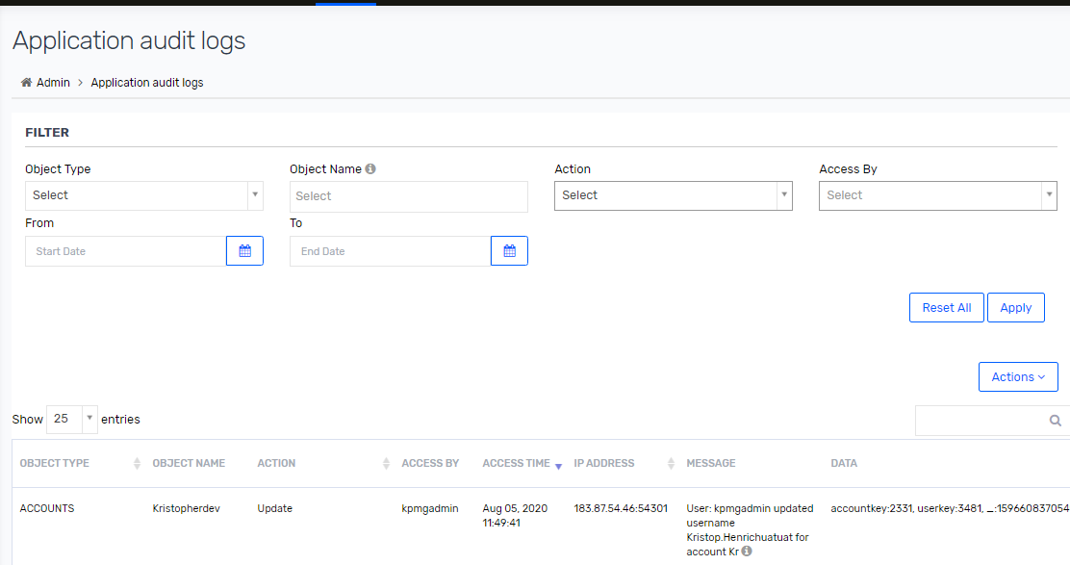

1. Click Reset All too clear all the existing filters and display the default view of the page.

#### Download Audit Log Reports

You can download the audit logs in a CSV or Microsoft Excel file. To download the logs, perform the following steps:

1. Go to ADMIN 🡪 Admin Function 🡪 Application Audit Logs.
2. Select the filter criteria for the report you want to generate.
3. Click Actions. Select the file format CSV or Microsoft Excel file to export the logs.
4. Go to user login menu and click My Download. The Download Reports page is displayed with the list of reports you have exported.

Figure 248 : Download Reports

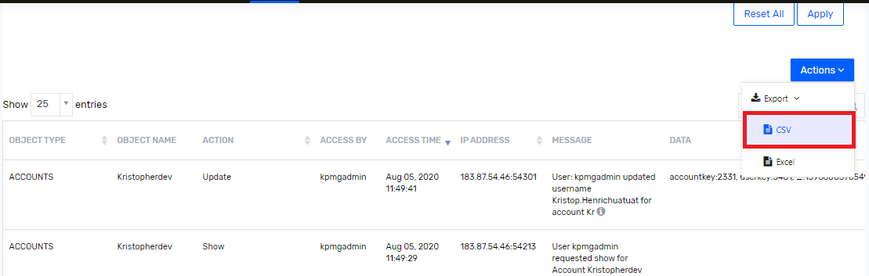

1. Click Download from the Action column for the exported audit log report to save the copy in your system. To delete the downloaded report, click Delete.

### Monitor Oracle HCM Atom Feed logs in Saviynt.

To monitor Oracle HCM Atom feed import job log, IAM admin must login into Saviynt and follow below step to check logs.

1. Login to Saviynt as IAM Admin
2. Navigate to “Admin” tab.

Figure 249: Admin tab

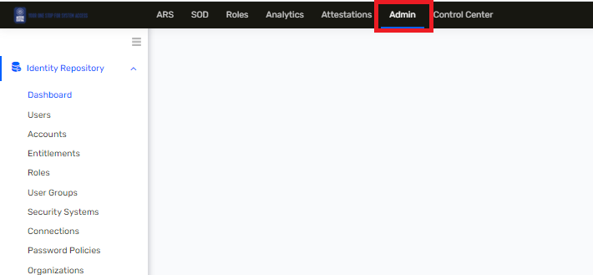

1. Navigate to “Application logs and click on it.

Figure 250: Application Logs

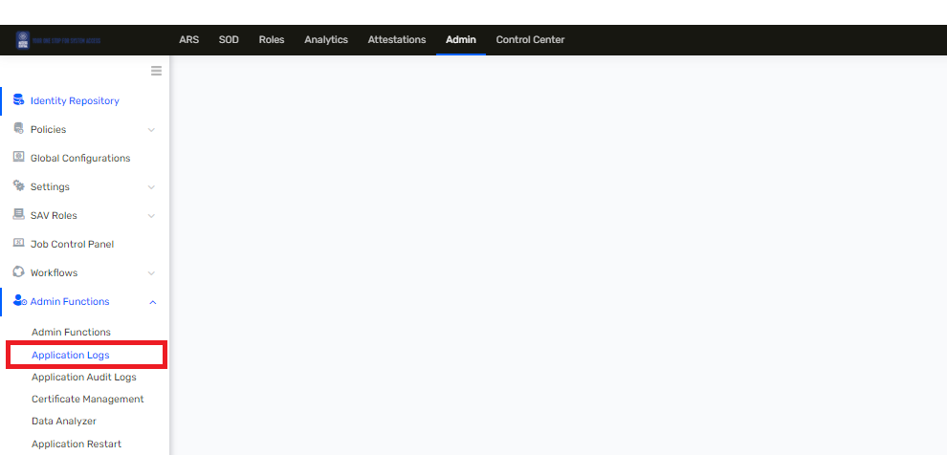

1. Select log from drop down menu bar. For Oracle HCM atom feed custom code logs will be redirected to following file naming convention.

Log file Format :- OracleHCMAtomFeed_YYYYMMDD_HH_MM_SS.log

Figure 251 : Application Logs

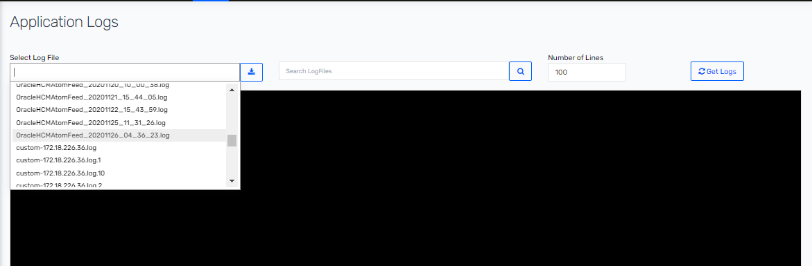

1. Enter Number of lines that is required to fetch and click on “Get Logs” button.

Figure 252: Application Logs

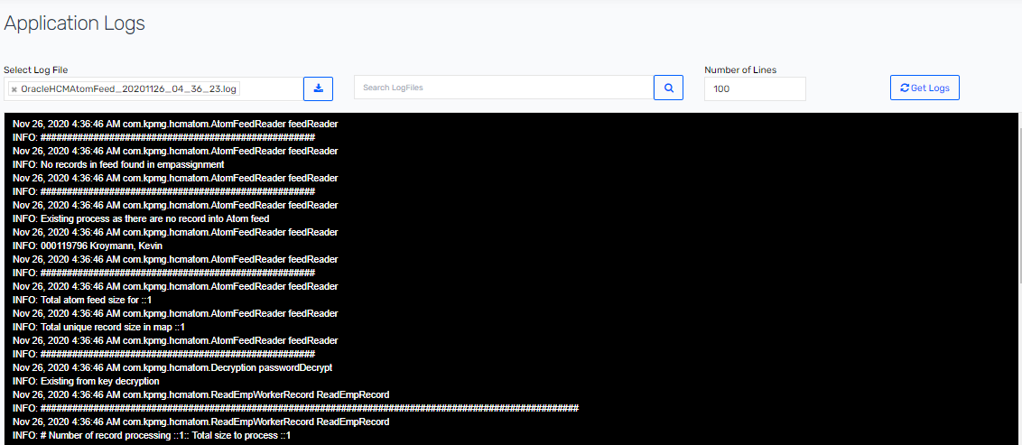

### PowerShell Script Log Details

This section is about log file that are generated by Create and Terminate operation executed for Mailbox. To view Mailbox PowerShell script executed logs. Windows Connector Server application owner must login into Windows Connector Server with Service account as mentioned in section 3.2.3

1. Login into Windows Server Connect box with service account.
2. Navigate to 🡪 C:\ScriptLogs\PROD\MailboxScript\TerminateMailbox\ folder. ScriptLogs folder contains sub folder naming with each individual operation execute by SSM using PowerShell Script.
   1. createdMailbox
   2. TerminationScript
3. Double on folder to view logs and open log file to view details

## Common Errors

This section will describe common errors that may occur in the environment and their possible solutions.

### Provisioning Retry Error

With provisioning retry feature enabled for all lifecycle management use cases, if all retry attempts fail then task will move into completed tasks with status as an error. For each application task failure report will be send to IAM admin team and respective application owner.

Below task failure report is schedule and notification email will be sent to application owner and IAM Admin.

Table 33 : Task Failure Report

|  |  |  |  |
| --- | --- | --- | --- |
| Task Failure Report | Application | Description | Failure Report send to |
| Active Directory Failure Task | Active Directory | Provides the failure task details for Active Directory application | SaviyntSecTecAdmin@hormel .com,ITS_Wintel_Systems_P rogrammers@hormel.com |
| [Mailbox Failure Task](https://ssm-uat-ads.ssmcloud.net/ECM/analyticsConfigES/show?id=86) | Mailbox | Provides the failure task details for Mailbox application | emailsecadmin@hormel.com |
| [Reconciliation Failure](https://ssm-uat-ads.ssmcloud.net/ECM/analyticsConfigES/show?id=90) | All Application | Provides reconciliation failure job details for all application. | SaviyntSecTecAdmin@hormel .com |

#### Hormel Active Directory Failure Task

This section describe about some sample task failure error are captured in Saviynt that are sent to Active Directory application owner.

Table 34 : Active Directory Task Failure Report

|  |  |  |
| --- | --- | --- |
| Application Name | Error Message | Task Status |
| Active Directory | Checking DN for CN=KPMGTestUser1,OU=CORP,OU=Users,OU=Hormel,DC=hormeltestlab,DC=com.Not FOund DN for CN=KPMGTestUser1,OU=CORP,OU=Users,OU=Hormel,DC=hormeltestlab,DC=com. | New |
| Active Directory | Error while DELETE operation for account-DRDean to Group-CN=COR_CTX_Users,OU=Corporate,OU=Groups,OU=Citrix,DC=HFC,DC=AD in AD - [LDAP: error code 50 - 00002098: SecErr: DSID-03150F93, problem 4003 (INSUFF_ACCESS_RIGHTS), data 0 ] | New |

Following are common error may occurred for Active Directory

##### Insufficient access right while provisioning AD task

Active Directory provisioning task will failed due to insufficient access right for below actions.

* Inadequate access/permission to Saviynt service account to specific OU.
* Inadequate access permission to Saviynt service account to add groups.
* Change password operation failed due to inadequate access/permission to Saviynt service account.

Table 35 : insufficient access Error

|  |
| --- |
| Error while DELETE operation for account-DRDean to Group-CN=COR_CTX_Users,OU=Corporate,OU=Groups,OU=Citrix,DC=HFC,DC=AD in AD - [LDAP: error code 50 - 00002098: SecErr: DSID-03150F93, problem 4003 (INSUFF_ACCESS_RIGHTS), data 0 ] |

To resolve above error for insufficient access issue , IAM admin must contact Active Directory team to provide appropriate access to perform action with Saviynt service account.

#### [Hormel Mailbox Failure Task](https://ssm-uat-ads.ssmcloud.net/ECM/analyticsConfigES/show?id=86)

This section describe about some sample task failure error are captured in Saviynt that are sent to Mailbox application owner.

Table 36 : Mailbox Failure Report

|  |  |
| --- | --- |
| Application Name | Error Message |
| Mailbox | {"auditDetails":{"call1":[{"headers":null,"statusCode":500,"description":null,"status":"Failed"},{"headers":null,"statusCode":500,"description":null,"status":"Failed"}, |

Mailbox application owner need to check logs referred in section 7.1.3 to verify all the operation are executed for terminated user.

#### Hormel Mailbox Reconciliation Failure

This section describe about some sample task failure error are captured in Saviynt that are sent IAM Admin.

Below error describe that PowerShell script is taking too long to fetch all mailbox account information.

Table 37 : Reconcilation Failure Report

|  |  |
| --- | --- |
| Endpoint Name | Error Message |
| Mailbox | Error - to Import Data correctly: Failed url-http://<url> /Saviynt/PS/executepsscript with Error Message-"Exception: Powershell script taking too long System.TimeoutException: Powershell script taking too long\r\n at MVC_FIM.Services.PowerShellService.fnExecuteScript(String ScriptName)" |
| Mailbox | Error - Failed to Connect or Import Windows Data : Failed : HTTP error code : 500 |

#### Hormel Oracle HCM Atom Feed Reconciliation Failure

This section describe about some sample task failure error are captured in Saviynt that are sent IAM Admin for Oracle HCM Atom Feed job failed.

|  |  |
| --- | --- |
| Endpoint Name | Error Message |
| Oracle HCM Atom Feed Job | Error - to Import Data correctly: Failed url-https://ekkh-test.fa.us2.oraclecloud.com/hcmRestApi/resources/latest/emps/?onlyData=true&totalResults=true&limit=1&expand=assignments with Error Message-  Internal Server Error  The server encountered an unknown error, possibly due to misconfiguration. Contact the server administrator: [no address given]  More information about this error may be available in the server error log. |
| Oracle HCM Atom Feed Job | Error - to Import Data correctly: Failed url-https://ekkh-test.fa.us2.oraclecloud.com/hcmRestApi/resources/latest/emps/?onlyData=true&totalResults=true&limit=1&expand=assignments with Error Message-  The cloud service you are trying to access is currently undergoing maintenance. Rest assured, we will get you up and running again as soon as possible. We apologize for the inconvenience. |
| Oracle HCM Atom Feed Job | Error - to Import Data correctly: Error in Users Import - Error while processing data: null |

IAM Admin need to check logs referred in section 7.1.3 to trouble the issue.

### Connection Failure

Connection to target applications such as Active Directory, Mailbox , and Oracle HCM may fail due to authentication failure or service account being disabled or locked out.

For connection failure, try reconfiguring username and password for the given application.

If service account is being disabled or locked out, then contact respective application administrator to resolve this issue.

## Saviynt Support

Saviynt Support central is a one stop portal to raise any support ticket with the vendor regarding any critical bugs or issues that happens in the environment. Below are the steps to raise support ticket with Saviynt.

### Submit Ticket in Saviynt Support

1. Login into Saviynt Freshdesk [<https://saviynt.freshdesk.com/support/login>] using username and password. And click on 🡪 Login button.

Figure 253 : Saviynt Support



1. After login into Saviynt Click on 🡪 Submit a ticket.

Figure 254 : Submit a ticket

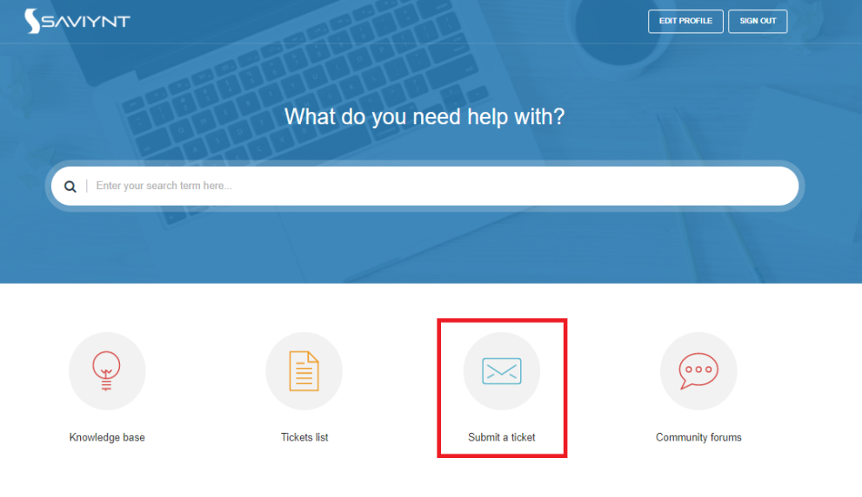

1. Describe error as detailed as possible detail in description section. And submit request. For priority refer 7.3.2 Saviynt SLA Definition Section.

Figure 255 : Submit ticket

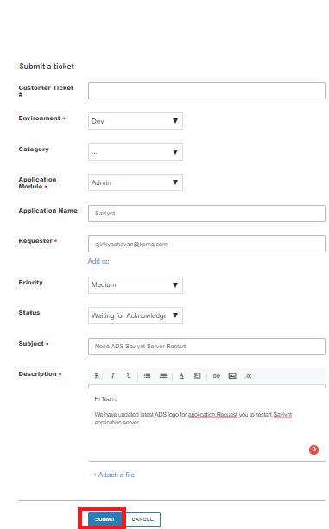

### Saviynt SLA Definition

Figure 256 : Saviynt SLA Definition

|  |  |
| --- | --- |
| Severity | Description |
| Urgent | •Production system is unavailable and / or not operational due to unplanned outage and service needs to be restored immediately  •Multiple functions of application are not working completely and has major financial impact  •Overall system performance is slow / below baseline during normal load conditions and application is not available for major group of users  •E.g. certification service is unavailable during active access certification cycle |
| High | •One of the critical functions of the system is not working as expected  •Important functions of applications are accessible but multiple users are unable to access some services of the application  •E.g. password sync is operational, but access provisioning service might be down |
| Medium | •Non-critical service impacted  •Only a small set of users impacted  •E.g. configuration not working as expected impacting a small set of users but can be achieved through a workaround in SSM |
| Low | •Informational Requests, Issues impacting Individual users, Data Change requests  •Customer can access all business resources  •E.g. Request for Data changes including changes to reports, dashboards, configuration changes etc.; feature Enhancements (No SLA) |

### Saviynt Helpline

Below are Saviynt helpline telephone number region wise.

* Australia:        +61390685719
* UK:                 +441983217784
* US Toll Free:  +1-(855) 856-4368

## Saviynt Community

Saviynt community is a one stop solution to connect to all community members who are using Saviynt Security Manager in their environment. This community provides access to couple of posts that provides solutions to different errors, new requirements and designs from community members all over the world. So, here any query related to error can be posted to find solution from experts.

This is accessible through URL : [<https://saviynt.freshdesk.com/support/discussions>]

1. Login into Saviynt Freshdesk [<https://saviynt.freshdesk.com/support/login>] using username and password. And click on 🡪 Login button.



1. After login into Saviynt Click on 🡪 Community forums.

Figure 257 : Community Forums

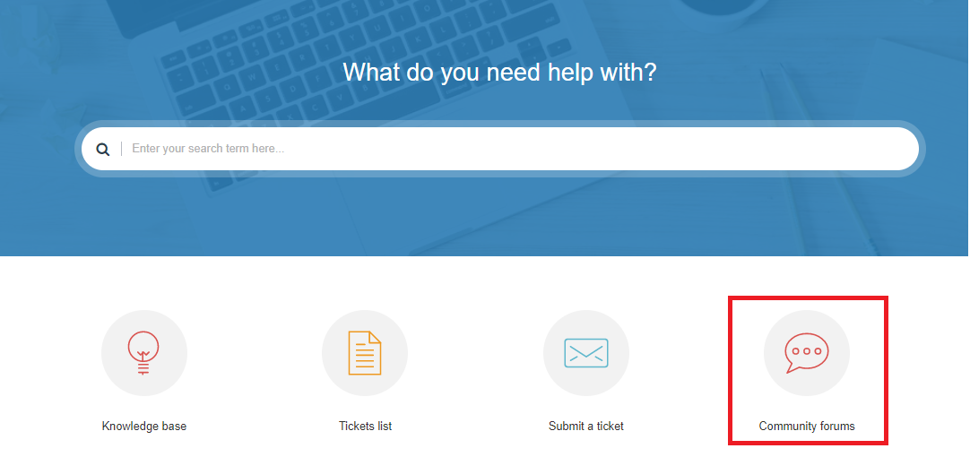

1. After successful login, the home page looks like below where we can search our contents and queries on forum

Figure 258 : Saviynt User Community Forums

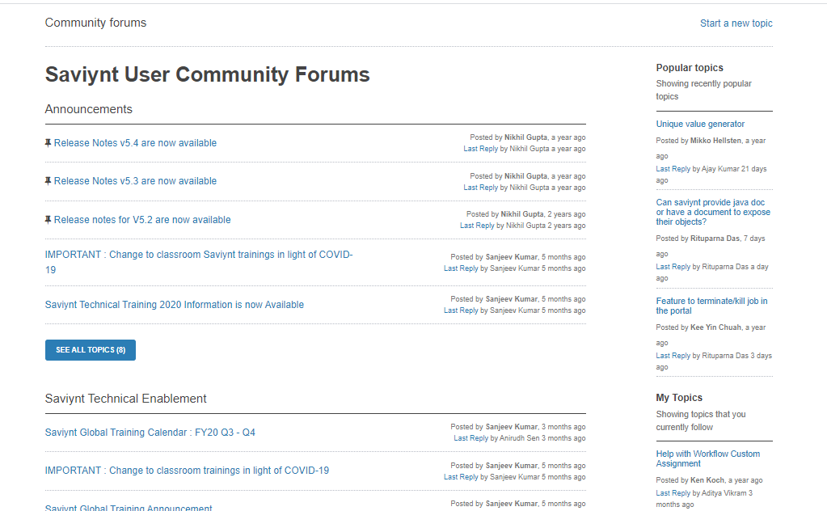

# Frequency Asked Questions (FAQs)

Below are the frequently asked questions and answers.

1. What is the authentication source of Saviynt?  
   **Answer**: Saviynt has SSO integration with Azure.
2. What happens if the user was previously created with an incorrect last name?  
   **Answer**: Once HR corrects user’s last name into Oracle HCM then it gets sync into Saviynt and last name is also gets sync in Active Directory. Note that change in display name and CN must be manually edited into Saviynt as per mentioned in section 5.4.11.
3. Does Saviynt shows the expired/inactive profiles?  
   **Answer**: Saviynt contains all the active and inactive users of US Employee and Other Users.
4. How quickly will the changes in the user profile be pushed from Saviynt to the target systems (e.g. – Active Directory)?  
   **Answer**: Profile changes are pushed from Saviynt to AD at the time of submission (within 15 min). As per Hormel team, there is a 30 minutes delay to sync data from on premise AD with Azure AD (in turn O365).
5. Is the Password reset be automated for both US Employee and Other Users?  
   **Answer**: Password reset process is the ad hoc request initiated by end user. When end user calls helpdesk validates the user and resets the user password.
6. When password is reset in Saviynt, does password be synced with all target systems?  
   **Answer**: At present SSM will sync the password in AD.
7. How far the future hire date? Is there any limit? Could be set 4 months from now?  
   **Answer**: Future hire date user can be onboarded into Saviynt upon 15 days ahead of current date. And user account will be provisioned only when the hire date is within 15 days from present day. Email notifications are sent on the day of account creation to Security team.
8. When we separate an employee will the separation date be aligned with the time zone/region where the US Employee is located?  
   **Answer**: Suppose if employee is terminated on 12-Jan then user will be inactive on 13-Jan.Assuming as 12-Jan is last day of user.
9. Is there a way of seeing the status of the account, whether it is locked or unlocked?  
   **Answer**: Currently Saviynt does not specify user’s account lockout status.
10. If an account is locked and Helpdesk team unlocks it. How long it will take to replicate in other systems? For example, Active Directory?  
    **Answer**: Saviynt pushes the account unlock almost instantly in AD. However, in some scenario, AD takes few minutes to sync the data in all Domain Controllers. Contact AD team for more information.
11. What if inactive status become "Active" and how would that occur? Could that be reactivated and what would be the Other User?

**Answer**: For user, this status is driven from HR. Any updates to employee/contingent worker employment status would have to be requested to HR.

1. Is Service/Elevated account are handled in Saviynt?

**Answer**: All Service and Elevated account are not handled by Saviynt. And Currently it is out of scope.

1. How much time takes to sync password to Active Directory?

**Answer**: Once user password is changed is sync to Active Directory within 1 min.

1. How long failure task will remain in Pending Task queue ?

**Answer**: For all application number of provisioning retry is up to 2880 that is 30 days. Except User Mailbox terminate endpoint has 3 retry count to execute PowerShell script.

1. How many reminder emails do assignee will receive if approver is not approved request?

**Answer**: Assignee will receive reminder notification about request on 3rd days

1. How long will request is active if approval do not approve it?

**Answer**: Request will be auto expired if no action is taken within 10 days.

1. Is there any audit report available in Saviynt to check user audit history ?

**Answer**: Yes. There are many OOTB and customs reports available in Saviynt , where IAM admin can execute and view result and even download. Refer section 7.1.2

1. What happens if the employee/contingent worker user was previously created with an incorrect last name?  
   **Answer**: HR team must correct last name in Oracle HCM. Saviynt will reconcile all record from Oracle HCM and corrected last name will update in Saviynt and SSM will trigger update task to update into downstream application.

# Reference

|  |  |
| --- | --- |
| Documents | Reference |
| Requirement Guide | <Update link after document is uploaded into FTP> |
| Design Document | <Update link after document is uploaded into FTP > |
| Configuration Guide | <Update link after document is uploaded into FTP > |
| Saviynt Documentation | <https://saviynt.freshdesk.com/support/solutions> |